IBM Cloud Pak for Automation

Lab instructions for

Business Automation Insights

BAI events setup for BPMN, Case and ODM with Kibana dashboards

Authors: Werner Fuehrich, Lars Grespan, Swapnil Agrawal, Radek Šulc

Owner: Radek Šulc

Version: 3.0.0

Table of Content

0 Introduction 4

0.1 Audience 4

0.2 Prerequisites 4

0.3 Objectives 5

Lab Structure 6

0.4 Tools, User IDs and Passwords 6

1 Exercise: Getting Started 8

1.1 Getting Started – Introduction to BAI 8

1.2 Getting Started – Introduction to the solution 10

1.3 Getting started – Check of the environment 11

1.4 Getting Started – Step by Step Instructions 14

1.5 Getting Started – Summary 17

2 Exercise: Modify the CP4Automation Solution to Emit Data 19

2.1 Modify the CP4Automation Solution to Emit Data – Introduction 19

2.2 Modify the CP4Automation Solution to Emit Data – Step by Step Instructions 20

2.3 Modify the CP4Automation Solution to Emit Data – Verification Instructions 28

2.4 Modify the CP4Automation Solution to Emit Data – Summary 36

3 Exercise: Explore Emitted Events in BAI 38

3.1 Explore Emitted Events in BAI – Introduction 38

3.2 Explore Emitted Events in BAI – Step by Step Instructions 40

3.3 Explore Emitted Events in BAI – Summary 41

4 Exercise: Getting started with Kibana 42

4.1 Getting started with Kibana – Introduction 42

4.2 Getting started with Kibana – Step by Step Instructions 42

4.2.1 Introduction to the Kibana Desktop and Navigation 43

4.2.2 Management: Understand and learn about Index Patterns 44

4.2.3 Discover the data in Elasticsearch and use Saved Searches 51

4.2.4 Visualizations 71

4.2.5 Dashboards 90

4.2.6 Advanced Topics 101

4.3 Getting started with Kibana – Verification Instructions 103

4.4 Getting started with Kibana – Summary 104

5 Exercise: Understand the available dashboards on monitored Cases, Processes and Decisions 106

5.1 Understand the available out-of-the-box dashboards – Introduction 106

5.1.1 Workflow - Cases Dashboard 106

5.1.2 Workflow – Case Activities Dashboard 108

5.1.3 Workflow - Processes Dashboard 110

5.1.4 Workflow - Process Tasks Dashboard 111

5.1.5 Decisions Dashboard 113

5.1.6 Hiring Sample Dashbaord 115

5.2 Understand the available dashboards – Step by Step Instructions 116

5.2.1 Questions 116

5.2.2 Answers 118

5.3 Understand the available dashboards – Summary 122

6 Exercise: Create new Visualizations specific to the Mortgage Application Solution 123

6.1 Create new Visualizations and a Dashboard for the Mortgage Application Solution – Introduction 123

6.2 Create new Visualizations and a Dashboard for the Mortgage Application Solution – Step by Step Instructions 124

6.2.1 Open mortgage applications grouped by age 124

6.2.2 Trend of accepted vs. rejected mortgage applications 134

6.2.3 Trend of Final Decision Deviating from ODM Proposal 139

6.2.4 Avg of Durations for a Mortgage Application to complete separated by rejected/accepted 145

6.2.5 Create a new Dashboard for the Mortgage Application-specific solution 154

6.2.6 Create mortgage-specific visualizations without step-by-step instructions 157

6.3 Create new Visualizations and a Dashboard for the Mortgage Application Solution – Verification Instructions 163

6.4 Create new Visualizations and a Dashboard for the Mortgage Application Solution – Summary 165

# Introduction

In this lab, you will implement the complete IBM Business Automation Insights (BAI) sub-scenario of the Cloud Pak for Automation (CP4Automation) Labs and Demos. To do this you will primarily work with BAI tools but also work with some tools of IBM Business Automation Workflow (BAW) and IBM Operational Decision Manager (ODM).

The insights will be created for a Mortgage Application scenario that is based on a bank’s solution to automate its handling of new mortgage applications. The mortgage application scenario uses all the pillars of the DBA platform but, in this lab, we will primarily focus on the available BAI emitters from BAW and ODM. You can build the BAW portion of the mortgage application solution in Lab 4 and the ODM portion in Lab 6.

Duration: ~10 hours.

## Audience

Everyone interested in the Cloud Pak for Automation (CP4Automation) space, especially for those looking to create and view insights into their business and implementation. This will also be a pre-cursor to future labs that deal with Artificial Intelligence for the DBA platform. Some of the roles in the Audience can be:

Business User

Gain insights using the business data from the CP4Automation solution(s). For example, in the Mortgage Application solution, see how many mortgages get approved despite a high-risk recommendation from ODM.

Process Owner

Gain insights into the operations of the CP4Automation solution(s). For example, in the Mortgage Application solution, see which users are performing which tasks efficiently.

DevOps / System Admins

Gain insights into the workings of the CP4Automation solution(s). For example, in the Mortgage Application solution, understand which tasks, processes and rules take the longest to complete.

## Prerequisites

* Some experience in IBM Business Automation Workflow and IBM Operational Decision Manager would be useful but is not required.

## Objectives

As part of this sub-scenario, you will:

1. Learn the high-level architecture and features of BAI.
2. Get introduced to the tools that are a part of BAI.
3. Modify a BAW solution to emit business data – a BPMN Process and a Case.
4. Modify ODM rules to emit business data.
5. View the emitted data in BAI datastores (Elasticsearch/Kibana & Hadoop).
6. Understand the basics of using Kibana.
7. Use the out-of-the-box dashboards that ship with BAI.
8. Create new visualizations and dashboards that use the emitted business data in Kibana.

## Lab Structure

This lab is subdivided into multiple exercises. Most exercises consist of the following sections:

1. Exercise Introduction  
   Describes what you will learn & complete in this exercise.
2. Step by Step Instructions  
   Guides you in easy to understand steps through the whole exercise. To be used by less experienced attendees.
3. Verification Instructions  
   Guides you through how to test & verify your implementation.
4. Exercise Summary  
   Summarizes what you have completed & learned.

## Tools, User IDs and Passwords

In this lab, you will access the following tools. The tool to access, along with the username and password will also be mentioned in the lab exercise itself.

For your convenience, we have prepared bookmarks in Chrome and Firefox for all the tools mentioned below.

|  |  |  |
| --- | --- | --- |
| Tool | Location in Chrome/Firefox Bookmarks Toolbar | User ID(s) / Password |
| Windows | N/A | Administrator / passw0rd |
| Kibana | BAI > Kibana  <https://mini:5601/> | admin / passw0rd |
| Hadoop Filesystem | BAI > HDFS – Browse  <http://namenode:50070/explorer.html#/> | Not needed |
| Workflow Center | BAW > Workflow Center  https://ibmbaw:9443/WorkflowCenter/ | admin / admin |
| Case Administration tool | Available from the Workflow Center | admin / admin |
| Process Designer | Available from the Workflow Center | admin / admin |
| Mortgage Application Desktop | BAW > Desktops > Mortgage Application  <https://ibmbaw:9443/navigator/?desktop=MA> | admin / admin |
| Case Client | BAW > Desktops > BAW  <https://ibmbaw:9443/navigator/?desktop=baw> | admin / admin |
| ODM Rule Execution Server | ODM > Rule Execution Server  <http://localhost:9090/res/> | resAdmin / resAdmin |
| ODM Decision Center Business Console | ODM > Decision Center Business Console  <http://localhost:9090/decisioncenter> | rtsAdmin / rtsAdmin |

Note: User admin with password admin can be used for almost all tools in this scenario.

# Exercise: Getting Started

## Getting Started – Introduction to BAI

In this exercise, you will:

1. Understand the high-level architecture of BAI.
2. Verify that your environment has started successfully.
3. Verify that you can login to the tools required for the remaining exercises.

IBM Business Automation Insights provides functionality to enable platform-level visual insights and feeds a data lake to infuse artificial intelligence into IBM Digital Business Automation.

A typical BAI high-availability deployment is done on an OpenShift platform with Kubernetes cluster. Let’s look at BAI’s architectural diagram on an OpenShift platform.

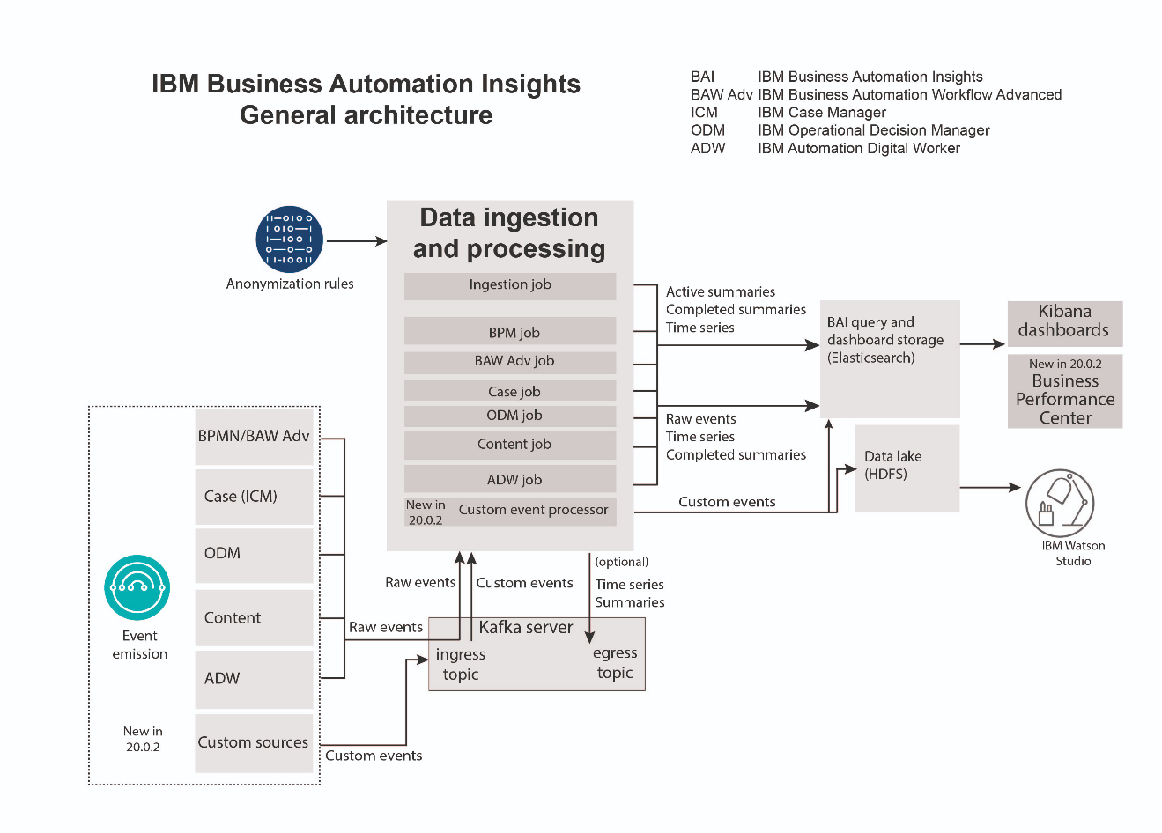

Important things to note from the architectural diagram above:

1. Currently, there are 5 emitters available for BAI from the CP4Automation platform – BPMN/BAW Advanced, Case, ODM, Content and Digital Worker.
2. Since BAI V20.0.2 there is a new way allowing processing of custom events described by Avro schema from custom sources.
3. Emitters from the different pillars of the CP4Automation platform send raw events in Business Event format to Kafka which are then processed by BAI and finally stored in different datastores.
4. Data is stored in Elasticsearch and a data lake (HDFS - if configured). You will explore the Elasticsearch datastore in exercise 3.
5. The type of data stored is different in each datastore. E.g.: Only the Hadoop datastore stores the raw events.
6. Anonymization rules are available to anonymize data going into the long-term storage (Hadoop) as per GDPR requirements. You will create anonymization rules to protect business data in exercise 4.
7. The data in the long-term storage can be used in conjunction with Watson or other Data Science technologies to enable artificial intelligence on the business data.
8. The data stored in Elasticsearch can be used to create UI based visualizations and dashboards in Kibana. You will work with Kibana in exercises 5-7.
9. The visualizations created in Kibana can be embedded into other UIs such as the task UI for a knowledge worker in BAW. You will do this in exercise 8.

However, deployment to a single node in a development or production environment is also available. This is a simplified deployment used during the lab. It does not need a Kubernetes cluster, just Docker with Docker Compose. It is a lightweight deployment with all the features available for BAW and ODM.

Additional information about BAI is also available in the [Knowledge Center](https://www.ibm.com/support/knowledgecenter/SSYHZ8_20.0.x/com.ibm.dba.bai/topics/con_bai_overview_top.html). It can be Googled easily when searching e.g. for “IBM BAI knowledge center”.

## Getting Started – Introduction to the solution

BAI always collects and processes events from some components. That’s why it is important to understand context and details of the whole solution. What are the collected events, what business data are propagated and what is the expected outcome – processed data, dashboards, alerts, AI/ML inputs etc.

In our lab, BAI is processing events from a Case solution with a Case. The Case has couple of activities which are implemented as BPMN processes. And one of the processes (Perform Risk Assessment) calls ODM Decision Service for risk evaluation. All the components interact and exchange specific business data about the customer, loan, approvals, risk assessment etc.

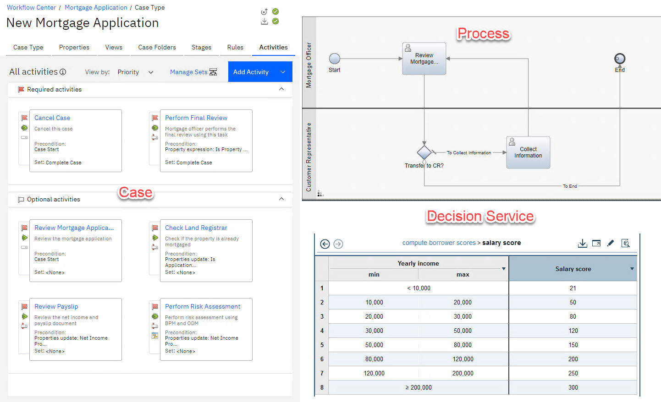

## Getting started – Check of the environment

The lab environment performs automated startup of all the components needed for the lab:

* IBM Business Automation Workflow (BAW)
* IBM Operation Decision Manager (ODM)
* IBM Business Automation Insights (BAI)

Several windows are present on the desktop after startup. Please handle the like described on the screenshots below.

ODM:

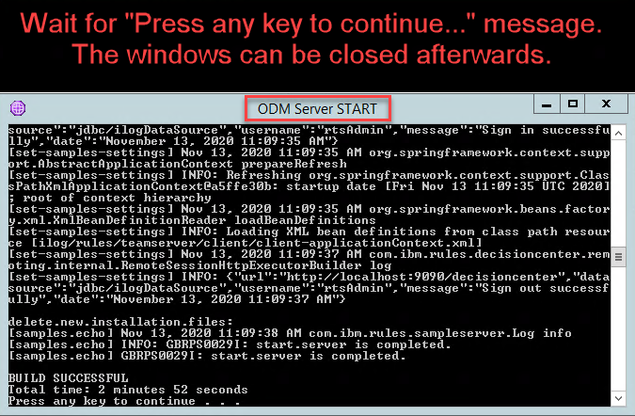

BAW:

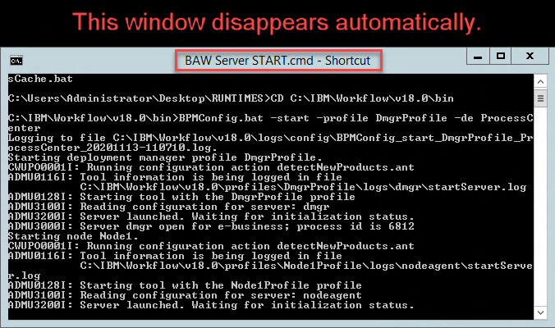

Note: BAW continues starting in the background after its startup window disappears. It may take a while.

BAI:

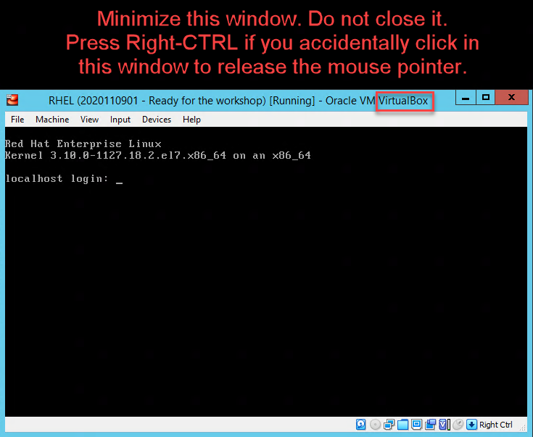

If you use different setup make sure that BAW, ODM and BAI with HDFS are started and all the lab artifacts imported.

Before starting with the labs, you can also check that the BAI Flink Jobs are running.

Open Chrome web browser, then open a new tab and select **BAI** > **Apache Flink Web Dashboard**. The screen should like the screenshot below with eight Flink jobs in green color.

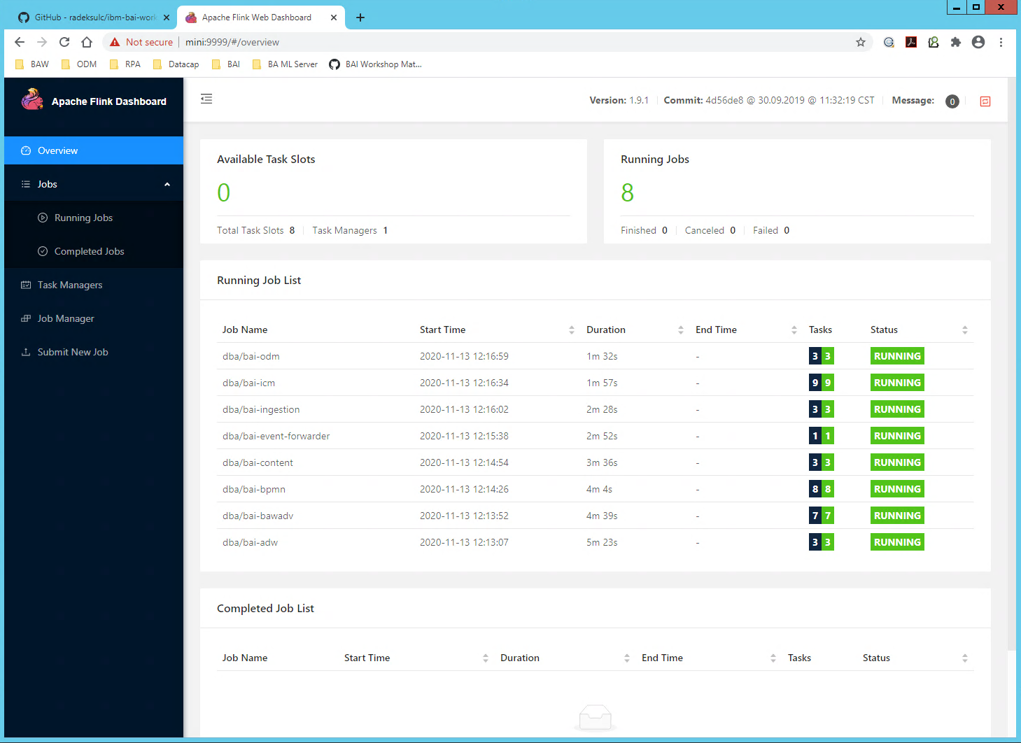

Starting all the Flink jobs may take couple of minutes. They must be present on the list and green.

Now you are ready to start with the lab.

## Getting Started – Step by Step Instructions

1. Open Chrome web browser from the Windows taskbar.  
   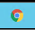
2. Open a new tab.
3. You can check that BAI is running by opening Kibana user interface in Chrome. In the Chrome’s bookmarks bar open **BAI** > Kibana  
   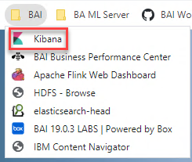
4. You can see Kibana login screen once it starts up.  
   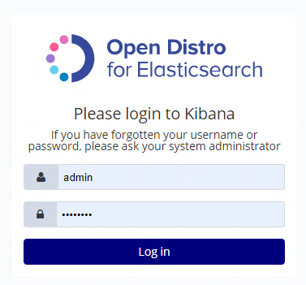  
   Now you can login with pre-filled credentials – admin / passw0rd (with zero).
5. Click on **Dashboard** in the left sidebar.
6. Click on the **Workflow – Processes** dashboard. You should see a screen like the one below with zero in Started/Completed process instances. Which is fine as the default time period filter is last 15 minutes. Nothing has started or finished during this period.

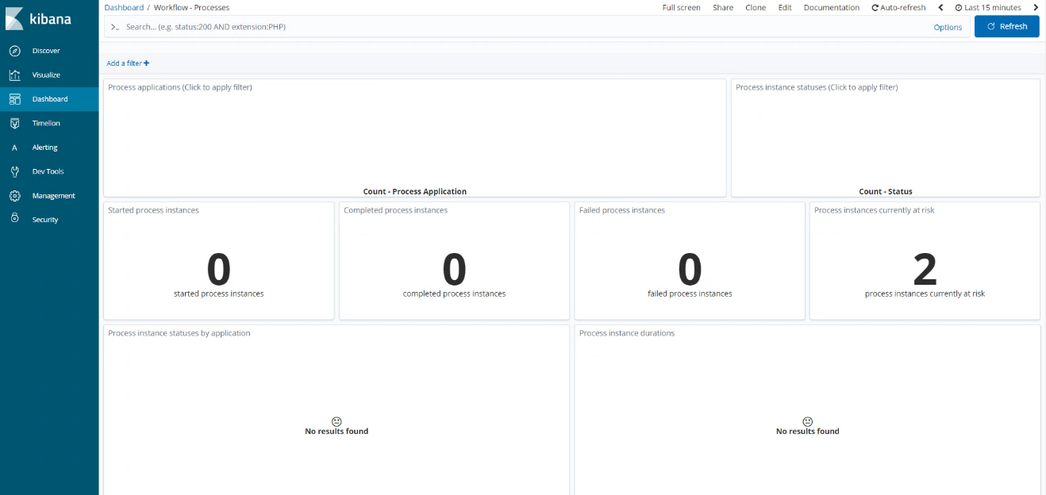

Events will be generated in exercise 2 by running a new instance of the mortgage application. You will also get an introduction to Kibana and import pre-generated events in exercise 5.

1. In the top-right corner, select the time range **Last 15 minutes** and choose the time range **Today**.  
   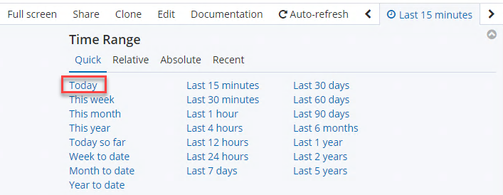
2. The Dashboard should remain unchanged as there is no data being emitted to BAI yet today. If you can already see some data visible, it is also fine. You can also use e.g. “Year to date” if you want to play around. Do not forget to switch back to “Today” in that case.
3. Similarly, explore the other out of the box Dashboards and verify that they have no data. You will get a further deep dive into the out of the box Dashboards in exercise 6.
4. Open a new tab (e.g. using CTRL+T) and open **BAI** > **HDFS - Browse** to open web browser of HDFS.
5. Go to the **user** folder under the Name column.

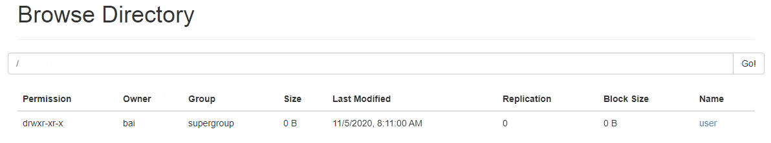

From there, go to the **bai** folder and its **ibm-bai** subfolder.

Events will be created once you run an instance of the mortgage application solution.

Note

It might be that you see some files in this directory as shown in the below screenshot. You can safely ignore the differences.

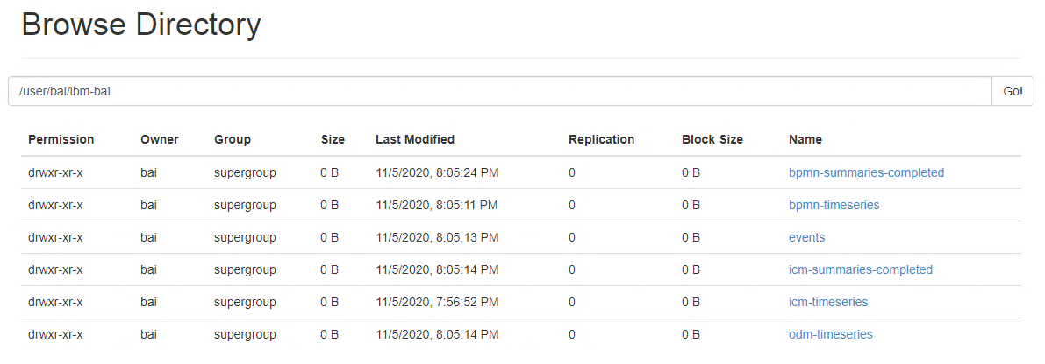

1. Open Firefox browser from the Windows taskbar.  
   
2. In Firefox bookmark folder, open **ODM** > **Rule Execution Server**.
3. Log in with username **resAdmin** and password **resAdmin**.
4. Click on the **Explorer** tab in the top toolbar.

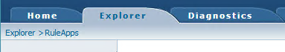

1. Verify that you see the **Loan_Computation** and **Loan_Evaluation** RuleApps deployed.

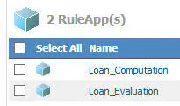

1. Back in Chrome, open a new tab and in bookmark folder select **BAW** > **Workflow Center - Solutions**.
2. Log in with username **admin** and password **admin**.

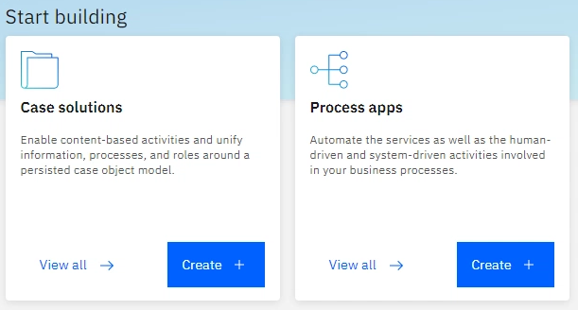

1. Click on Process apps and verify that the **Risk Assessment** Process app is present.
2. In the upper-left corner, click on the hamburger **Menu** icon and select **Case solutions**.



1. Verify that the **Mortgage Application** Case solution is present.

## Getting Started – Summary

In this exercise, you have:

1. Accessed the demo lab environment needed to perform the BAI sub-scenario.
2. Connected to and started VM in your environment.
3. Learned how to work with your environment and start-up the tools required for this lab.

4. Gotten introduced to some of the BAI / CP4Automation UIs and tools.

5. Gained a basic understanding of the high-level BAI architecture.

# Exercise: Modify the CP4Automation Solution to Emit Data

## Modify the CP4Automation Solution to Emit Data – Introduction

In this exercise, you will:

1. Modify the Case, BPM and ODM pillars of the Mortgage Application CP4Automation solution to emit specific business data into BAI.
2. Run an instance of the Mortgage Application solution and check Kibana to verify that the data is being emitted into BAI and processed.

Each pillar has its own types of events and a way to enable the emission of specific business data which became part of the payload of the events. You will go over each of these ways in this exercise. Once the emitters are configured, you will run an instance of the Mortgage Application solution to send the events to BAI.

BPMN, Case and ODM emitters are already configured and connected to BAI’s Kafka. You can find configuration of the emitters in directory “C:\dba\bai\emitters” of the primary Windows VM.

BPMN Variables

To emit business data from a Process, you must [enable tracking for the variables](https://www.ibm.com/support/knowledgecenter/SS8JB4/com.ibm.wbpm.wle.editor.doc/topics/how_perfsvr_stores_data_a.html) that need to be emitted into BAI. For this exercise, you will create a tracking group to emit business data from the Perform Final Review Process.

Case Properties

To emit business data from a Case, you must [configure the audit log](https://www.ibm.com/support/knowledgecenter/en/SSYHZ8_20.0.x/com.ibm.dba.bai/topics/tsk_bai_case_emitter_config_audit_log.html) for the properties that need to be emitted into BAI. For this exercise, we will create an audit configuration that emits all the properties for the New Mortgage Application Case type.

ODM Ruleset Parameters

To emit data from an ODM ruleset, you must [set the built-in ruleset properties](https://www.ibm.com/support/knowledgecenter/en/SSQP76_8.10.x/com.ibm.odm.dserver.rules.res.console/topics/con_rescons_rs_prop_bai.html). In this exercise, you will set the built-in ruleset properties that emits the ruleset parameters and execution traces.

Note: These approaches are only possible after configuring the various pillars to emit events in the first place. This has already been done for the current lab environment.

You are now ready to start this exercise.

## Modify the CP4Automation Solution to Emit Data – Step by Step Instructions

* 1. In Chrome bookmark folder, open **BAW** > **Worklow Center - Solutions**.
  2. Login with username **admin** and password **admin**.

First, you will [create an audit configuration](https://www.ibm.com/support/knowledgecenter/en/SSYHZ8_20.0.x/com.ibm.dba.bai/topics/tsk_bai_case_emitter_config_audit_log.html) for the Case Solution to enable emission of specific business data of the case for all the properties of the New Mortgage Application Case type.

* 1. Click on the **Case Solutions** tile to open the list of Case solutions.
  2. Hover on the **Mortgage Application** solution tile to see the dotted menu action button.
  3. Click on the dotted menu and then click on **Advanced**. Opening the window and loading of the content make take a while for the first time.

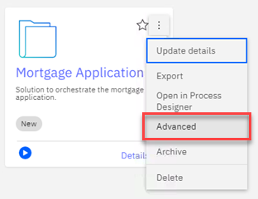

* 1. In the IBM Business Automation Workflow Case administration window that opens, click once on the **Mortgage Application** solution.

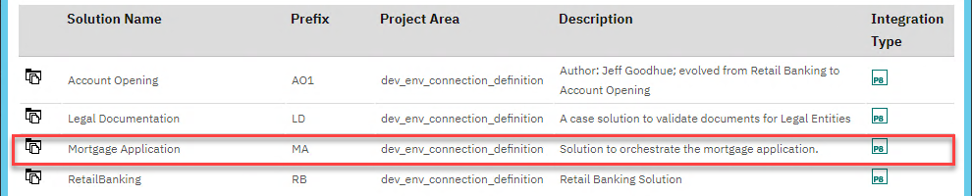

* 1. Click on **Actions** > **Manage** > **Audit Configuration**.
  2. In the **Manage Audit Configuration** tab that opens, select the option **Create an audit configuration**.

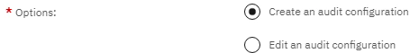

* 1. Click on the **Next** button.
  2. Enter the name **MA_AuditConfiguration** in the Audit manifest name field.

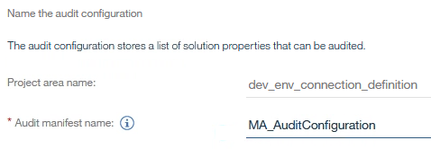

* 1. Click on the **Next** button.
  2. Click on the **Add** button.
  3. In the **Select Properties** dialog, add all the available Properties to the **Selected Properties** section.

Hint: You can use Ctrl + A or use the Shift key to select multiple properties at once.

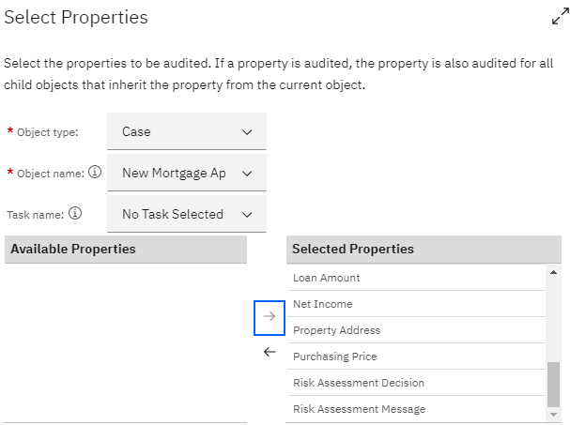

Note: The auditing can also be configured for Task properties. In the current DBA solution, no task properties are defined but in a production environment, the business analyst can identify case/task properties they want to see in BAI.

Note: The New Mortgage Application Case type is automatically selected as it is the only Case type in the Mortgage Application Case solution.

* 1. Click on the **OK** button.
  2. Click on the **Next** button.
  3. Check the checkbox **Apply audit configuration**.

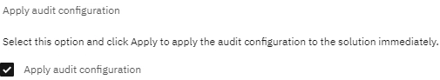

* 1. Click on the **Apply** button and wait for the Success message.
  2. Click on the **Save** button
  3. Close the Case administration browser window.

**This completes the procedure required to emit business data for Case properties. Next, you will modify the Workflow solution to enable emission of business data for the BPMN component.**

* 1. In Chrome bookmark folder, open **BAW** > **Workflow Center - Solutions**.
  2. Click on the **Case solutions** tile to open the list of Case solutions.
  3. Hover on the **Mortgage Application** solution tile to see the dotted menu action button.

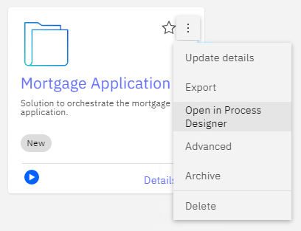

* 1. Click on **Open in Process Designer** to access the process part of the solution.

You will modify the Perform Final Review task that points to a BPM Process to emit some of the business data from the BPM. This is done by tracking the variables in the Process. There are [different ways to track variables in a Process](https://www.ibm.com/support/knowledgecenter/en/SS8JB4/com.ibm.wbpm.wle.editor.doc/topics/how_perfsvr_stores_data_a.html). We will use the Tracking Groups approach to do so in this exercise. You can also enable auto tracking for the whole process.  
  
Note: Ideally, you can just modify the Audit Configuration of the Case solution to emit the solution’s properties but if the BPM Process contains variables in addition to the solution’s properties, they will have to be emitted from the BPM Process. This approach also showcases how to enable emission of specific business data for BPM Processes if you are not using Case.

**IMPORTANT – The way the tracking of process variables is defined in the process is exactly the same like for the traditional Performance Data Warehouse. From design perspective you simply do not need to care of the fact that at the end the events with data are emitted to the BAI. No new toolong support, no new skills needed. Simple. The same is valid for autotracking.**

* 1. From the **Processes** menu, open the **Perform Final Review** process.

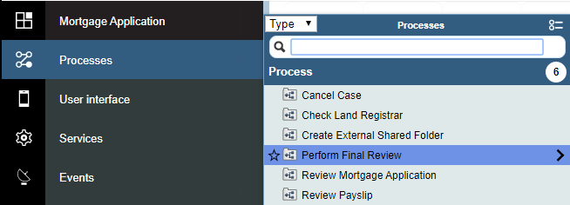

The process diagram with one human task opens looking like this:

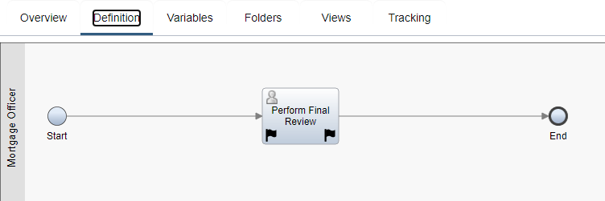

* 1. In the Process editor, click on the **Perform Final Review** user task.
  2. In the **Properties** section of the task, click on the **Tracking** tab (down in properties of the task, not in Tracking tab of the whole process on top).

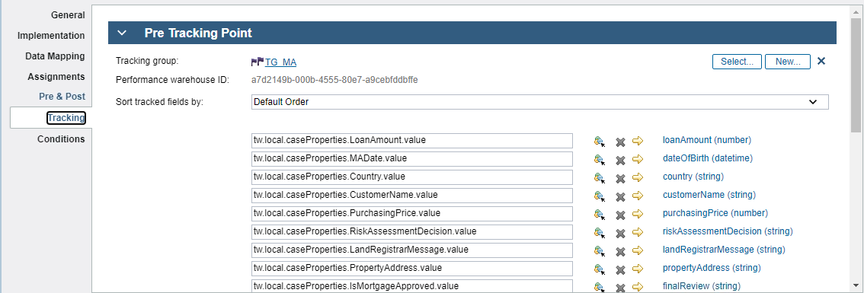

The tracking group defines set of specific process variables (business data) going to be tracked and become part of the BAI events payload. To make the lab faster we have already defined the tracing group for you and mapped the process variables to the specific fields of the tracking group.

Note that defiition of one tracing group can be re-used across more processes.

* 1. Click defition of the **TG_MA** tracking group to review it.  
     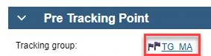
  2. **TG_<name>** prefix allows later easier identification of data in Elasticsearch which are coming from a tracking group.  
       
     You can see list of variables with specific data types in the tracking group definition. Thesed variables will be propagated to BAI.  
     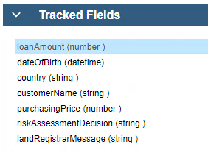
  3. Now you can close the tracking group definition and go back to the process and its task.  
     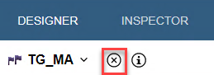
  4. Back in the Tracking properties for the **Perform Final Review** task, you can see that the same tracking group is used for both – **Pre Tracking Point** and **Post Tracking Point**. Panels of the Tracing Points have collapsible headers. This ensures that the business data gets sent to BAI both before and after the task is completed.  
       
     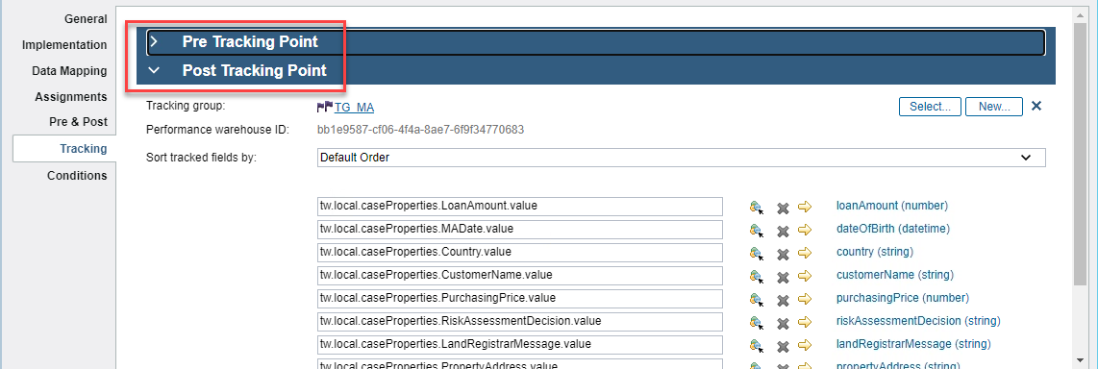  
       
     Note also that the caseProperties are available to the process as the are part of the Case solution. This is one example of integration between Cases and Processes.
  5. Click on the **Finish Editing icon** to unlock the Process.



* 1. Close the Process Designer browser window.

**This completes the procedure required to emit business data for BPM variables. Next, you will update the ODM rules to emit business data. This can be done by** [**setting ruleset properties**](https://www.ibm.com/support/knowledgecenter/en/SSQP76_8.10.x/com.ibm.odm.dserver.rules.res.console/topics/con_rescons_rs_prop_bai.html)**.**

* 1. In Firefox, go to the **ODM** bookmark folder and click on the **Rule Execution Server** link.
  2. If not already logged in, login with username **resAdmin** and password **resAdmin**.
  3. Click on the **Explorer** tab.
  4. Click on the RuleApp **Loan_Computation**.
  5. Click on the Ruleset **get_scores_and_repayments**.
  6. Click on **Add Property** in the top bar.



* 1. In the New Ruleset Property dialog, select the Name “bai.emitter.enabled”true and set the Value to true.

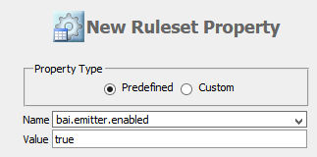

This property enables the ODM emitter for the ruleset.

* 1. Click on the Add button.
  2. Similarly, add the following properties:

|  |  |  |
| --- | --- | --- |
| Name | Value | Description |
| bai.emitter.input | true | Includes the input parameters in the emitted events. |
| bai.emitter.output | true | Includes the output parameters in the emitted events. |
| bai.emitter.trace | true | Includes the execution traces in the emitted events. |

The details of each property are also described in the [Knowledge Center](https://www.ibm.com/support/knowledgecenter/en/SSQP76_8.10.x/com.ibm.odm.dserver.rules.res.console/topics/con_rescons_rs_prop_bai.html).

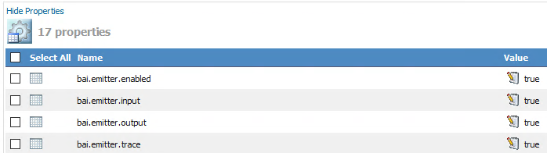

* 1. Click on RuleApps in the top navigation bar.



* 1. Repeat the previous steps to add the 4 properties for the ruleset in RuleApp “Loan_Evaluation” with “Loan_Evaluation” Ruleset inside. **In case some properties had been already assigned, just review them.**
  2. Click on Sign Out to sign out of the RES Console.

**You have now successfully modified the Case, BPMN and ODM implementations to emit specific business data for the Mortgage Application solution. Next, follow the verification instructions to run an instance of the New Mortgage Application Case type end-to-end and to verify that all the events with specific business data appear in BAI.**

## Modify the CP4Automation Solution to Emit Data – Verification Instructions

1. In Chrome bookmark folder, open **BAW** > **Desktops** > **Mortgage Application**. It opens a desktop of Content Navigator allowing to upload **Loan Application** and **Payslip** documents. The document repository and Case have defined events bound to these document classes.

|  |  |
| --- | --- |
| **Document Class** | **Event** |
| Loan Application | A new case is created when a new document of this class is uploaded. The properties of the document are used to feed the new case with data. One property is customer name. |
| Payslip | When a new document of Payslip is uploaded a custom event is fired taking customer name as a parameter. This event tries to find and existing running case with the same customer name. If such case does exist, the Payslip document is added to this case. |

It means that upload of any document of the classes above performs at the end some actions related with a new or existing case and its activities. You can explore all the case activities, their logic and pre-conditions in the **Mortgage Application** Case solution on Workflow Center.

1. If not already logged in, Log in with username **admin** and password **admin**.
2. In the **ICMtos** store (name of a Target Object Store), double-click on the folder **Incoming Mortgage Application Documents** to open it.

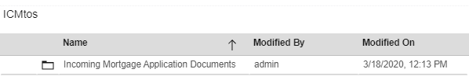

1. In the top toolbar, select **Add Document**.

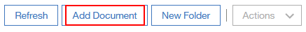

1. In the General section, enter the following values:
   1. Entry template: **Loan Application Form Entry Template**
   2. File name: Choose any file on the system e.g.: one of the files in the C: drive

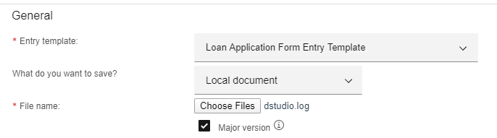

1. Enter the following details under the Properties section:

|  |  |
| --- | --- |
| Property | Value |
| Document Title | John Moore Application Form |
| Customer Name | John Moore |
| Date of Birth | 6/6/1972 |
| Loan Amount | 150000 |
| Property Address | 80 Trinity St, 07860 Newton, NJ |
| Purchasing Price | 215000 |
| Country | United States |
| EMail Address | johnmoore@example.com |

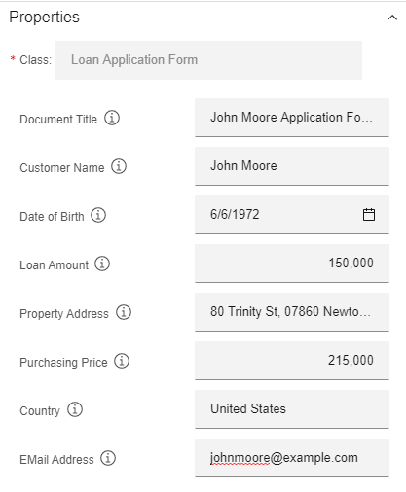

1. Click on the **Add** button to add the document.
2. Click on **Add Document** in the top bar to add another document.

1. In the Entry template field, select **Payment Slip Entry Template**.
2. Click on the **Choose Files** button to choose any file on the system e.g. one of the files in the C: drive.
3. Enter the following details under the Properties section:

|  |  |
| --- | --- |
| Property | Value |
| Document Title | John Moore Payslip |
| Customer Name | John Moore |
| Payment Date | *leave it empty* |
| Net Income | 18000 |

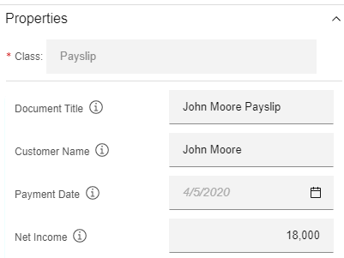

**Important: The “Customer Name” must be the same for both documents as it is used as an correlation ID for assignment of the documents with same Customer Name to the same Case.**

1. Click on the **Add** button to add the document.

You have now added documents that trigger the start of a new mortgage application in the Case Client.

1. In Chrome bookmark folder, open **BAW** > **Desktops** > **BAW**.
2. Log in with username **admin** and password **admin**.
3. Go to the work basket by clicking **Work** tab and **My Work** tab. You should see two tasks – **Review Mortgage Application** and **Review Payslip**.

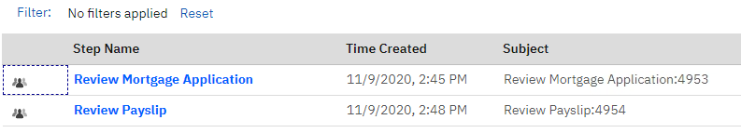

1. Click on the activity – **Review Mortgage Application**.
2. In the dialog that pops up, click on the **Claim** button.
3. In the activity page, scroll down the left side of the screen and click on the **Finish** **Review** button to complete it.
4. Similarly, complete the **Review Payslip** task.
5. Click on the **Cases** tab in the upper-left corner.

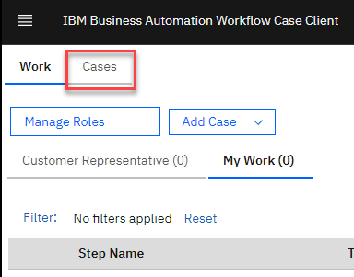

1. Ensure that the date selected is the date when you added the first document to the **Mortgage Application Desktop**.
2. Click on the **Search** button.

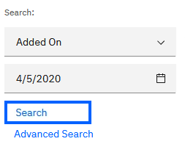

1. Click on the title of the Mortgage Application Case that shows up in the search results. If you can see more case, select the freshest one.



1. In the Case Details, click on the **Activities** tab.

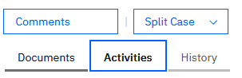

1. You can see some activities already completed, some waiting and some ready to be started manually. Scroll to the bottom of the list and click **Start** on the optional task **Perform Risk Assessment**.

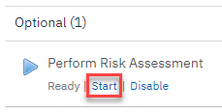

1. Click on **Yes** in the confirmation dialog. This will start the **Perform Risk Assessment** Case activity which is implemented as a Process calling ODM for Risk Evaluation. The process does not have any human task, it is performed completely automatically. Just wait a moment until the process/activity is done.
2. Refresh the activities list by clicking on the **Activities** tab again.
3. Verify that the **Perform Risk Assessment** activity shows completed. If not, keep refreshing the **Activities** tab till it is.
4. Click on the **Activities** tab again to refresh the list of activities.
5. Verify that the **Check Land Registrar** activity shows completed. If not, keep refreshing the **Activities** tab till it is.  
     
   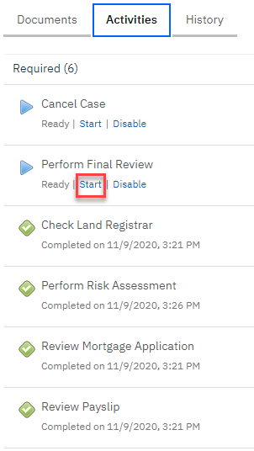
6. Click **Start** on the required task **Perform Final Review** as shown above.
7. Click on **Yes** in the confirmation dialog.
8. Go back to the **Work** tab.

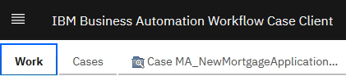

1. Click on the step **Perform Final Review**.
2. In the Claim Task dialog, click on the **Claim** button.
3. In the activity page, click on the **Approve** button.
4. Switch back to the Case view. You can see now all the activities completed.  
   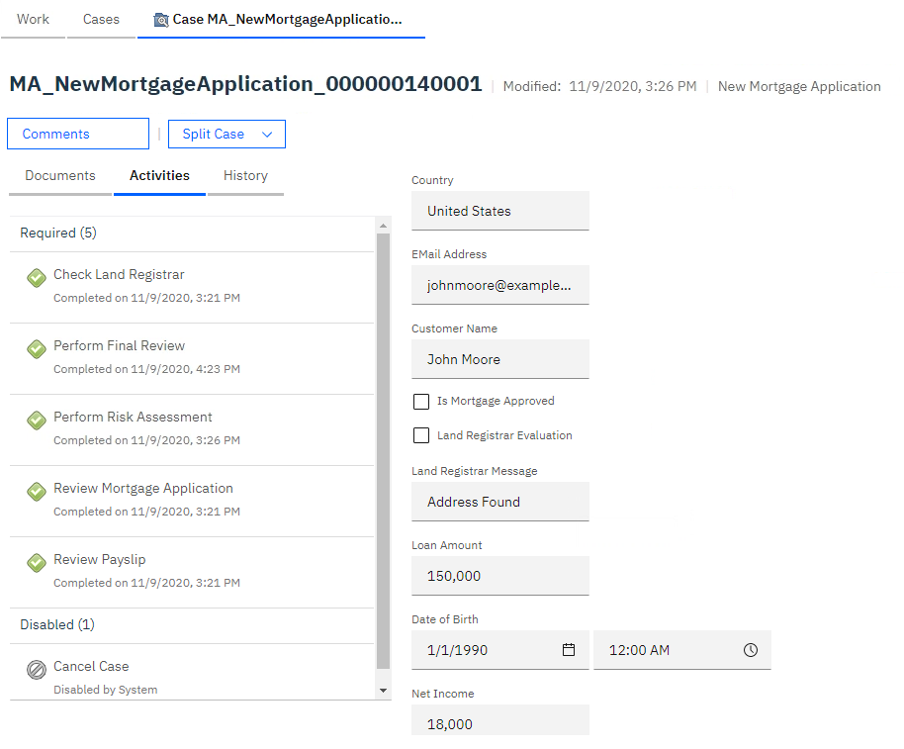
5. **Log out** of the Case Client.

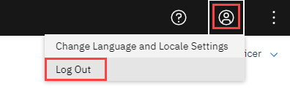

You have created and completed a new instance of the mortgage application. Now, let’s verify that the business data is being emitted to BAI.

1. In Chrome bookmark bar, open **BAI** > **Kibana**.
2. If not already logged in, log in with username admin and password passw0rd.
3. Click on the **Management** tab in the sidebar.
4. Click on **Index Patterns**.

Note: The emitted events are now enriched with selected business data – like columns in a table. The data are propagated to Elastic search. Now we need to update the Kibana index patterns. Once event emitters with new properties emit events, each of the index patterns listed here needs to be refreshed to include those properties. However, for this exercise, we will only refresh 3 of the index patterns. You will learn more about index patterns in exercise 5.

This can be done by manually for each of the 3 index patterns by clicking the Refresh icon in the upper-right corner.

1. Click on the **process-summaries\*** index pattern to select it.
2. Click on the **Refresh** icon in the upper-right corner.



1. Click on the **Refresh** button in the Refresh field list dialog.
2. In the Filter field, type **TG_MA**.
3. Verify that you see the properties newly added when creating the BPMN Tracking Group.

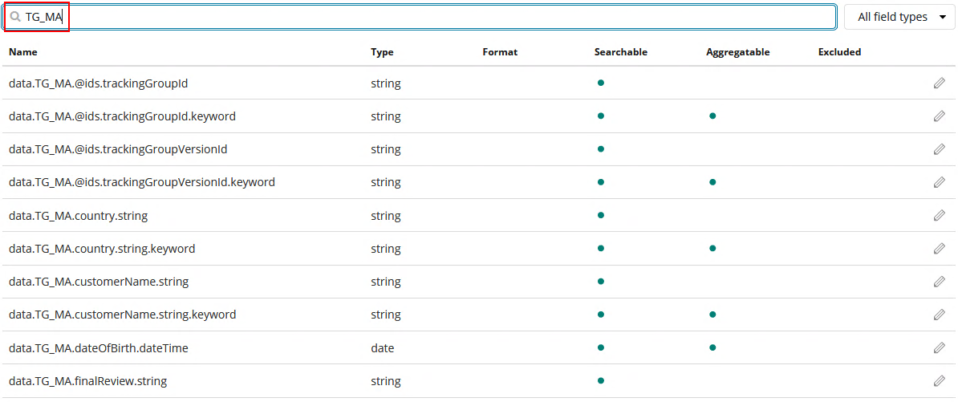

1. Similarly, refresh the **case-summaries\*** index pattern.
2. In the **Filter** field, type **MA_**.
3. Verify that you see the properties added when configuring the audit log for the Case solution.

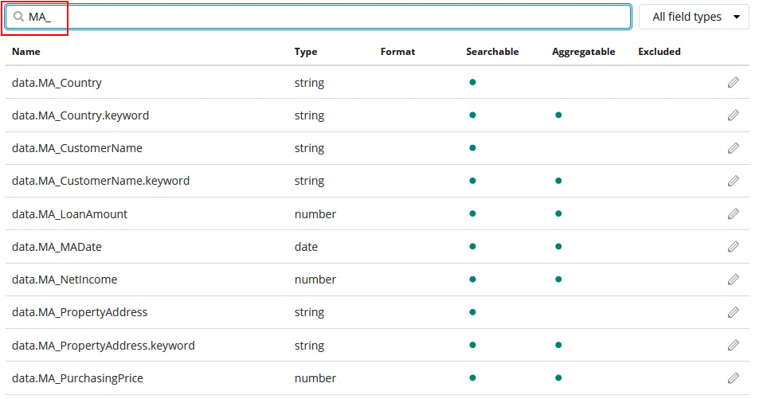

1. Similarly, refresh the **odm-timeseries\*** index pattern.
2. In the Filter field, type **Loan_Evaluation**.
3. Verify that you see the properties of the ruleset Loan_Evaluation.

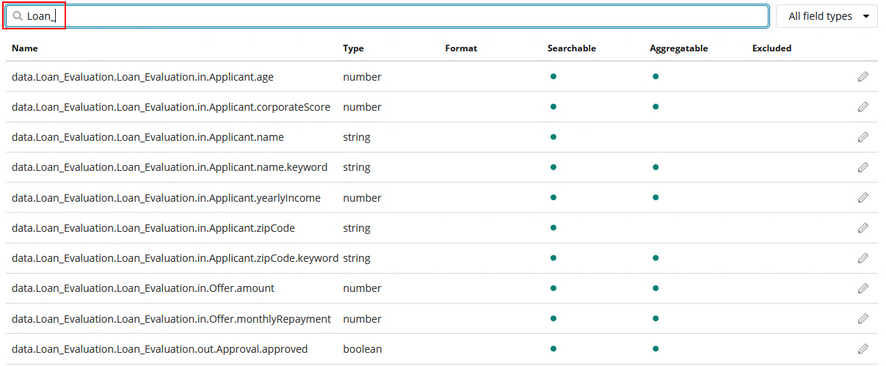

Viewing the properties in the Index Patterns completes the verification of the events being emitted. You will build visualizations and dashboards with these properties in exercises 5-7.

## Modify the CP4Automation Solution to Emit Data – Summary

In this exercise, you have:

* 1. Modified a Case solution to emit Case properties.
  2. Modified a BPMN Process to emit BPM variables.
  3. Modified an ODM ruleset to emit the ruleset’s parameters.
  4. Started and completed a new instance of the Mortgage Application solution to verify that the emitted data is visible in BAI.

In the next exercise, you will learn the different concepts of event types in BAI and how they are stored in the various datastores.

# Exercise: Explore Emitted Events in BAI

## Explore Emitted Events in BAI – Introduction

In this exercise, you will:

1. Learn about the different concepts of BAI events – Raw events, time series and summaries.
2. Explore the events emitted in the Elasticsearch datastore.



As you can see from the diagram above, the following datastores exist in BAI:

**Elasticsearch**

Elasticsearch allows for easy querying and visualization/dashboard storage. With Kibana on top of Elasticsearch, users of BAI can gain visual insights into their business. You will create these visualizations in exercises 5-7.

**Data lake (HDFS)**

HDFS (Hadoop File System) enables data scientists to build artificial intelligence models using IBM Watson Studio or other data science tools. This datastore is optional and events will only be emitted to it if a data lake is configured. You can also protect the business data in the Data lake by configuring anonymization rules. You will do this in exercise 4.

As you can also see from the diagram above, there are 3 different concepts of the emitted events in the various datastores – Raw events, time series and summaries (active and completed).

**Raw events**

Each emitter emits events to Kafka. These events are later processed in BAI to be stored in various datastores. The raw event however is stored in the data lake (Hadoop).

Raw events from all pillars are available in the data lake.

**Time series**

These events are simplified and flattened versions of the raw events.

**Summaries**

These events are aggregations of time series. They can be active or completed. For example, a summary event is completed when a process, activity or case is completed.

Additional details for each of these concepts are available in the [Knowledge Center](https://www.ibm.com/support/knowledgecenter/SSYHZ8_20.0.x/com.ibm.dba.bai/topics/con_bai_overview.html).

As you can also see from the diagram above, the following pillars of CP4Automation currently support BAI emitters:

Workflow ([BPMN](https://www.ibm.com/support/knowledgecenter/SSYHZ8_19.0.x/com.ibm.dba.bai/topics/ref_bai_bpmn_ref.html?view=kc#reference_e5p_ksv_j2b) / [BPM Advanced](https://www.ibm.com/support/knowledgecenter/SSYHZ8_19.0.x/com.ibm.dba.bai/topics/ref_bai_bpel_ref.html?view=kc#ref_bai_bpel_ref) and [Case](https://www.ibm.com/support/knowledgecenter/SSYHZ8_19.0.x/com.ibm.dba.bai/topics/ref_bai_case_ref.html?view=kc#reference_e5p_ksv_j2b))

[ODM](https://www.ibm.com/support/knowledgecenter/SSYHZ8_19.0.x/com.ibm.dba.bai/topics/ref_bai_decisions_ref.html?view=kc#ref_bai_odm_ref)

[Content](https://www.ibm.com/support/knowledgecenter/SSYHZ8_19.0.x/com.ibm.dba.bai/topics/ref_bai_cntevnt_ref.html?view=kc#ref_bai_cntevnt_ref)

[Digital Worker](https://www.ibm.com/support/knowledgecenter/SSYHZ8_19.0.x/com.ibm.dba.bai/topics/ref_bai_adw_ref.html?view=kc) - deprecated

You are now ready to start this exercise.

## Explore Emitted Events in BAI – Step by Step Instructions

1. In Chrome, open “BAI” > “Kibana” in the bookmark folder.
2. Login as admin / passw0rd (with zero instead of o).
3. Click on the Discover tab in the left sidebar.
4. In the list of index patterns, select the process-summaries* index pattern.

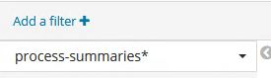

Note that “process-summaries*” index pattern does use “completedTime” timestamp field of the events as the field’s associated core type. Other index patterns with similar names simply do use other timestamps like suspendedTime, resumedTime etc. That’s the reason why different index patterns have been defined. The same approach is implemented for case summaries.

1. In the upper-right corner, set the time range to This week.
2. The discover UI will now show you all the summary events from the BPMN emitter in the process-summaries* index within the selected time range.
3. Click on the expand icon for the first event. The timestamp value can be different, it is OK.

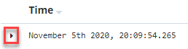

1. Explore the data shown in the Table and JSON tabs.

Note: The JSON tab shows the raw event data sent by the BAI Data Ingestion and Processing component to Elasticsearch while the Table tab makes it readable in a table form.

1. Similarly, select the case-summaries* index pattern and explore the summary events from the Case emitter.
2. Similarly, select the odm-timeseries* index pattern and explore the timeseries events from the ODM emitter.

You will build visualizations and dashboards with the BPMN and Case summary events in exercises 5-7.

## Explore Emitted Events in BAI – Summary

In this exercise, you have learned about the different event concepts and datastores in BAI.

# Exercise: Getting started with Kibana

## Getting started with Kibana – Introduction

This exercise is addressing the developer of a BAI solution. This persona is responsible to implement custom dashboards driven by business requirements based on the BAI offering.

You will be introduced to Kibana, basic concepts and theory which you need to understand to fully exploit the BAI technology.

Pre-requisites

* Overall knowledge of the DBA portfolio
* Some understanding of the architecture and concepts of Business Automation Insights (BAI)
* Basic understanding of Kibana based on the [Video on Getting started with Kibana](https://www.elastic.co/webinars/getting-started-kibana?elektra=startpage) or [Kibana 4 Video Tutorials Part 1](https://www.elastic.co/blog/kibana-4-video-tutorials-part-1)
* BAI environment fully configured in terms of product integration, LDAP configuration, SSO and emitter configuration
* Mortgage Solution with ECM, Case - and BPM Process Manager, RPA, as well as ODM
* Basic understanding to the Case solution with the start condition, results, performer and according to this to the generated test data

## Getting started with Kibana – Step by Step Instructions

Introduction

Kibana is an open source analytics and visualization platform designed to work with Elasticsearch. You use Kibana to search, view, and interact with data stored in Elasticsearch indexes. You can easily perform advanced data analysis and visualize your data in a variety of charts, tables, and maps.

Kibana makes it easy to understand large volumes of data. Its simple, browser-based interface enables you to quickly create and share dynamic dashboards that display changes to Elasticsearch queries in real time.

Disclaimer:

1. It is not the intention of this lab to replicate the Kibana Getting Started, online help, and Q&A documentation. Where required we explain this in the intro and step-by-step instructions per section, while you should refer to the given Kibana links.
2. This exercise includes step-by-step instructions. However, for introductory purposes several links and explanations have been added to provide background to subsequent exercises.
3. Some of the screenshots might be different from yours because they were captured with a different set of data compared with the test data in your lab environment.
4. Through this exercise you should save any artefacts you create with your initials as a prefix. This avoids overwriting your work with the provided solution proposal starting with <your initials> - MA – xxxx – version. This solution proposal will be imported at the end of an exercise to compare with your specification.

Note  
For exercise 5 to 7 you only use ElasticSearch and Kibana and don’t have to wait for the DMgr, Node, and Server of BAW started.

### Introduction to the Kibana Desktop and Navigation

1. Open Firefox.
2. Click on the BAI bookmark in the upper left corner and select the Kibana bookmark.
3. When a security window pops-up, click Advanced and confirm configuration.
4. The sign in window appears. Log in with following credentials:

Username: admin Password: passw0rd

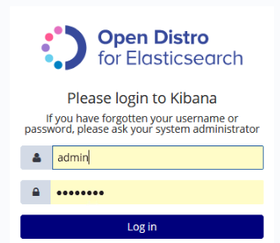

1. The Kibana navigator is shown.
2. In the Kibana navigator select the Management tab.

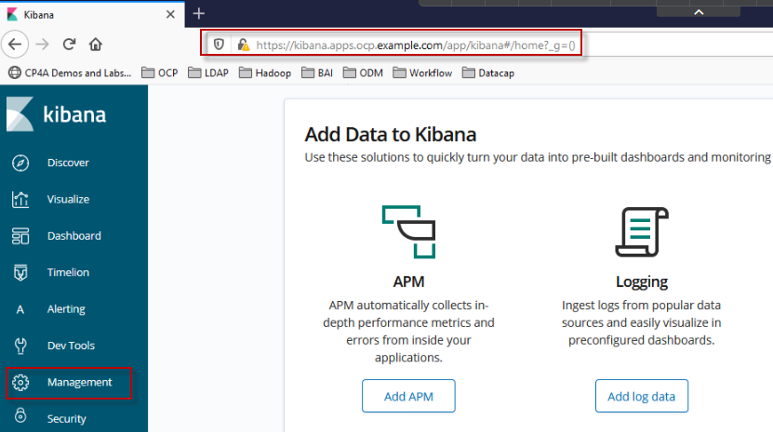

### Management: Understand and learn about Index Patterns

Introduction

The Management application is where you perform your runtime configuration of Kibana, including both the initial setup and ongoing configuration of index patterns, advanced settings that tweak the behaviors of Kibana itself, and the various "objects" that you can save throughout Kibana such as searches, visualizations, and dashboards.

[Kibana Management](https://www.elastic.co/guide/en/kibana/current/management.html) and [Kibana Defining your Index](https://www.elastic.co/guide/en/kibana/current/tutorial-define-index.html)

Index patterns tell Kibana which Elasticsearch indexes you want to explore. An index pattern can match the name of a single index or include a wildcard (*) to match multiple indexes.

For example, process-…. typically creates a series of indexes in the format process-YYYY.MMM.DD. To explore all the log data from April 2019, you could specify the index pattern process-2019.04*. An index pattern can also simply be the name of a single index.

*summaries*

This index pattern provides a way to parse all the summaries stored in Elasticsearch by IBM Business Automation Insights. It does not provide any time field. Therefore, all searches and visualizations based on this index pattern span the entire data set, and the time range picker is not available for them.

*-summaries-*

This index pattern enables you to parse all the summaries stored in Elasticsearch by IBM Business Automation Insights, based on the timestamp field. This allows you to filter out results by using the time range picker. The timestamp field is updated each time IBM Business Automation Insights updates a summary document

Refer to the [KC - Index Patterns](https://www.ibm.com/support/knowledgecenter/en/SSYHZ8_20.0.x/com.ibm.dba.bai/topics/ref_bai_index_patterns.html), for example on

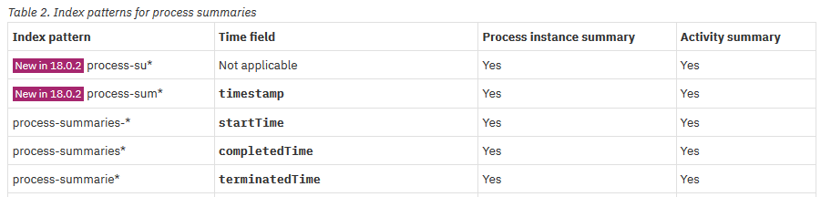

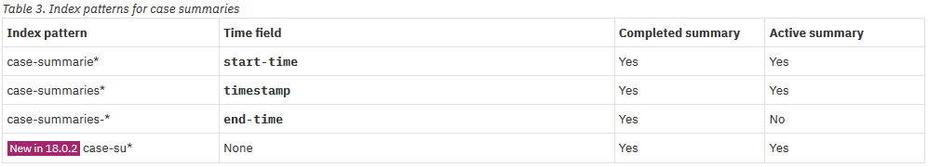



* + - 1. Management: Understand and use provided Index Patterns

BAI provides a set of index patterns for Cases, Processes and ODM/Decisions. We will explore some of these indexes now. The term index pattern and index are used interchangeably.

1. Click the Management tab.   
   Select Index Patterns.   
   The new window shows the available indexes. The [KC - Index Patterns](https://www.ibm.com/support/knowledgecenter/en/SSYHZ8_20.0.x/com.ibm.dba.bai/topics/ref_bai_index_patterns.html) entry describes the purpose and scope of each index.

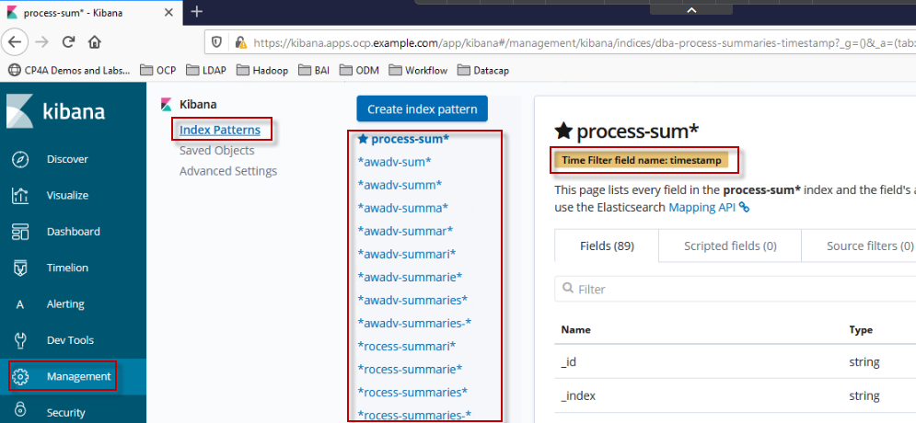

The orange box always refers to the time filter field the index is optimized for when you use the Time Picker later on.

1. Select the case-summarie* index.  
   The orange box shows the attribute the index is configured and optimized, here for the start-time of cases and case activities (tasks). It contains all documents containing a start-time.  
   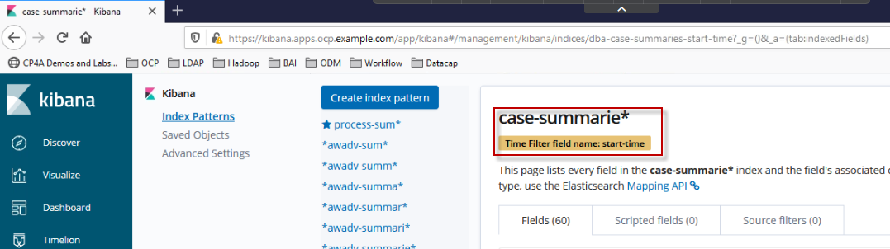

Note  
When this index is used during discover or in a visualization only these cases and case activities are listed whose start-time is within the time range of the time picker.

1. Select the index: case summaries-* for comparison.   
   This index is configured and optimized for the end-time. It refers to all completed cases as well as case tasks. Although, the start-time is included as well in the index.

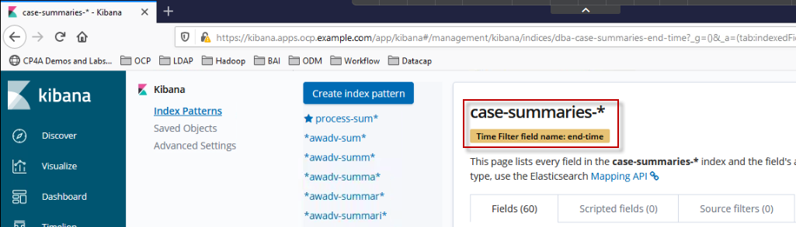

1. Select the index: case su* for comparison reasons. This one includes all attributes on cases and case tasks on summary events without a timestamp.  
     
   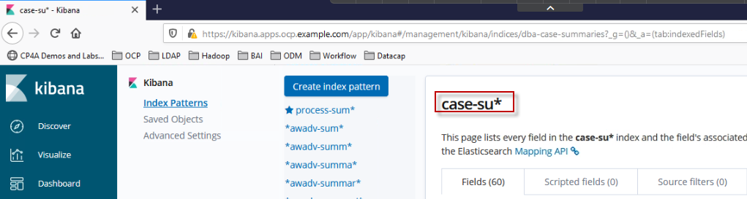

1. Search for attributes in this index. Enter state in the query bar.   
   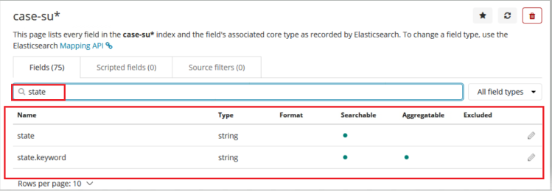  
   Note  
   See the pencil on the right for each attribute. This allows to modify the fields. This is practical for times or durations given in seconds to change the “human readable format”.
2. Familiarize yourself with one of each of a Case -, Process - and ODM/Decision-related indexes, their attributes, meaning and potential values.

Study the [Case and Activity Summary Event Formats](https://www.ibm.com/support/knowledgecenter/en/SSYHZ8_20.0.x/com.ibm.dba.bai/topics/ref_bai_case_summary_formats.html)   
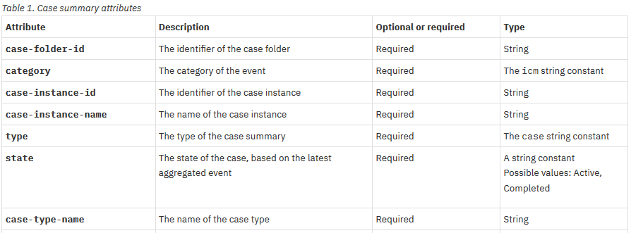  
as well as the [BPMN Summary Event Formats](https://www.ibm.com/support/knowledgecenter/en/SSYHZ8_20.0.x/com.ibm.dba.bai/topics/ref_bai_bpmn_summary_formats.html).  
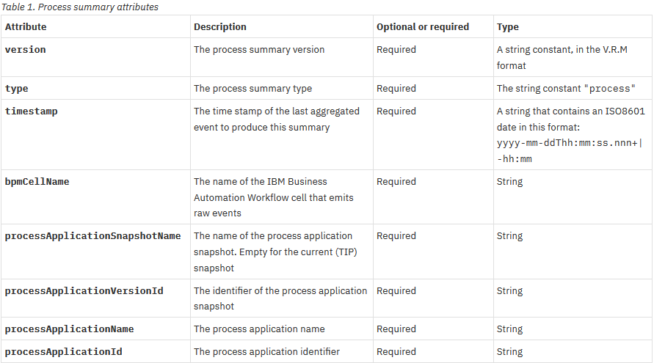

* + - 1. Download and Import generated test data

For the demonstration of dashboards about Cases, Process and Decisions we require a series of test data. Test data have been generated in a randomized fashion with varying values for the input data, decisions, state, etc. The data change in span a time window from 2020-03-22 till 2020-03-05 which must be considered when filtering these events.

Test data are available to you. Perform the following step to import them:

1. Open Windows command prompt by clicking Windows Start button, typing “cmd” and pressing Enter.
2. The command prompt is open in the home directory “C:\Users\Administrator”. It is important to start within this directory.
3. Change directory to the folder containing data import artifacts by typing:  
   **cd ibm-bai-workshop-main\labs\bpmn-case-odm-kibana\data-import**
4. Run the data import script by typing  
   **import-data.bat**

This will load the test data for cases, processes, and decisions directly into Elasticsearch.

Note  
The test data imported to Elasticsearch are immediately accessible via Kibana, i.e. even with an emitter, Kafka or the Flink jobs currently not available you could perform this lab using Kibana only. You can also import the data in your own installation of Elasticsearch with Kibana and perform the lab.

* + - 1. Refresh and Import Index Patterns
         1. *Refresh Index Patterns*

In chapter Modify the DBA Solution to Emit Data – Verification Instructions you had defined audit – and tracking variables which are executed in the case towards its completion. In order to be subsequently accessed it is required to refreshed some of the index patterns. This is shown in the screenshot beneath.  
  
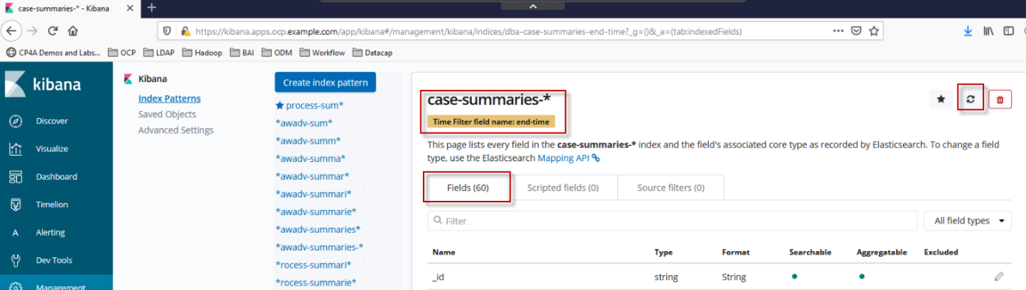  
  
When you Refresh an index you see that the number of fields will change.

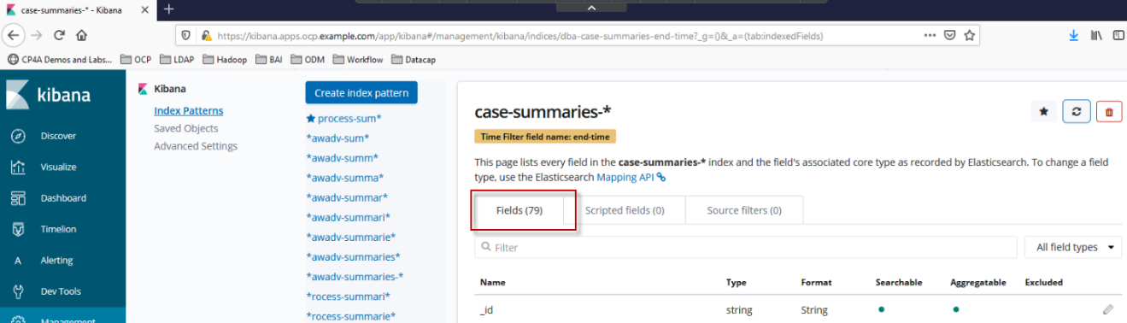

After the refresh the audit – and tracking variables are available in the index as well.

Following conventions apply to these variables:

1. data.MA_... origin from the Mortgage Application Case solution
2. data.TG_... origin from the BPMN tracking groups
3. data.Loan_ origin from ODM rules

After you have executed one or several case – or process instances you must manually refresh the major indexes. This updates the available indexes to show the tracking variables as well. They are available for use and queries and visualizations subsequently.

When you specify visualizations using tracking variables you need to ensure that all indexes have been refreshed. To save time you don’t need to manually refresh every OOTB index but to import indexes that have been updated already.

Make sure you have refreshed following index patterns:

* case-summaries-*
* process-summaries-*
* odm-timeseries*
  + - * 1. *Import Index Patterns*

1. In Kibana, click Management. Click **Saved Objects**.   
   The **Edit Saved Objects** window appears
2. Click **Import**  
   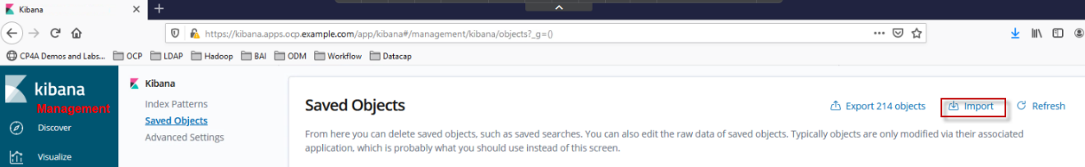
3. Click the Import icon and select file **c:\Users\Administrator\ibm-bai-workshop-main\labs\bpmn-case-odm-kibana\indexes-refreshed.json**.
4. Indicate whether to overwrite objects already in Kibana.   
   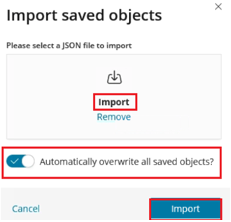
5. Click Import.

Note  
If the import fails try to use another browser.

### Discover the data in Elasticsearch and use Saved Searches

Introduction

The functionality of the Kibana “Discover” tab enables you to explore your data stored in Elasticsearch. You have access to every document in every index that matches the selected index pattern. You can submit search queries, filter the search results, and view document data. You can also see the number of documents that match the search query and get field value statistics. If a time field is configured for the selected index pattern, the distribution of documents over time is displayed in a histogram at the top of the page.

Ref: [Discover](https://www.elastic.co/guide/en/kibana/current/discover.html)

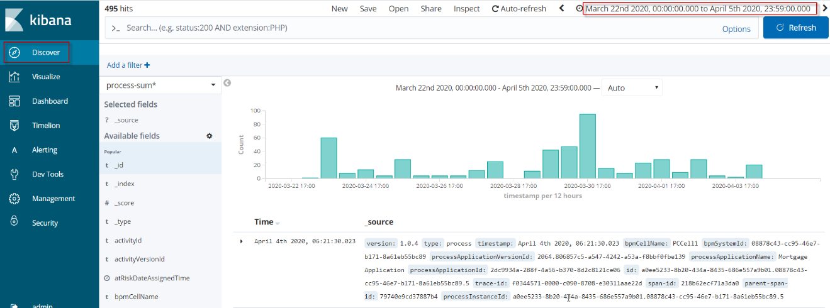

In this section you will

* be introduced to filtering and its syntax
* learn about documents and filters
* review tracking data in BAI summaries (indexes)
* learn about provided Saved Searches
* create your own Saved Search
  + - 1. Setting the time filter

The time filter restricts the search results to a specific time period. You can set a time filter if your index contains time-based events and a time-field is configured for the selected index pattern.

By default, the time filter is set to the last 15 minutes. You can use the time picker to change the time filter or select a specific time interval or time range in the histogram at the top of the page.



Filtering with the time picker

Click on the time picker. You can specify a time filter in one of four ways:

* Quick. Click your desired time window from the options listed.
* Relative. Specify a time filter relative to the current time. You can specify the end time relative to the current time. Relative times can be in the past or future.
* Absolute. Specify both the start and end times for the time filter. You can adjust the time by editing the To and From fields.
* Recent. Click one of the times from your list of recently used time filters.

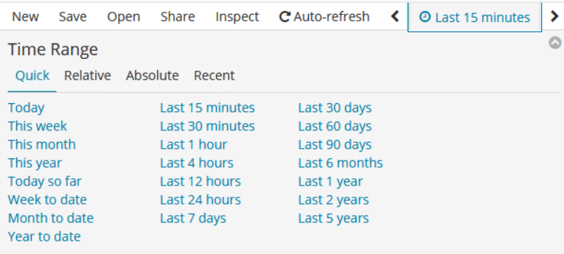

Normally the options under tab Quick are sufficient. However, if you want to filter more specifically, the other tabs are also recommended.

* + - 1. Specify absolute values for the time picker

Note

Your Skytap environment includes test data that has been generated randomly using different amounts, countries, decisions, end users and start-dates. When you visualize case - / process data later you must specify an absolute time range according to the time period of the generation.

1. In Kibana, go to Discover and select index pattern **process-summaries-\***.  
     
   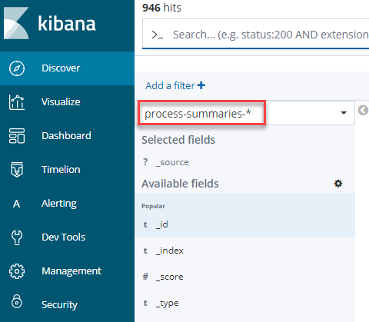
2. Select the Time Picker. Select Absolute Time Range.  
   Specify the range from 2020-03-22 0:00:00.000 to 2020-04-05 23:59:00.000  
   Press Go.   
   Note  
   This is the time range of the pre-generated case-, process- and rules data imported before.  
   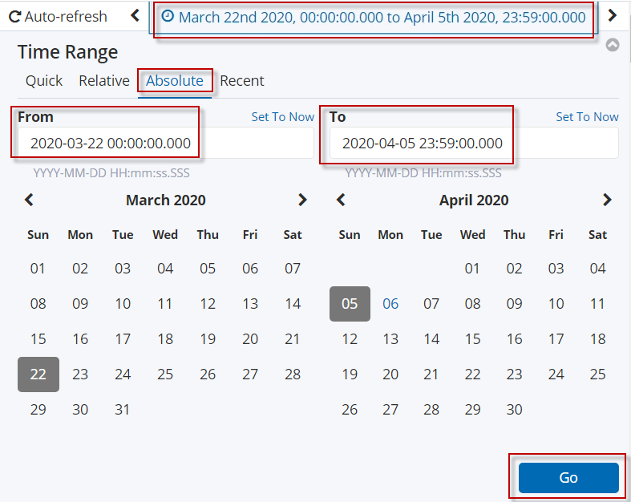
3. The window is refreshed and shows the documents (single summary events) and a histogram on all events for the given index and time range.  
   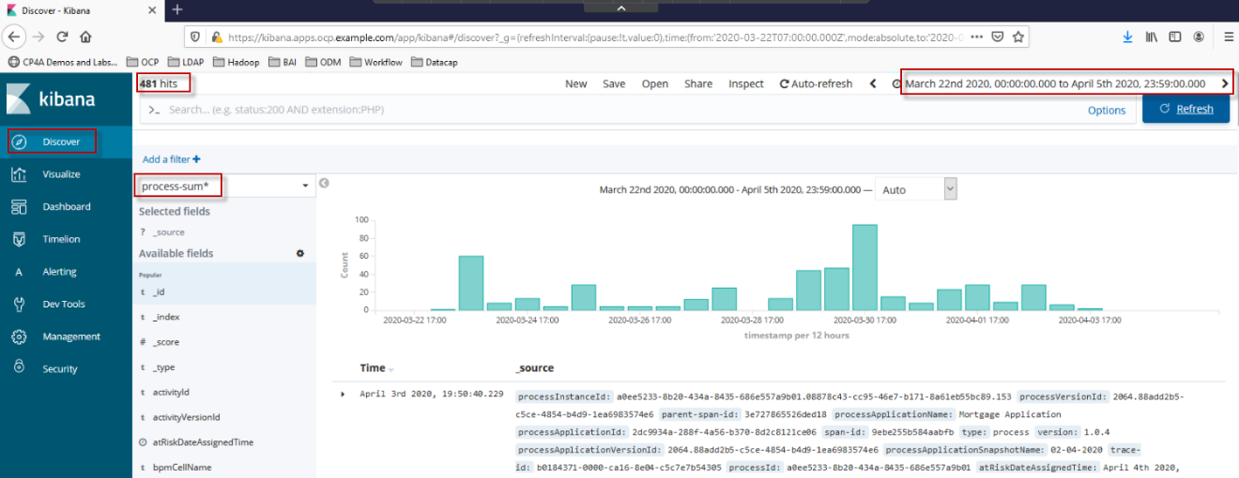  
     
   Note   
   Throughout this lab instructions screenshots and the numbers of found items might be different to yours because they were captured with a different set or different time range compared with the test data in your Skytap environment.
   * + 1. Filter and narrow down the time range in the histogram

[Setting the time filter](https://www.elastic.co/guide/en/kibana/current/set-time-filter.html#set-time-filter)

You can set a time filter from the histogram in one of two ways:

1. Click the vertical bar that represents the time interval you want to zoom in on. 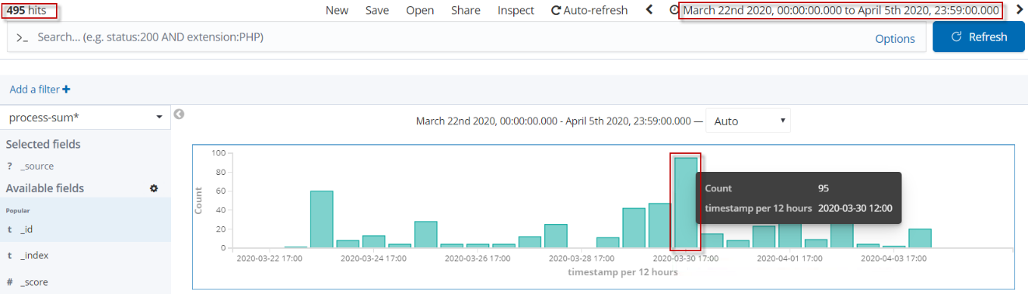

This results in a diagram for a narrowed down time range.  
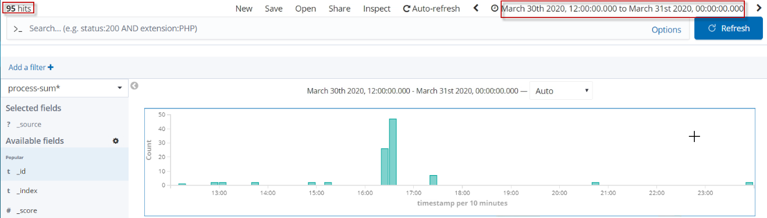

Note the time picker and the number of hits.

1. Use the Browser back button and ensure to change back the time range from 2020-03-22 to 2020-04-05.
2. Click and drag the cursor over an area to drill down on a specific timespan. You must start the selection with the cursor over the background of the chart—the cursor changes to a plus sign when you hover over a valid start point.  
   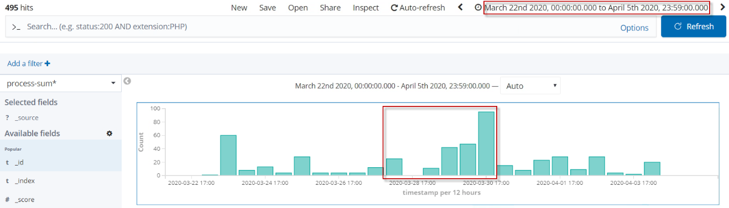  
   The diagram changes due to the narrowed down time range. Note the time picker and the number of hits change as well.

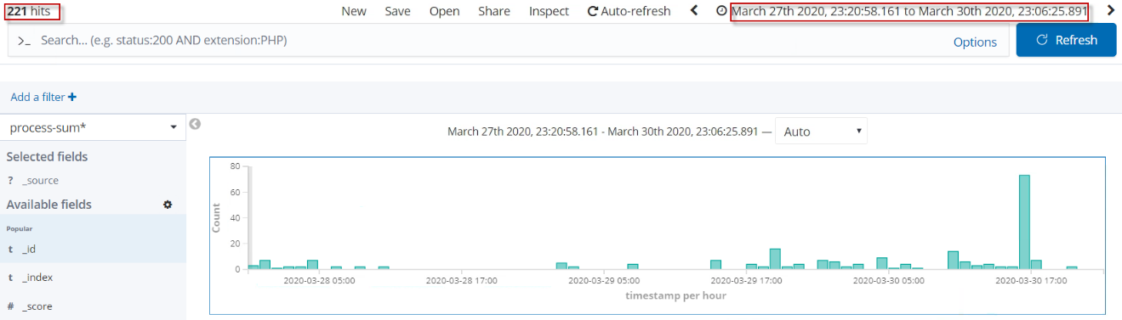

1. Use the browser Back button to undo your changes. 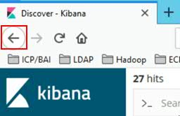
2. To move forward or backward in time, click the arrows to the left or right of the time rage. 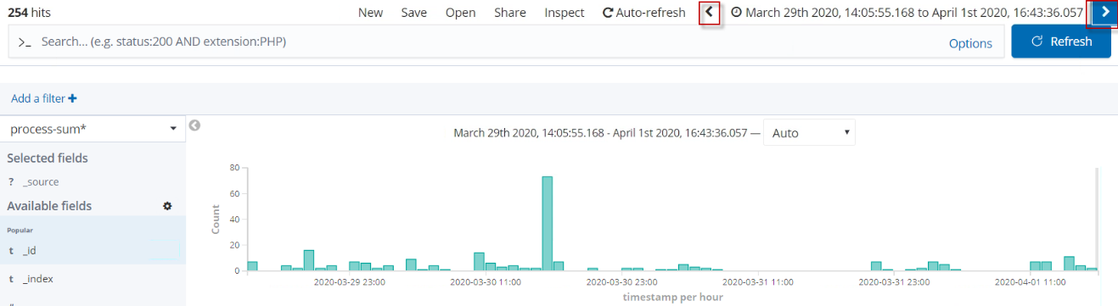
3. Ensure to change back the time range from 2020-03-22 to 2020-04-05.  
   * + 1. Viewing Document Data

When you submit a search query, the 500 most recent documents that match the query are listed in the Documents table. You can optionally configure the number of documents shown in the table by setting the discover:sampleSize property in [Advanced Settings](https://www.elastic.co/guide/en/kibana/current/advanced-options.html).

1. To view a document’s field data, click the Expand button to the left of the document’s table entry. 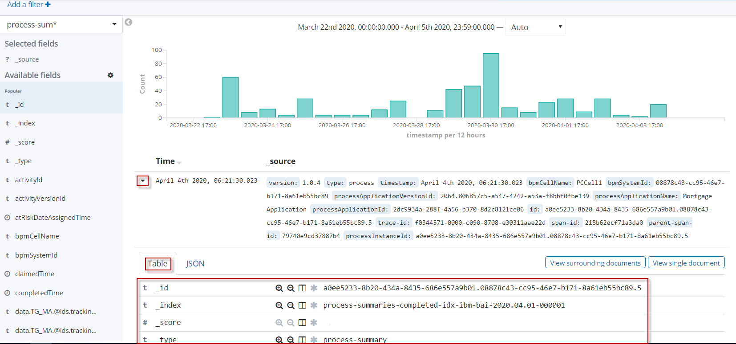



1. To view the original JSON document (pretty-printed), click the JSON tab. 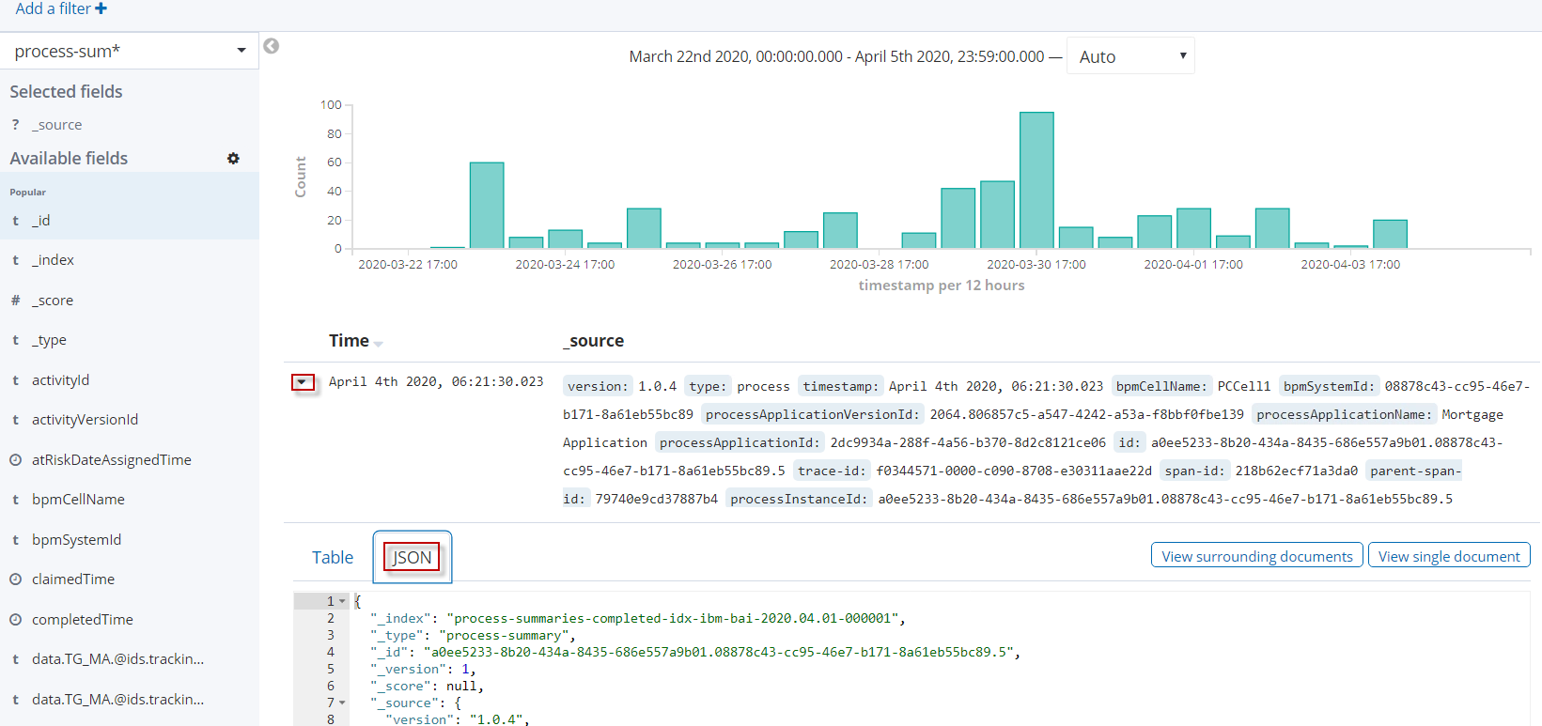
2. By default, the Documents table shows the localized version of the time field that is configured for the selected index pattern and the document _source. You can add fields to the table as columns from the Fields list or from a document’s field data.

To [add](https://www.elastic.co/guide/en/kibana/current/document-data.html#adding-columns) a field to the table hover over the field and click its add button.  
[Adding columns](https://www.elastic.co/guide/en/kibana/current/document-data.html#adding-columns)

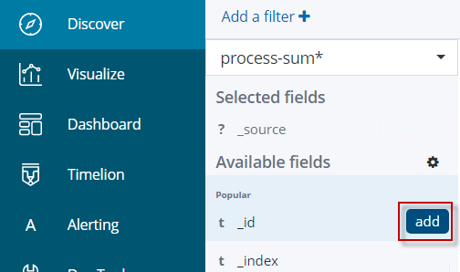

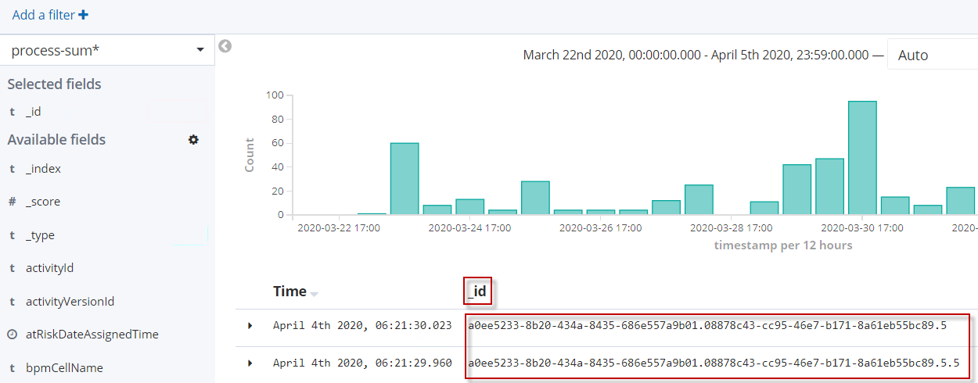

1. To remove a field column from the Documents table, hover over the header of the column you want to remove and click the Remove button .



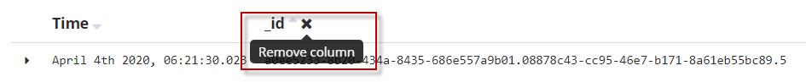

1. The data can be ordered by time fields. Therefore, add field claimedTime from the field list. Hover over the claimedTime and select the arrow icon twice, until it is pointing down, to order the data in descending claimedTime order.

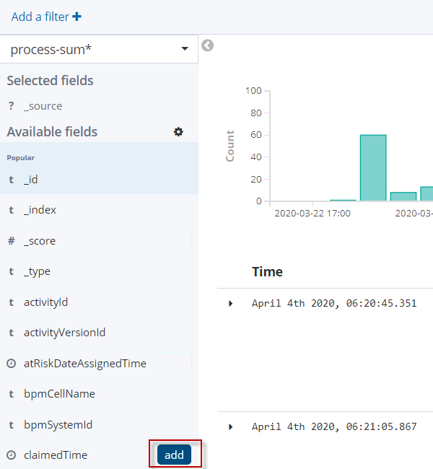

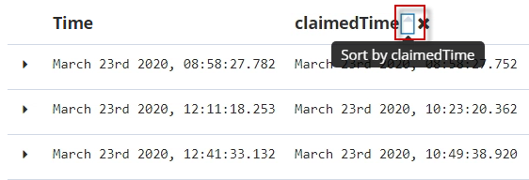

1. Remove the claimedTime field from the table again.
   * + 1. Searching for Data

When you submit a search request, the indexes that match the currently selected index pattern are used to query available summary events. The current index pattern is shown below the toolbar.

[Discover - Searching your data](https://www.elastic.co/guide/en/kibana/7.x/search.html)

1. Click the Discover tab.  
   Select the process-summaries* index pattern.  
   Ensure that the absolute time range is still set from 2020-03-22 till 2020-04-05.  
   Observe the number of hits in the upper box on the left.

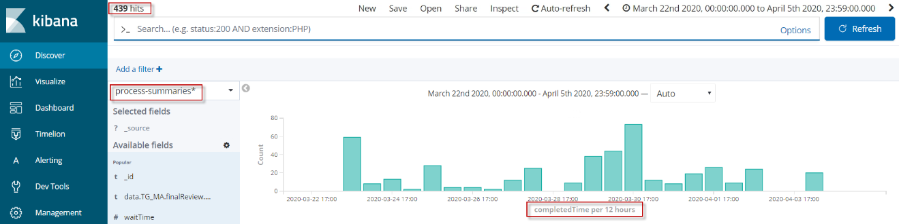

1. Select the case-summaries-* index. See the different number of hits, a different histogram, and a different list of fields.   
   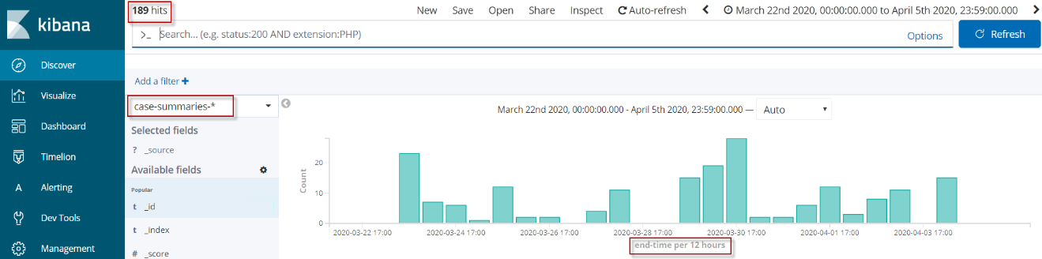

You can search the indexes that match the current index pattern by entering your search criteria in the Query bar. You can use Kibana’s standard query language (based on Lucene [query syntax](https://lucene.apache.org/core/2_9_4/queryparsersyntax.html)) or the full JSON-based [Elasticsearch Query DSL](https://www.elastic.co/guide/en/elasticsearch/reference/6.7/query-dsl.html).

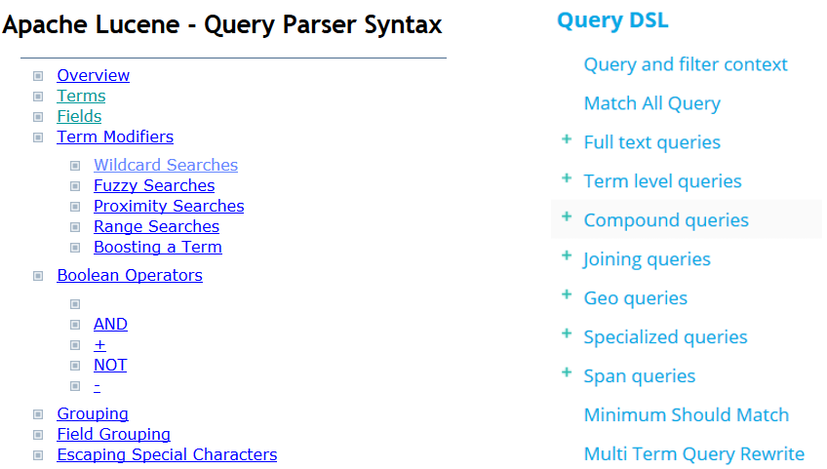  
Familiarize yourself with the syntax.

To search your data, enter your search criteria in the Query bar and press Enter or click Search to submit the request to Elasticsearch.  
Ref: [Search](https://www.elastic.co/guide/en/kibana/current/search.html)



1. Search
   1. Continue with the case-summarie* index pattern. This optimizes for the start-time.

Enter state:working in the query bar. Click the Update button.   
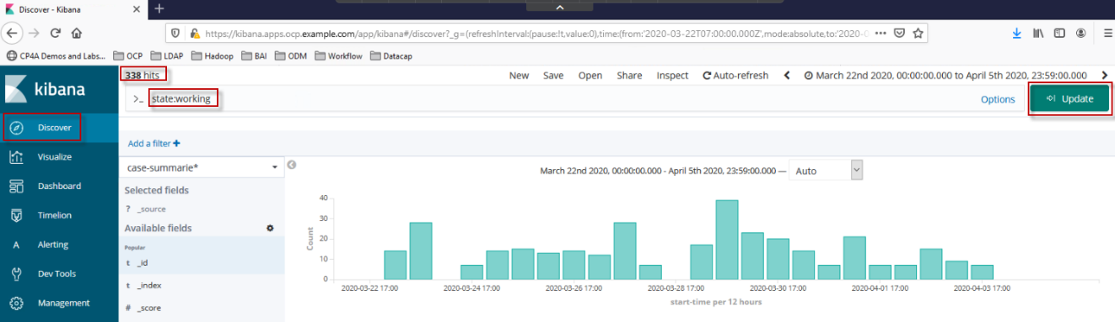

This results into 43 entries found.

**Note: The amount of records found can differ on you environment.**

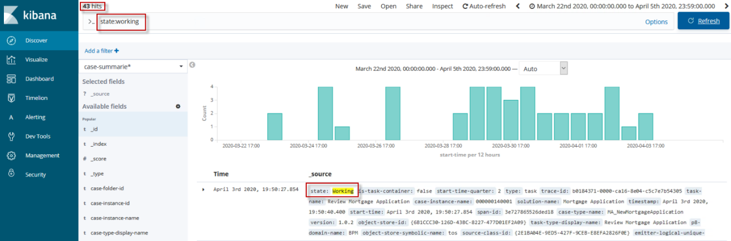

This results in all documents (summary events) where the latest state turned into “working”. However, it includes entries of type:case as well as type:task.

* 1. Access the fields list.   
     Hover over the state fields and click add.

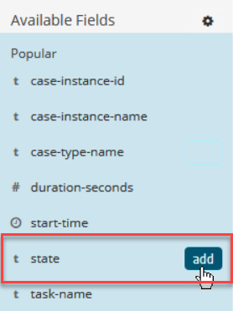

A table with the state field is created. 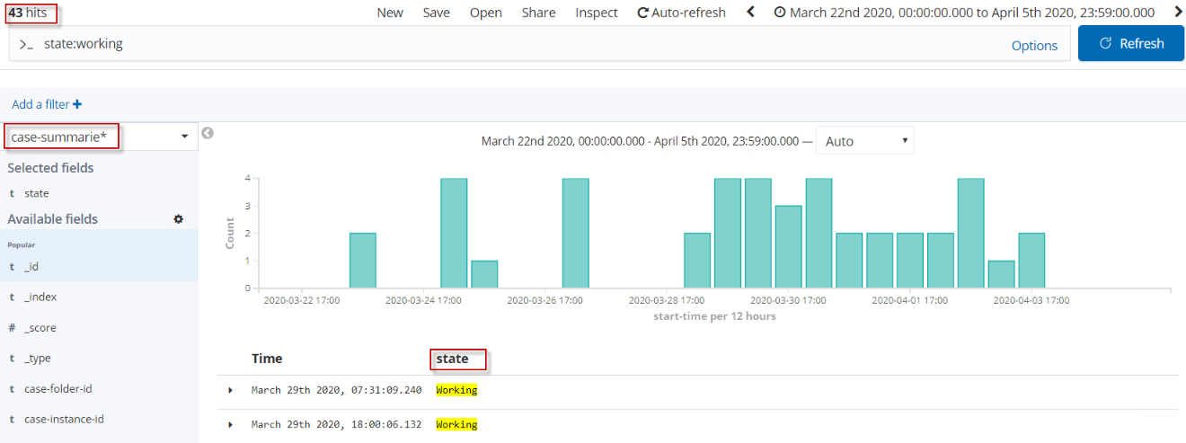

* 1. Extend the current query by adding the following expression to the query bar: AND type:task. Click the Update button.  
       
     **Note: Use uppercase AND!**  
       
     Hover over the type field to add it to the table as well

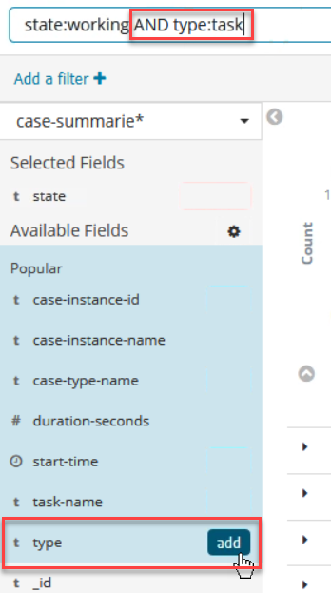

The screenshot beneath shows the result. 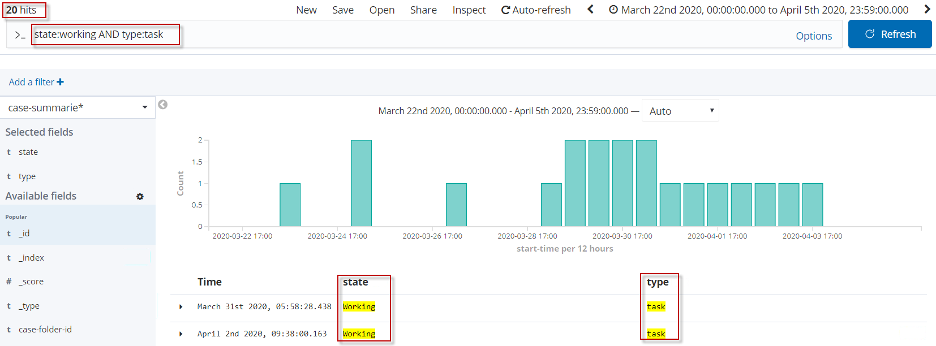

Note

In the field lists are two type fields available. The first type field is written with an underscore. This field is wrong. Add the second type field without an underscore.

Another way to search for data is the Add a filter function. To demonstrate this, the previous search must be removed / deleted.  
  
Ref: [Filtering by field](https://www.elastic.co/guide/en/kibana/current/field-filter.html)

1. Add a filter  
   Delete the expressions in the query bar. Click the Update button. However, we leave the previously added fields in the table.
   1. Click the Add a filter + function

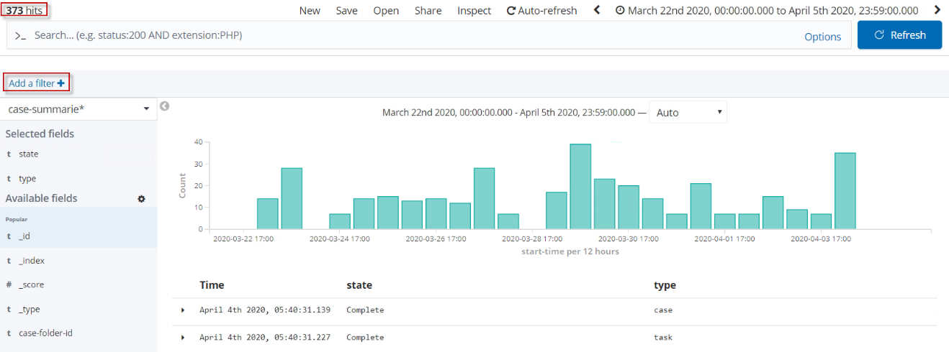

* 1. Select state in the filter choice list.
  2. Select is in the operator choice list.
  3. Enter working in the value field.
  4. Press Save.

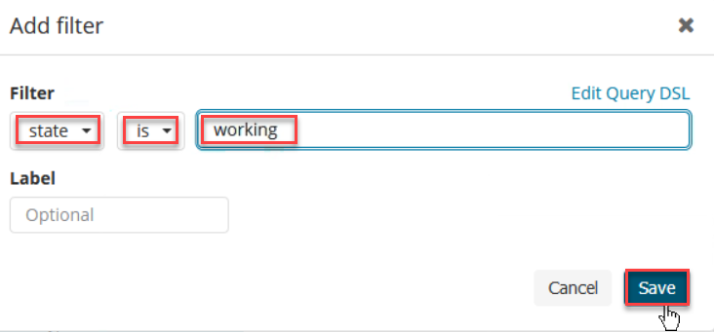  
Note  
The functionality and results entering a search in the search bar or using the Filter expression builder is the same. However, the later on allows you perform following filter actions: Enable or Disable the Filter, to Pin Filter, to Invert Filter, Remove Filter, and Edit Filter.  
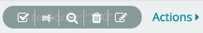

* 1. Check the result. It’s like the search in the query bar above.

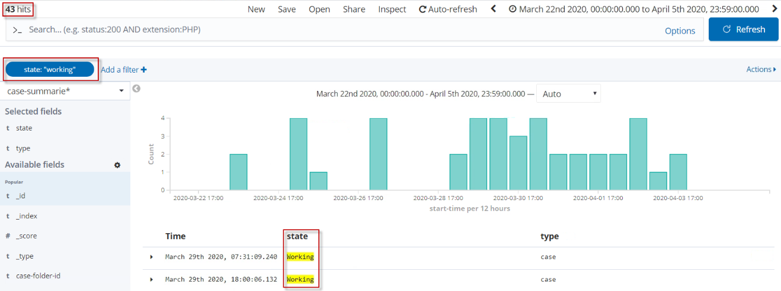

* 1. Again, click the Add a filter + function.
  2. Select type in the filter choice list.
  3. Select is in the operator choice list.
  4. Enter task in the value field.
  5. Press Save.

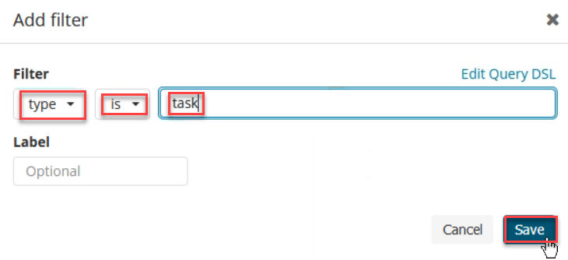

Check the result. It’s like the search in the query bar above.

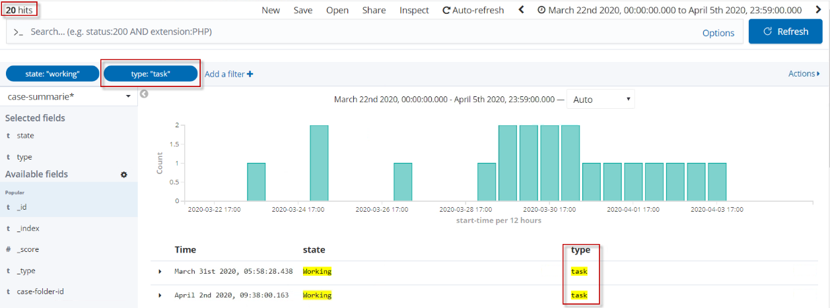

* + - 1. Create and Save your own Searches for Tracking Data

Saving searches enables you to reload them into Discover and use them as the basis for [visualizations](https://www.elastic.co/guide/en/kibana/current/visualize.html). Saving a search stores the index pattern it is based on, the filters/query applied and the table with the fields added.

For a later visualization we create a Saved Search:

1. Remove all filters that originate from the previous chapter  
   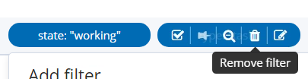
2. Select case-summaries-* as index for the index pattern with an end-date
3. You can remove state and type columns from the results view – hover on the column name and click on the Remove column button.
4. Add the following four fields from the field list by hovering the fields and click add:
5. data.MA_IsMortgageApproved
6. data.MA_LandRegistrarEvaluation
7. data.MA_LandRegistrarMessage
8. data.MA_RiskAssessmentDecision

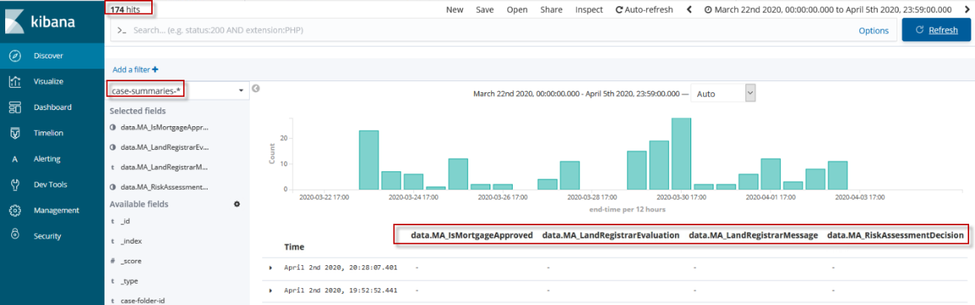  
  
From the screenshot you can see that not all columns have values. This is because the index contains two different types: case and task. This is because the audit manifest specified the tracking variables on case level but not on case activity level. Therefore, we must add a filter to just use cases.

1. Enter following expression in the query bar: type:case. Press Update button or hit Enter.  
   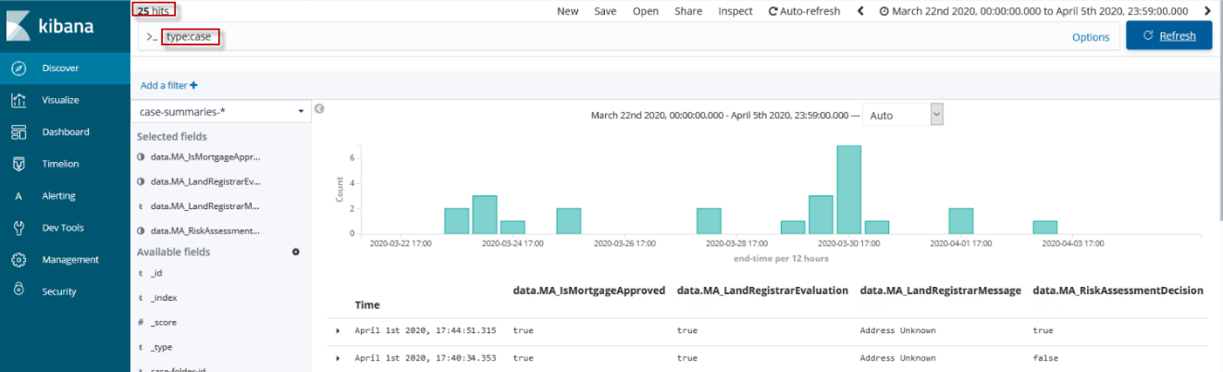Now we have all decisions made in the case at a glance.
2. Next is to store your search. Click Save in the Kibana toolbar.   
   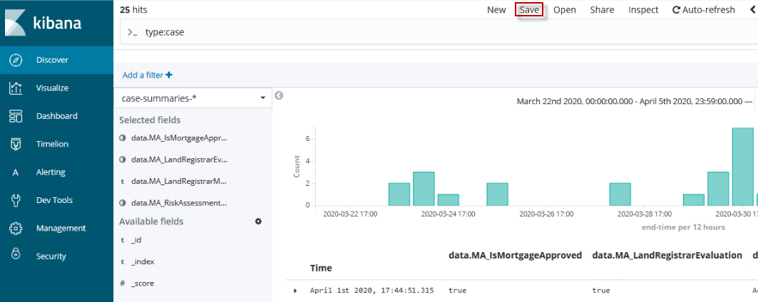
3. In the pop-up dialog enter a name for your Saved Search. For the Saved Search to be found quickly, please use the following naming convention.

<Initials of the student > - MA - SavedSearch for all decisions – v1.0

Click Confirm Save.

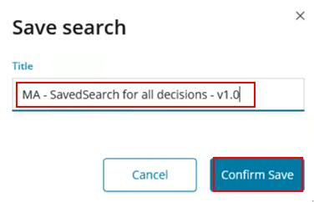

* + - 1. Opening existing Saved Searches

BAI comes with Saved Searches which are used in out-of-the-box visualizations. These can be viewed and explored. They should not be changed to avoid visualizations being negatively affected.

If you want to use and modify anything for your own purposes, perform a “Save as” for the out-of-the-box (OOTB) Saved Search and store it with your initials and a new name.

[Save or open a search](https://www.elastic.co/guide/en/kibana/current/save-open-search.html)

[KC: Searches related to Cases, Processes and Decisions](https://www.ibm.com/support/knowledgecenter/en/SSYHZ8_20.0.x/com.ibm.dba.bai/topics/ref_bai_searches.html)

1. Click Management.
2. Select Saved Objects.

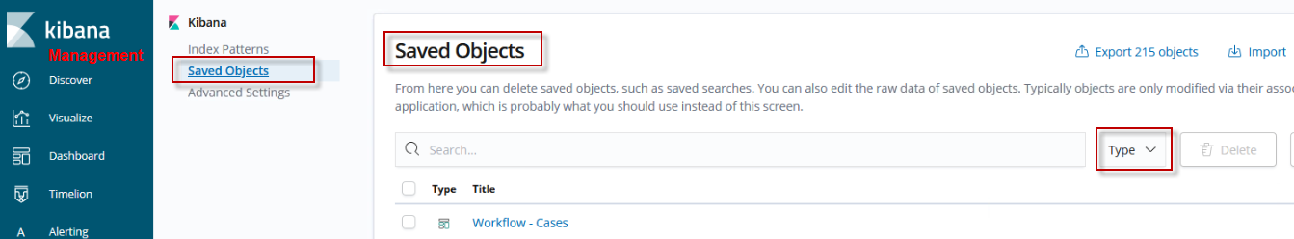

1. Expand Type field and select **search**.

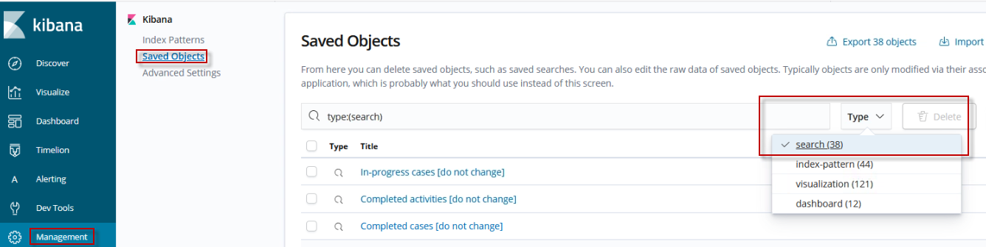

1. Add **cases** to the filter and hit Enter.  
   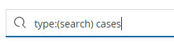
2. Select the Saved Search named **In-progress cases [do not change]**

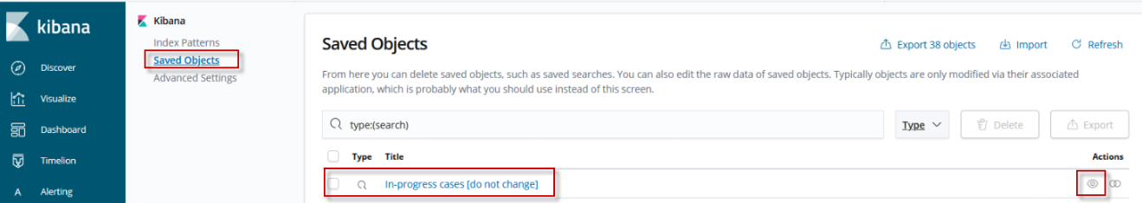

1. Click View search in the upper right corner

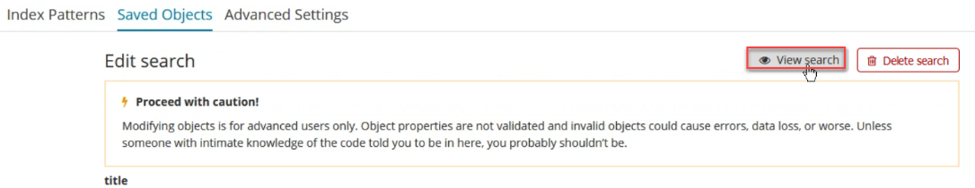

The Saved Search **In-progress cases [do not change]** opens. Don’t be afraid. You open and slightly modify it before saving it with a new name.

1. Modify the Saved Search and save it as a new visualization.

Add field _id.

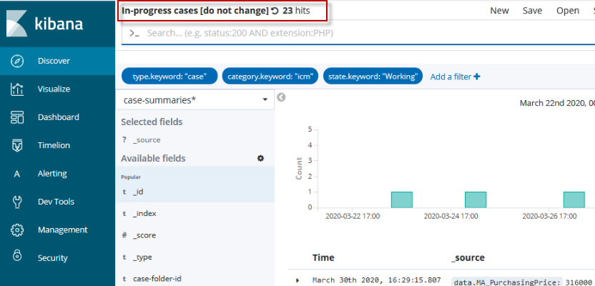

1. Click Save in the Kibana toolbar.

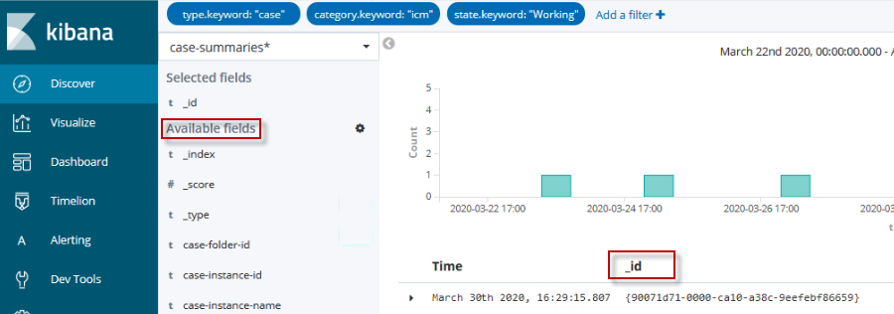

1. In the pop-up dialog enter a name for your Saved Search. To quickly find yours apply following naming convention.

<Initials of the student > - MA - SavedSearch for Overwriting – v1.0

Selecet the flag to **Save as a new search**. Press Confirm Save.

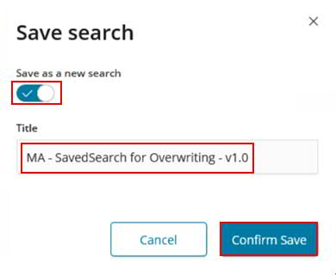

* + - 1. Refreshing the Search Results

As more documents are added to the indexes you are searching, the search results shown in Discover and used to display visualizations get stale. You can configure a [Autorefresh](https://www.elastic.co/guide/en/kibana/current/autorefresh.html) to periodically resubmit your searches to retrieve the latest results.

To enable auto refresh:

1. Click the Auto refresh. in the Kibana toolbar.
2. Choose a refresh interval from the list.

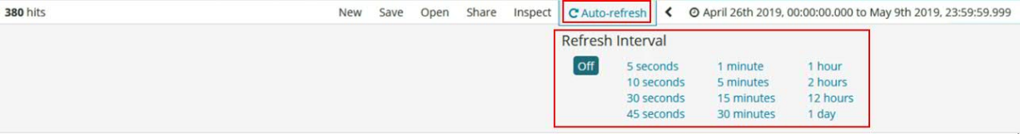

When auto refresh is enabled, the refresh interval is displayed next to the Time Picker, along with a Pause button. To temporarily disable auto refresh, click Off.

You have defined the Saved search and now you can proceed to the visualizations.

### Visualizations

Introduction  
“Visualize”enables you to create visualizations of the data in your Elasticsearch indexes. You can then build [dashboards](https://www.elastic.co/guide/en/kibana/current/dashboard.html) that display related visualizations.

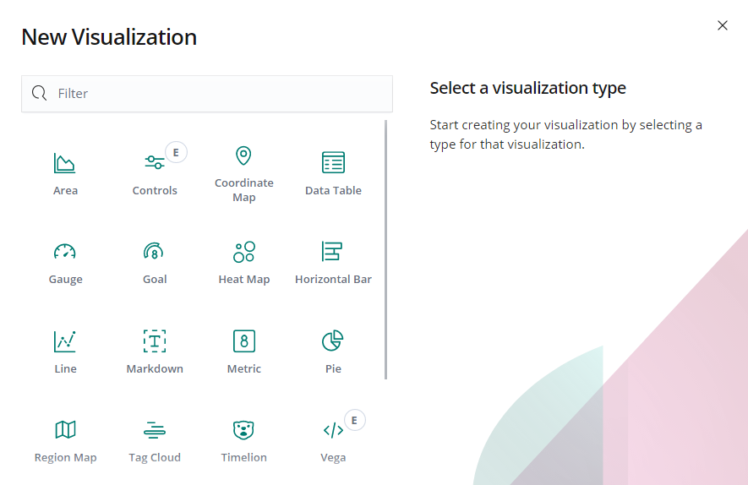

Kibana visualizations are based on Elasticsearch queries. By using a series of Elasticsearch [aggregations](https://www.elastic.co/guide/en/elasticsearch/reference/7.0/search-aggregations.html) to extract and process your data, you can create charts that show you trends, spikes, and dips you may need to know about.

Kibana offers a rich set of different charts. Development of a visualization starts with the selection of a chart type.

[Most frequently used visualizations](https://www.elastic.co/guide/en/kibana/7.6/most-frequent.html" \o "Most frequently used visualizations)

1. **Line, area, and bar charts** — Compares different series in X/Y charts.
2. **Pie chart** — Displays each source contribution to a total.
3. **Data table** — Flattens aggregations into table format.
4. **Metric** — Displays a single number.
5. **Goal and gauge** — Displays a number with progress indicators.
6. **Tag cloud** — Displays words in a cloud, where the size of the word corresponds to its importance.

[TSVB](https://www.elastic.co/guide/en/kibana/7.6/TSVB.html)

Visualizes time series data using pipeline aggregations.

[Timelion](https://www.elastic.co/guide/en/kibana/7.6/timelion.html)

Computes and combine data from multiple time series data sets.

Maps   
 [Elastic Maps](https://www.elastic.co/guide/en/kibana/7.6/maps.html) — Displays geospatial data in Kibana (Region Map)

[Heat map](https://www.elastic.co/guide/en/kibana/7.6/heat-map.html) - Display shaded cells within a matrix.

[Dashboard tools](https://www.elastic.co/guide/en/kibana/7.6/for-dashboard.html)   
 **Markdown widget** — Displays free-form information or instructions.   
 **Controls** — Adds interactive inputs to a dashboard.

[Vega](https://www.elastic.co/guide/en/kibana/7.6/vega-graph.html)

Completes control over query and display.

In general, you [create visualizations](https://www.elastic.co/guide/en/kibana/current/createvis.html) from a search saved under [Discover](https://www.elastic.co/guide/en/kibana/current/discover.html) or start with a new search query.   
Specify a search query to retrieve the data for your visualization:

* 1. To enter new search criteria, select the index pattern for the indexes that contain the data you want to visualize. This opens the visualization builder with a wildcard query that matches all the documents in the selected indexes.

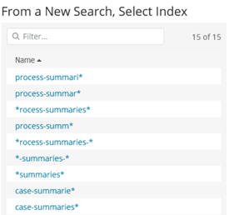

* 1. To build a visualization from a saved search, click the name of the saved search you want to use. This opens the visualization builder and loads the selected query.   
     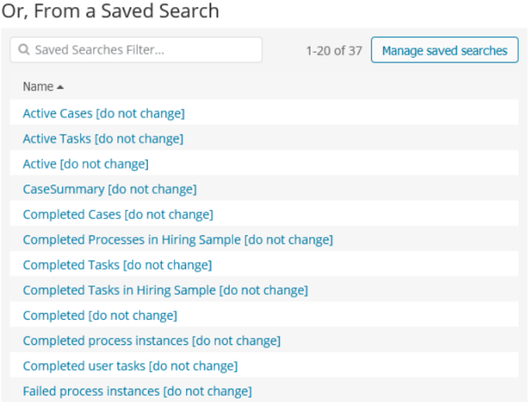

1. In the visualization builder you select the Metric Aggregation for the visualization’s Y axis:

Metric Aggregations

* [count](https://www.elastic.co/guide/en/elasticsearch/reference/7.0/search-aggregations-metrics-valuecount-aggregation.html)
* [average](https://www.elastic.co/guide/en/elasticsearch/reference/7.0/search-aggregations-metrics-avg-aggregation.html)
* [sum](https://www.elastic.co/guide/en/elasticsearch/reference/7.0/search-aggregations-metrics-sum-aggregation.html)
* [min](https://www.elastic.co/guide/en/elasticsearch/reference/7.0/search-aggregations-metrics-min-aggregation.html)
* [max](https://www.elastic.co/guide/en/elasticsearch/reference/7.0/search-aggregations-metrics-max-aggregation.html)
* [standard deviation](https://www.elastic.co/guide/en/elasticsearch/reference/7.0/search-aggregations-metrics-stats-aggregation.html)
* [unique count](https://www.elastic.co/guide/en/elasticsearch/reference/7.0/search-aggregations-metrics-cardinality-aggregation.html)
* [median](https://www.elastic.co/guide/en/elasticsearch/reference/7.0/search-aggregations-metrics-percentile-aggregation.html) (50th percentile)
* [percentiles](https://www.elastic.co/guide/en/elasticsearch/reference/7.0/search-aggregations-metrics-percentile-aggregation.html)
* [percentile ranks](https://www.elastic.co/guide/en/elasticsearch/reference/7.0/search-aggregations-metrics-percentile-rank-aggregation.html)
* [top hit](https://www.elastic.co/guide/en/elasticsearch/reference/7.0/search-aggregations-metrics-top-hits-aggregation.html)
* [geo centroid](https://www.elastic.co/guide/en/elasticsearch/reference/7.0/search-aggregations-metrics-geocentroid-aggregation.html)

Parent Pipeline Aggregations:

* [derivative](https://www.elastic.co/guide/en/elasticsearch/reference/7.0/search-aggregations-pipeline-derivative-aggregation.html)
* [cumulative sum](https://www.elastic.co/guide/en/elasticsearch/reference/7.0/search-aggregations-pipeline-cumulative-sum-aggregation.html)
* [moving average](https://www.elastic.co/guide/en/elasticsearch/reference/7.0/search-aggregations-pipeline-movavg-aggregation.html)
* [serial diff](https://www.elastic.co/guide/en/elasticsearch/reference/7.0/search-aggregations-pipeline-serialdiff-aggregation.html)

Sibling Pipeline Aggregations:

* [average bucket](https://www.elastic.co/guide/en/elasticsearch/reference/7.0/search-aggregations-pipeline-avg-bucket-aggregation.html)
* [sum bucket](https://www.elastic.co/guide/en/elasticsearch/reference/7.0/search-aggregations-pipeline-sum-bucket-aggregation.html)
* [min bucket](https://www.elastic.co/guide/en/elasticsearch/reference/7.0/search-aggregations-pipeline-min-bucket-aggregation.html)
* [max bucket](https://www.elastic.co/guide/en/elasticsearch/reference/7.0/search-aggregations-pipeline-max-bucket-aggregation.html)

For the visualizations X axis, select a bucket aggregation:

* [date histogram](https://www.elastic.co/guide/en/elasticsearch/reference/7.0/search-aggregations-bucket-datehistogram-aggregation.html)
* [range](https://www.elastic.co/guide/en/elasticsearch/reference/7.0/search-aggregations-bucket-range-aggregation.html)
* [terms](https://www.elastic.co/guide/en/elasticsearch/reference/7.0/search-aggregations-bucket-terms-aggregation.html)
* [filters](https://www.elastic.co/guide/en/elasticsearch/reference/7.0/search-aggregations-bucket-filters-aggregation.html)
* [significant terms](https://www.elastic.co/guide/en/elasticsearch/reference/7.0/search-aggregations-bucket-significantterms-aggregation.html)

Bar, line, or area chart visualizations use metrics for the y-axis and buckets for the x-axis.

1. Buckets are analogous to SQL GROUP BY statements. Pie charts, use the metric for the slice size and the bucket for the number of slices.

You can further break down the data by specifying sub aggregations. The first aggregation determines the data set for any subsequent aggregations. Sub aggregations are applied in order. You can drag the aggregations to change the order in which they’re applied or temporarily switch them off.

In this section you will

* verify the provided visualizations
* create a new visualization and learn about the chart types
* create a visualization including tracked data
* copy and save an existing visualization
* verify out-of-the-box visualizations

BAI provides a set of predefined, out-of-the-box visualizations. These are later on used in OOTB Case- , Process - or Decision dashboards.

These visualizations can be viewed or used as a template for new visualizations. However, you should not overwrite the existing ones. If you want to create a modified visualization based on an out-of-the-box visualization save it under a new name to avoid inconsistencies.

In this section you will learn how to view these visualizations and create your own based on them. Let’s begin.

Follow these steps to open and save an out of the box visualization using a new name

1. Navigate to Visualize
2. On the start page you can access or search for existing visualizations.   
   Browse through the available BAI visualizations.
3. Click visualization **Activities in progress [do not change]**

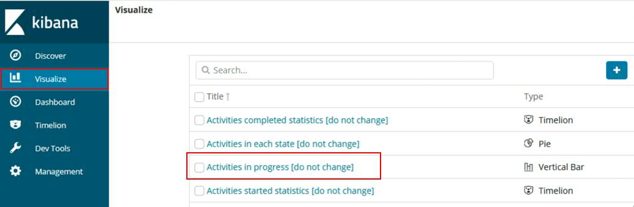

Now we can edit this visualization. For our purposes it is enough to change the bars to lines.

1. Select the Metrics & Axes tab
2. Change Chart Type from bar to line
3. Click the “Apply Changes” button which is symbolized as a “Play”-icon. The diagram is refreshed.

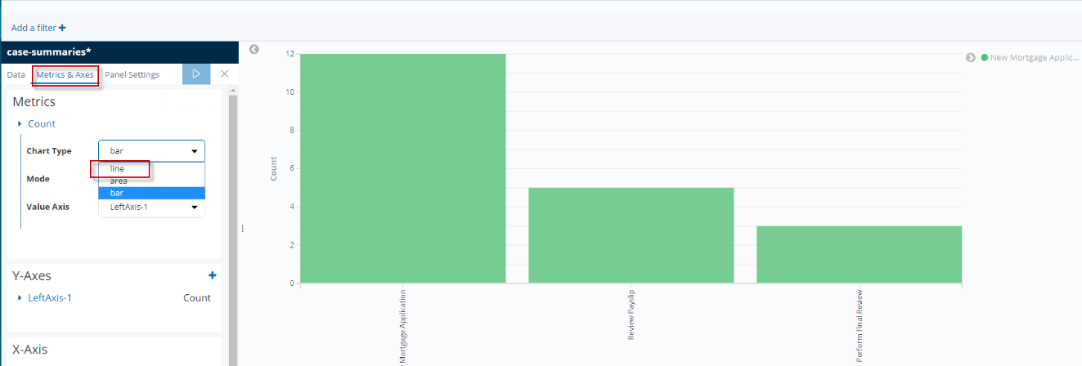

1. Click the Save button in the toolbar on top.  
   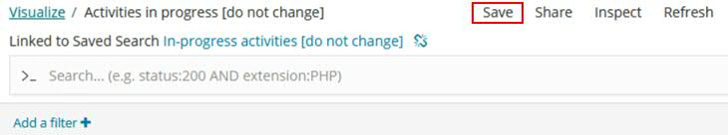
2. In the pop-up dialog enter a name for your Visualization so the visualization can be identified easily by following naming convention.  
   <Initials of the student > - MA - Visualization for Overwriting – v1.0  
   Select the Control next to Save as a new visualization.   
   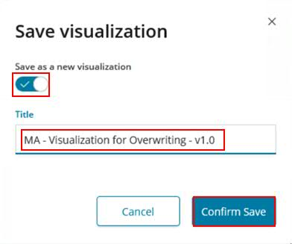
3. 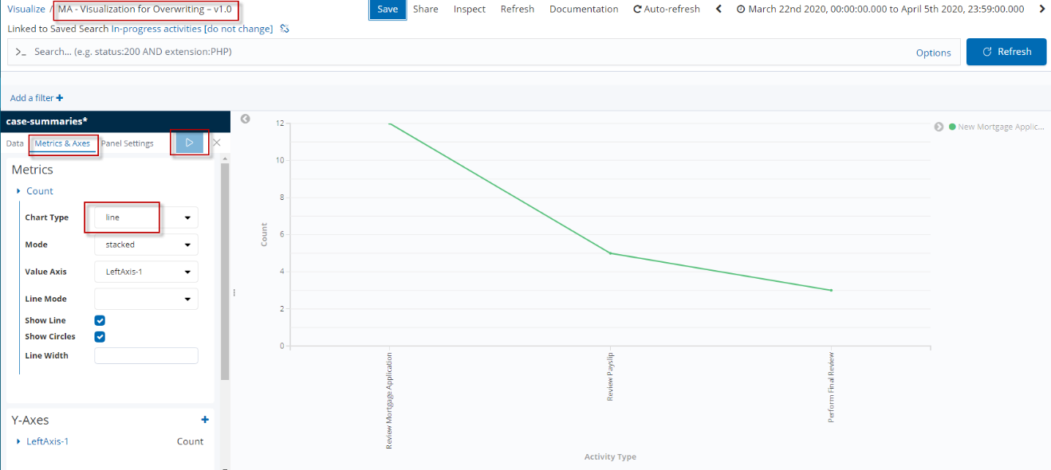
   * + 1. Create your first visualizations – Data Table

Objective

The goal of a data table is to get a compact view of a certain topic. In our case we want to display all decisions made during the Case in one table.

Detailed Requirements

All decisions made in the case are presented in one table. This includes the following four decisions:

* data.MA_IsMortgageApproved
* data.MA_LandRegistrarEvaluation
* data.MA_LandRegistrarMessage
* data.MA_RiskAssessmentDecision

Additionally, all results must be of type:case.

Key Considerations

It should be noted that all four decisions are only included in the case as soon as it is completed. Therefore, we use the index case-summaries-* which contains all completed cases.

Building the Visualization – High-Level Instructions

In a previous chapter, we already created a Saved Search that filters for type:case and includes the index case-summaries-*. We just need to create the visualization based on this Saved Search.

1. Create a data table visualization based on your saved search created in chapter 2.2.3.5. which include the following properties

* data.MA_IsMortgageApproved
* data.MA_LandRegistrarEvaluation
* data.MA_LandRegistrarMessage
* data.MA_RiskAssessmentDecision

Building the Visualization – Step-by-Step Instructions

1. Click on Visualize in the side navigation.
2. Click the Create new visualization button or the „+“ button. 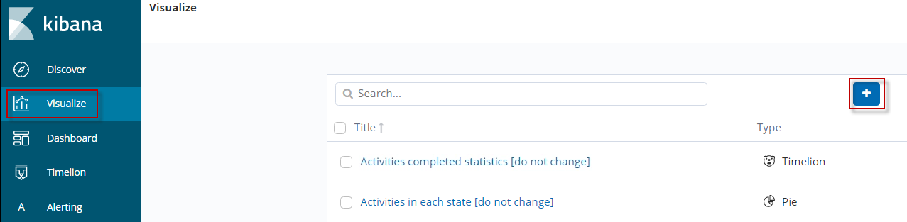
3. Select visualization type: Data Table

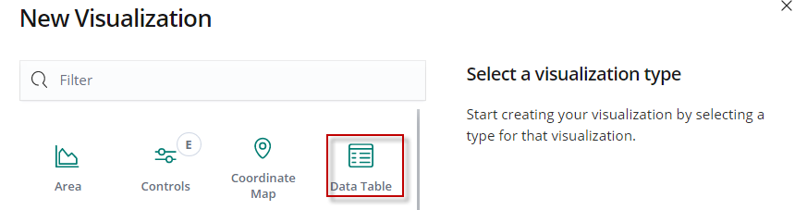

1. Locate the previously created Saved Search:   
   <Initials of the student> - MA – Saved Search for all decisions – v1.0.   
   Click Enter.   
   Note  
   It is also possible to enter only a few words (keywords). Suggestions are generated immediately. Your Saved Search will be found in the search results.   
     
   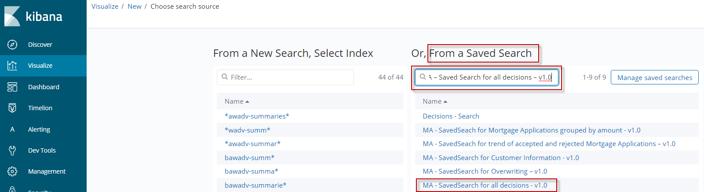
2. Click on this Saved Search to select it.
3. Define the “rows” of the table:
4. In the Buckets area, select Split Rows

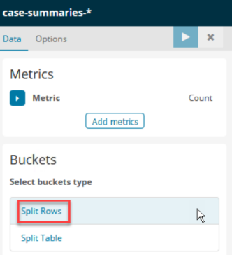

1. For the Aggregation field, select Terms
2. As Field use data.MA_isMortgageApproved – you can easily type and search for a substring in the name of the field.
3. For the custom label enter Approved?
4. Click the “Apply Changes” button which is symbolized as a “Play”-button at the top. The diagram is refreshed.

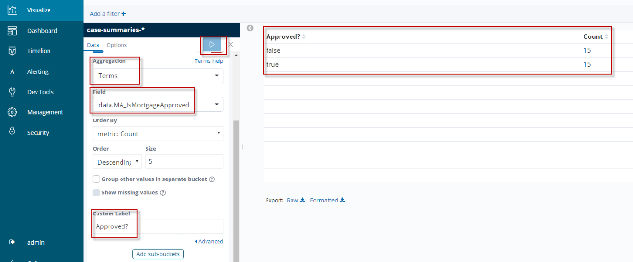

1. Repeat step 6 clicking Add sub-buckets for the other three field values:   
   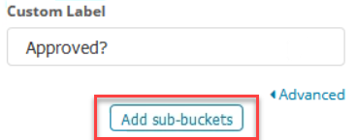  
   * data.MA_LandRegistrarEvaluation label: AlreadyMortgaged?
   * data.MA_LandRegistrarMessage label: RegistrarMessage
   * data.MA_RiskAssessmentDecision label: RiskAssessment
2. When finished your Data Table definition should look like the screenshot beneath.

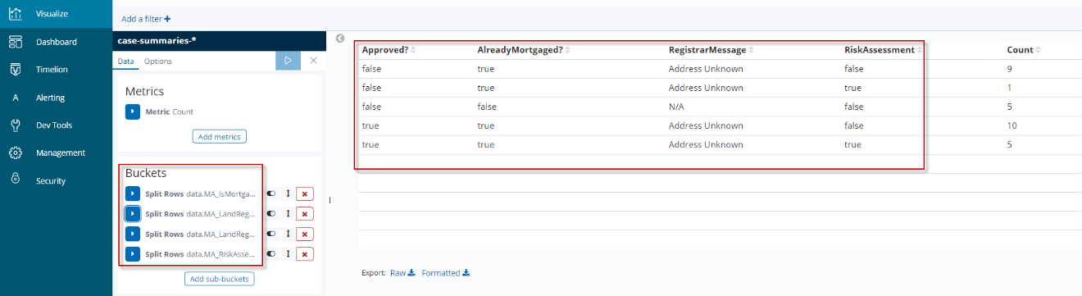  
When satisfied with your visualization click Save.  
  
Note   
Your data and counts might differ as the test data were generated randomly.

1. In the pop-up dialog enter the name for the visualization with your initials:

<Initials of the student > - MA – Data table for Decisions - v1.0

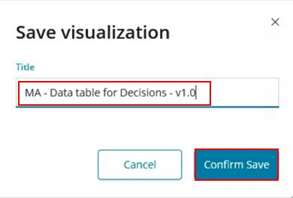

Summary

With this Data Table you have a good overview on what decisions were made in the RPA- and ODM-implementation during the mortgage application as well as confirmed or overruled by the Mortgage Officer.

* + - 1. Create a Visualization of type Gauge

Objective

A goal or gauge visualization displays how your metric progresses towards a fixed goal. A gauge visualization displays in which predefined range and color your metric falls.  
In our scenario, as soon as too many Mortgage Applications are rejected, the pointer should turn yellow or red.

Detailed Requirements

We are interested in the number of rejected mortgages. Based on the number we must define limits, from when the number becomes critical. As we want to have all completed cases, we use the index: case-summaries-*.

Key Considerations

You will specify ranges to correspond to a satisfaction level, like a critical parameter (key performance indicator - KPI). For our purposes we use 15 as the limit for the yellow, 30 as the limit of the red range.

Building the Visualization – High-Level Instructions

Note

You might try to create this second visualization on your own based on the high-level instructions.

1. Create a Gauge visualization
2. Use property data.MA_isMortgageApproved:false for grouping the gauge.
3. Specify the ranges and label

Building the Visualization – Step-by-Step Instructions

1. Click on Visualize.
2. Click the Create new visualization button or the “+” button.

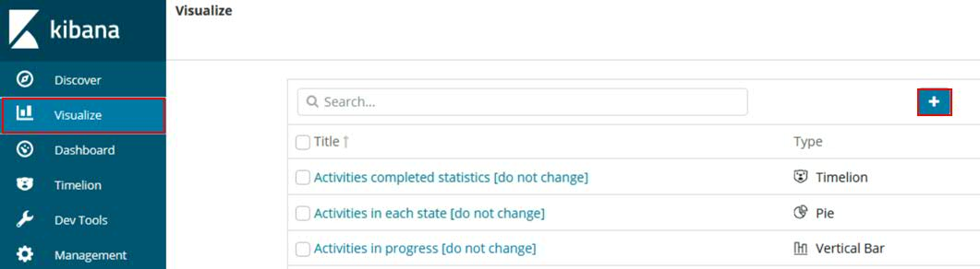

1. Select visualization type: Gauge

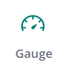

1. Use index case-summaries-*

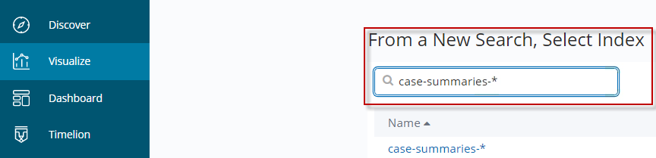

1. Specify the gauge:
2. Click Buckets > Split Group

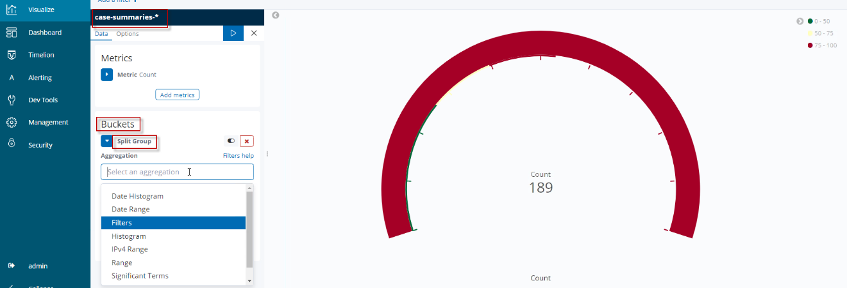

1. For the Aggregation field, select Filters
2. For Filter1 enter data.MA_IsMortgageApproved:false – you need to insert the value manually.
3. Click the “Apply Changes” button which is symbolized as a “Play”-button at the top. The diagram is refreshed.

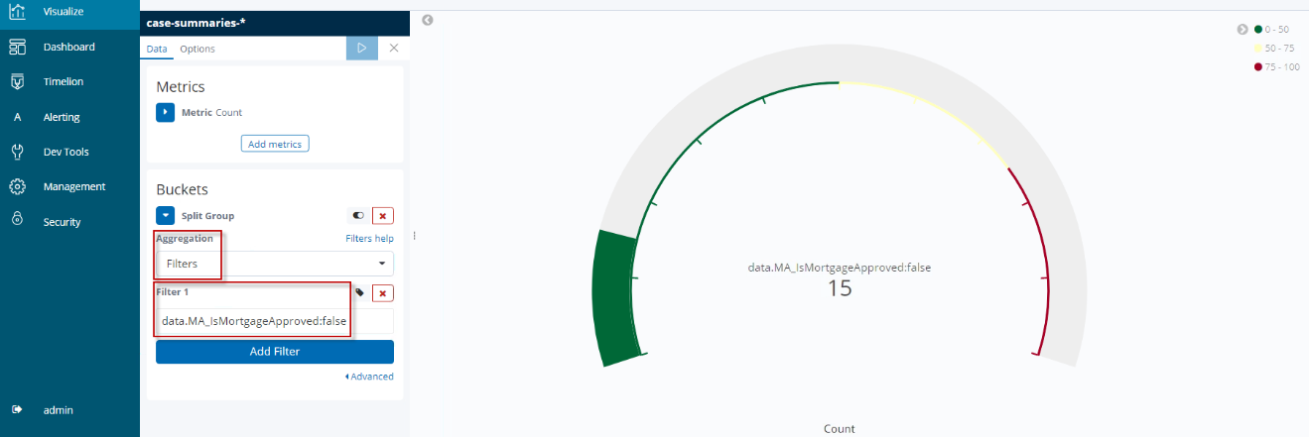

1. Specify the ranges:
2. Click the Options tab
3. Update the ranges:

From 0 to 15

From 15 to 30

From 30 to 50  
Note  
The values for the ranges might need to be adopted due to the amount of summary events (test data) and time period observed. This is being specified in the dashboard later on.

1. Enter the name of the label **Mortgage Applications Rejected** in the Sub Text field
2. Click the “Apply Changes” button which is symbolized as a “Play” button at the top. The diagram is refreshed.

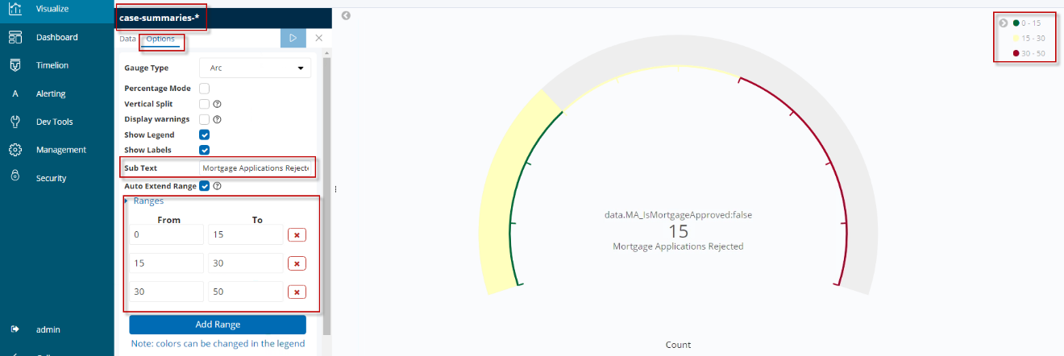

1. When finished your Gauge definition should look like the screenshot above. When satisfied with your visualization click Save.



1. In the pop-up dialog enter the name for the visualization with your initials:

<Initials of the student > - MA– Gauge for number of rejected mortgage applications - v1.0

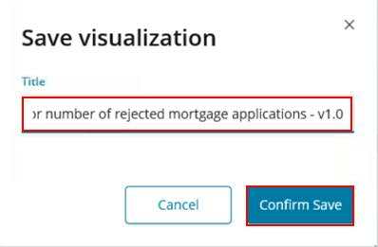

Click Confirm Save.

Summary

This gauge displays the number of mortgage applications rejected. The ranges would need to be adopted for the proper business objectives.

* + - 1. Create a Visualization of type Vertical Bar (Histogram)

Objective

With a vertical bar or a date histogram it is easy to display metrics and trends over time. In this section we display started cases over time. The cases are grouped according to their start times in weekly intervals. In addition, a trend line is specified for demo purposes.

Detailed Requirements

We summarize all mortgage applications of type case. These are ggregated by startTime in weekly time intervals. Therefore, we have to use the index case-summarie* which contains all and is optimized for startTimes.

Key Considerations

To define a trend line based on the count of cases you need to create a sub-bucket for the y axis. This should calculate an average based on the count of the main bucket.

To make sure that only mortgage applications of type case are displayed, the date histogram on the X-axis needs to be also filtered in addition to the date histogram.

Building the Visualization – High-Level Instructions

1. Create a vertical bar visualization.
2. Add as second y-axis with aggregation field average bucket.
3. Use Date Histogram for the x-axis
4. Filter for type:case
5. Modify the average bars to a line

Building the Visualization – Step-by-Step Instructions

1. Click on Visualize in the side navigation.
2. Click the Create new visualization button or the “+” button.



1. Select visualization type: Vertical bar



1. Use index case-summarie*  
   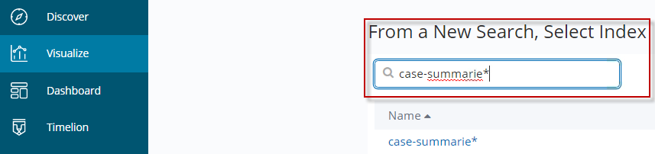

For the definitions of the vertical bar follow these steps.

1. Expand the Y-Axis. The Aggregation setting Count is set as default
2. Select the Add metrics function below the Custom Label field

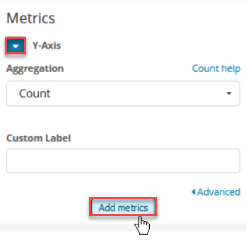

1. Select Y-Axis.   
   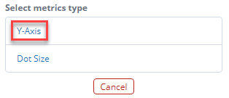
2. In the Aggregation field, select Average Bucket (not just Average)
3. Set interval from auto to Weekly
4. Click the “Apply Changes” button which is symbolized as a “Play” button at the top. The diagram is refreshed.

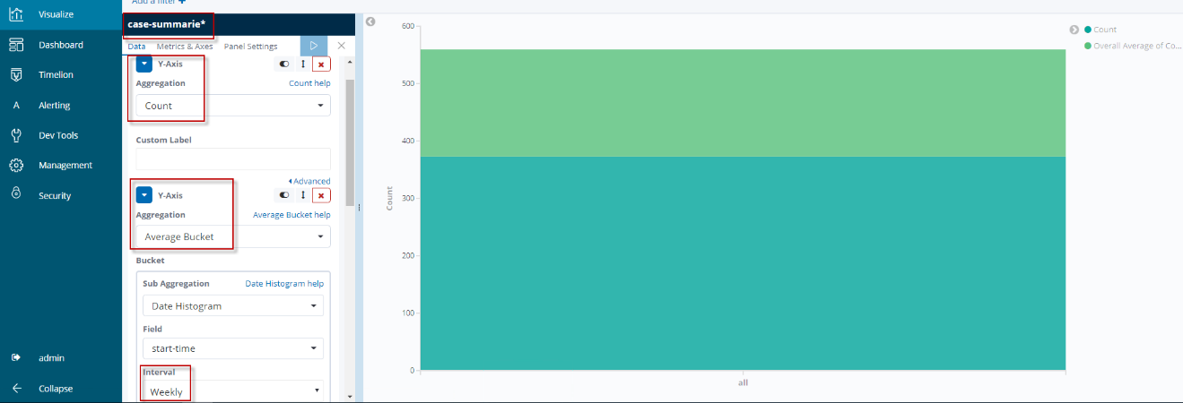

1. Select X-Axis down in the Buckets area

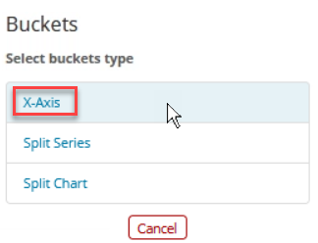

1. In the Aggregation field, select Date Histogram
2. Set interval from auto to Weekly.
3. Click the “Apply Changes” button which is symbolized as a “Play” button at the top. The diagram is refreshed.

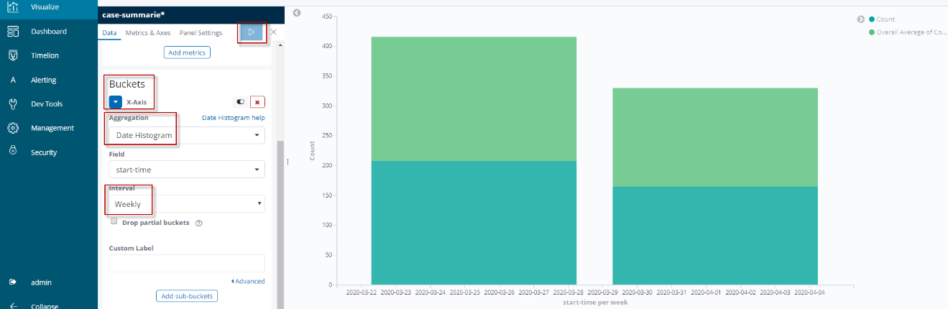

1. Click the Add Sub-bucket function in the bottom.
2. Select Split Series
3. In the Sub Aggregation field, select Filters
4. Enter the following expression in the Filter field: type:case
5. Click the “Apply Changes” button which is symbolized as a “Play”-button at the top. The diagram is refreshed.

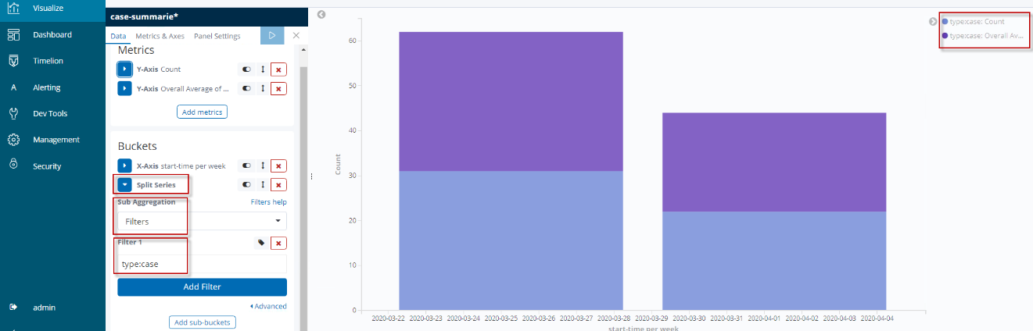

1. Specify trend line
2. Navigate to the Metrics & Axes tab
3. Expand the Overall Average of Count tab
4. Select Chart type line
5. Select Mode normal
6. Select Line Mode smoothed
7. Click the “Apply Changes” button which is symbolized as a “Play” button at the top. The diagram is refreshed.

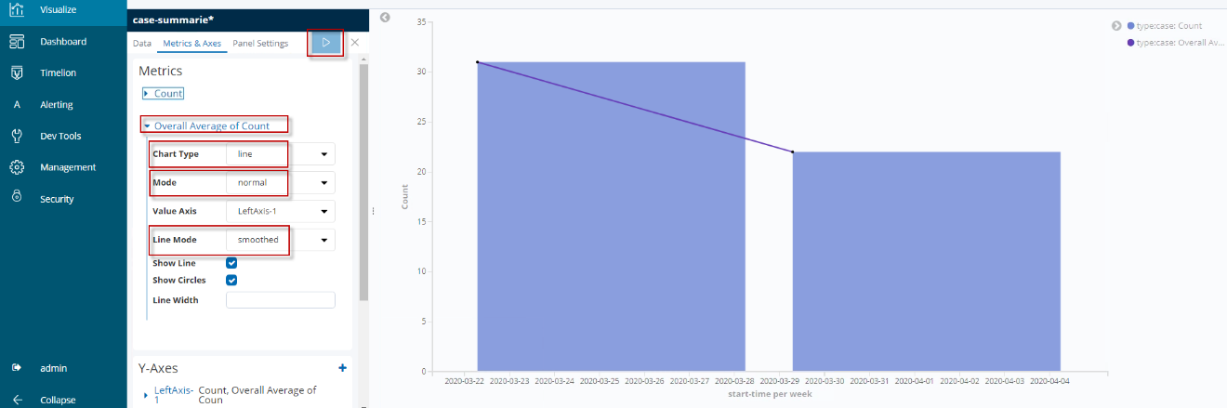

1. If you are satisfied with your visualization and it looks similar to the picture above, you can click Save.



In the pop-up dialog enter the name for the visualization with your initials:

<Initials of the student > - MA – Vertical bar for started cases - v1.0

Click Confirm Save

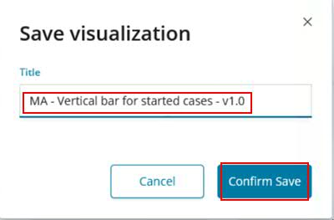

Summary

In a date histogram you can for example see how many cases are available in a given state, here started, per week. When historical data over several weeks exists, adding a trend line can provide further insights.

* + - 1. Create a Visualization of type Pie Chart

Objective

In this section you create a pie chart that is defined by the metrics aggregation. The slice size represents the number of process task named “Perform Final Review” any Mortgage Officer has performed.

Detailed Requirements

On the case level, no data about the employee performing a case activity is emitted.

Therefore, we need a process index that contains the variable performerName for completed tasks: process-summaries*.

Key Considerations

Since there are several tasks in the process index and the employee only takes over the task "Perform Final Review", filtering for this variable is required:  
name:”Perform Final Review”.

Building the Visualization – High-Level Instructions

1. Create a pie visualization.
2. Filter for name:”Perform Final Review”
3. Aggregate by variable performerName.keyword

Building the Visualization – Step-by-Step Instructions

1. Click on Visualize in the side navigation.
2. Click the Create new visualization button or the „+” button.



1. Select visualization type: Pie

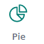

1. Use index process-summaries*

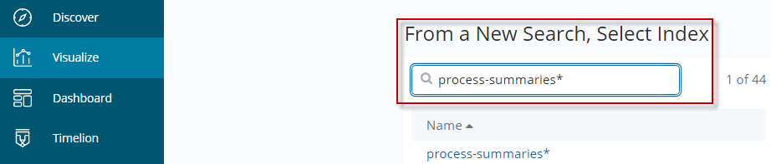

1. Specify the slices:
2. Enter following expression in the Search bar:  
   name: ”Perform Final Review”  
   Click the Update button.

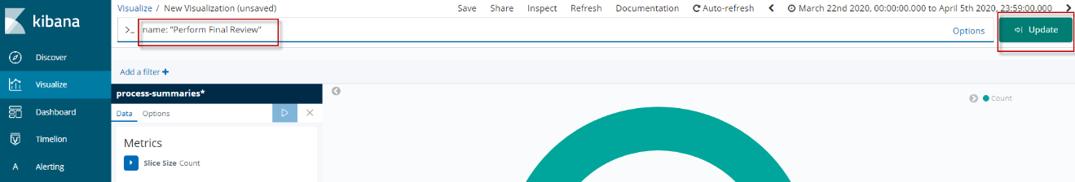

1. Select Buckets > Split Slices

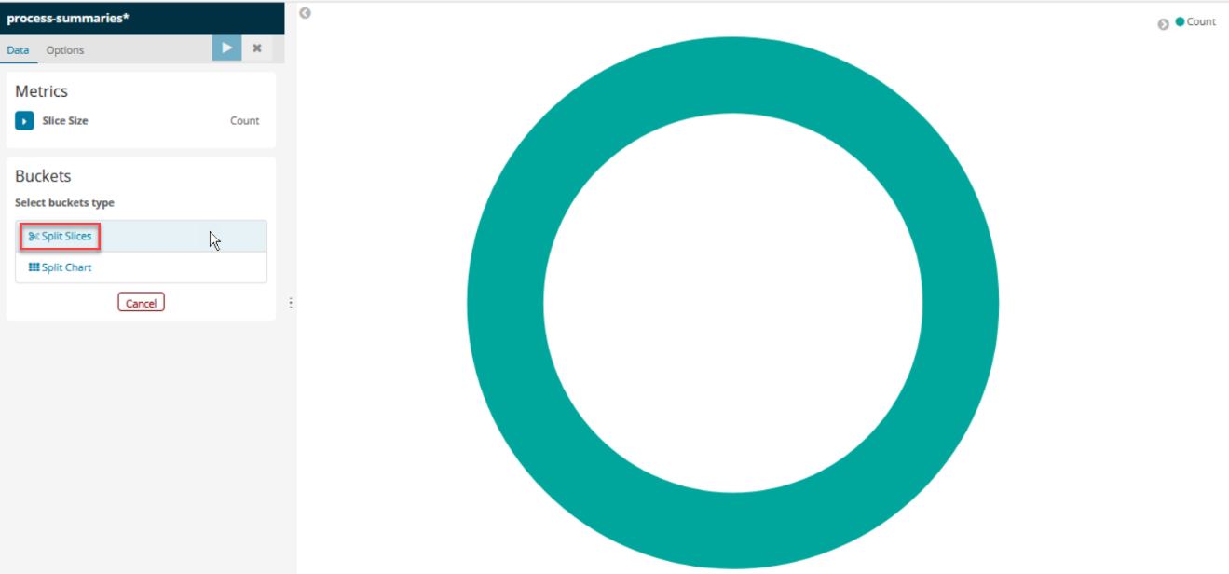

1. In the Aggregation field, select Terms
2. In the field Field, select performerName.keyword
3. Click the “Apply Changes” button which is symbolized as a “Play” button at the top. The diagram is refreshed.

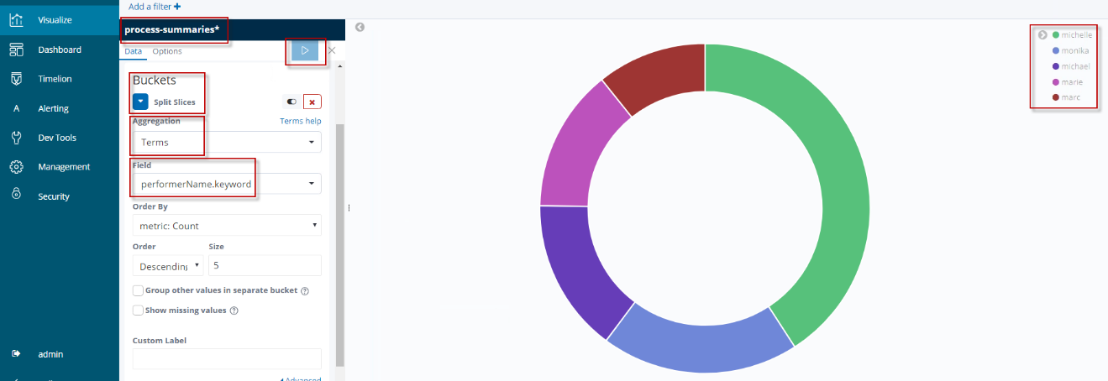

1. If you are satisfied with your visualization and it looks similar to the picture above, you can click Save.



In the pop-up dialog enter the following name for the visualization with your initials:

<Initials of the student > - MA – Pie chart for number of tasks split by performer - v1.0

Click Confirm Save

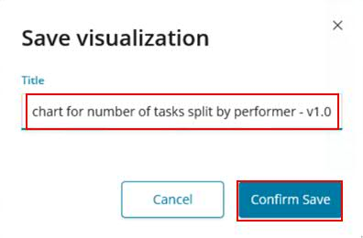

Summary

A pie chart is a goods means to represent the ratio or categories of variables and aggregations.

### Dashboards

Introduction

Now, as you understand how to create visualizations we may want to display them via a Dashboard.

Kibana offers *dashboards* for that purpose. Dashboards display a collection of visualizations and searches. You can arrange, resize, and edit the dashboard content and then save the dashboard so you can share it.

In this section you will

* verify the provided out-of-the-box dashboards
* create your own dashboard
* learn about dashboard layouts
* practice filtering, i.e. to disable, to pin, to exclude matches, to remove, and to edit filters
* export your dashboard
  + - 1. Verify the out-of-the-box Dashboards

BAI provides a set of out-of-the-box dashboards. These can be viewed in the Dashboard tab. The dashboards visualize information about Cases, Processes, Decisions and are specific to the Hiring Sample.

Follow these steps to open an existing dashboard:

1. Navigate to the Dashboard tab
2. On the start page for Dashboards you can search and select available dashboards. Open the **Workflow – Process Tasks** dashboard

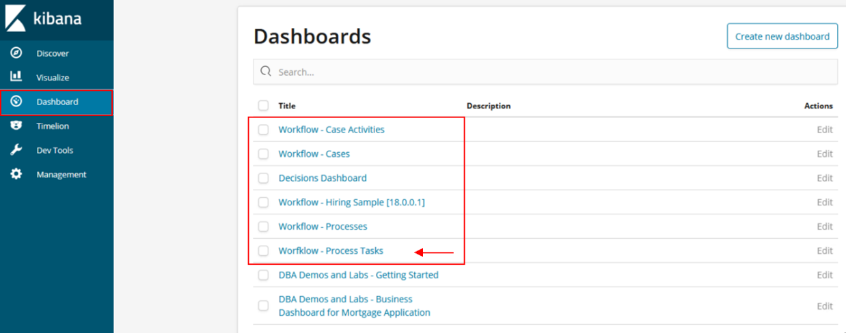  
Note  
The screenshot lists some custom dashboards not yet available at this stage in your environment.

1. The Workflow – Process Tasks dashboard opens.  
   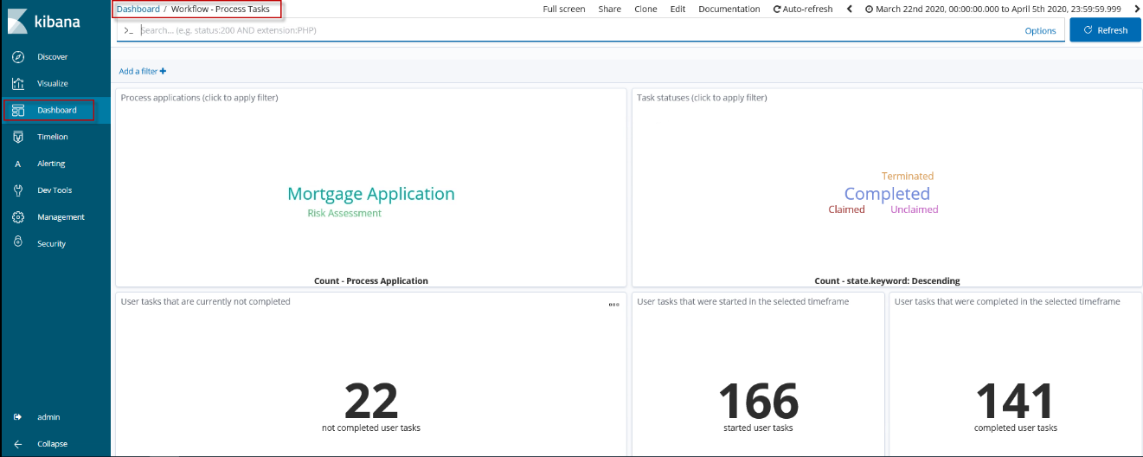  
     
   These OOTB dashboards will be introduced in the next exercise: Understand the available dashboards on monitored Cases, Processes and Decisions. Therefore we will continue with editing dashboard next.  
   * + 1. Edit a dashboard

Continue with the Workflow – Process Tasks dashboard to edit, update and save it under a new name. For our purposes of this section it is enough to add one visualization.

1. Click Edit in the Kibana toolbar   
   
2. Click Add in the Kibana toolbar



1. Select visualization **Cases in progress [do not change]**. Double-click to add it to the Dashboard. This visualization is based on a case. It is used for demonstration purposes.

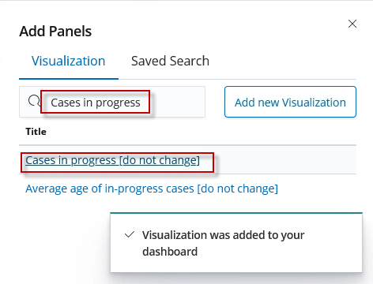  
The visualization is added at the **bottom** of this dashboard.

1. Click Save in the Kibana toolbar.
2. In the pop-up dialog enter a name for your Dashboard. That the Dashboard can be found quickly, please use the following naming convention.

<Initials of the student > - MA - Workflow – Process Tasks Dashboard for Overwriting – v1.0

Select the option to Save as a new dashboard. Click Confirm Save.  
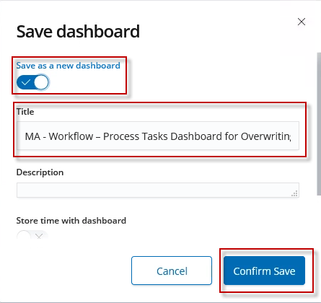

* + - 1. Create and build a new Dashboard

The visualizations created in the previous chapters are now added to a new dashboard.

[Building a Dashboard](https://www.elastic.co/guide/en/kibana/current/dashboard-getting-started.html)

1. Navigate to Dashboard.
2. Click Create new dashboard.

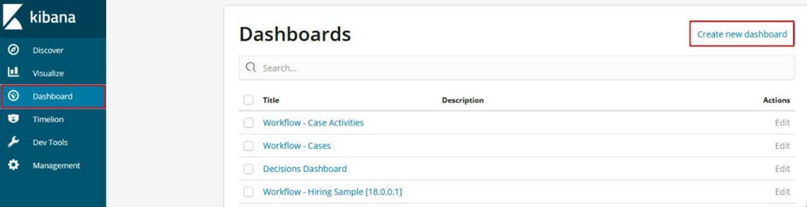

1. Click Add in the Kibana toolbar.

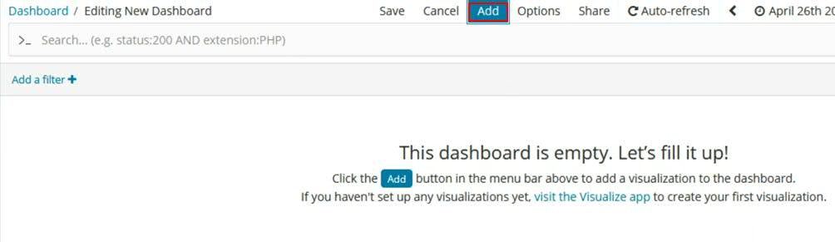

1. Use Add Panels to add visualizations and saved searches to the dashboard. Enter your Initials and click Enter.   
   Based on your initials you filter those visualizations you have recreated before.  
   Following visualizations should be offered:

* <Initials of the student > - MA – Data table for Decisions - v1.0
* <Initials of the student > - MA – Gauges for number of rejected mortgage applications - v1.0
* <Initials of the student > - MA – Vertical bar for started cases - v1.0
* <Initials of the student > - MA – Pie chart for number of tasks split by performer - v1.0

1. Click on each of your visualizations to add them to the new dashboard.

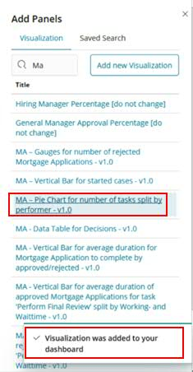

1. Click Save after you have added all four visualizations.
2. In the Save Dashboard dialog, enter the dashboard title and optionally a description. For our purpose use:   
   <Initials of the student > - MA - Getting Started Dashboard
3. Select Store time with dashboard to store the time period specified in the time filter.  
   Note  
   Remember we had specified an absolute time period from 2020-03-22 till 2020-04-05.  
   Click Confirm Save.   
   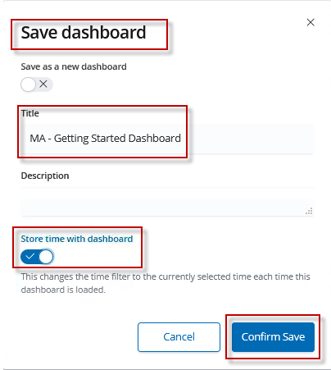

Your dashboard should look similar to the screenshot below.

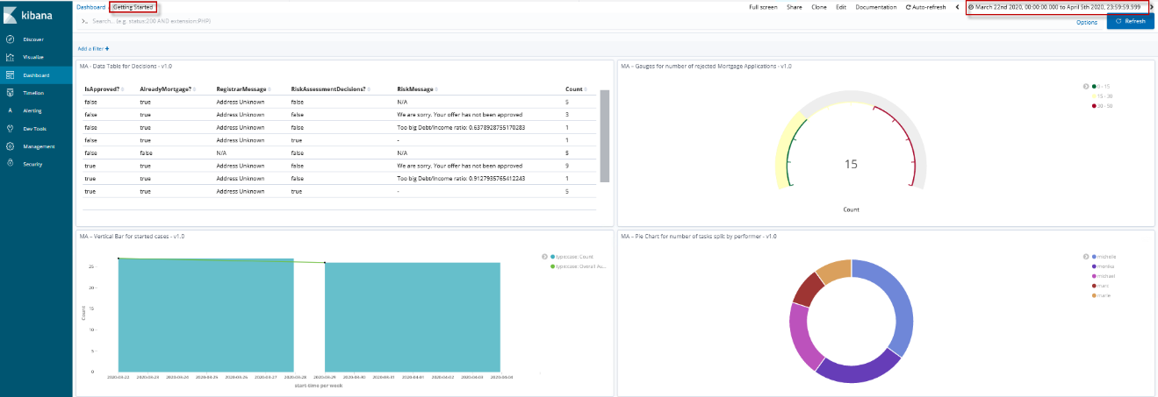

* + - 1. Inspecting a Visualization in a Dashboard

Many visualizations allow you to inspect the data as an end-user, i.e. you are not in Edit mode. This opens a data table which shows the detailed metrics that feed the graphical representation.

A further kind of inspection is filtering by modifying the time period that is shown in the dashboards as introduced in Filter and narrow down the time range in the histogram.  
Ref: [Inspecting a Visualization from the Dashboard](https://www.elastic.co/guide/en/kibana/7.6/dashboard-create-new-dashboard.html)

1. Hover over the upper right corner of a visualization until three dots appear.  
   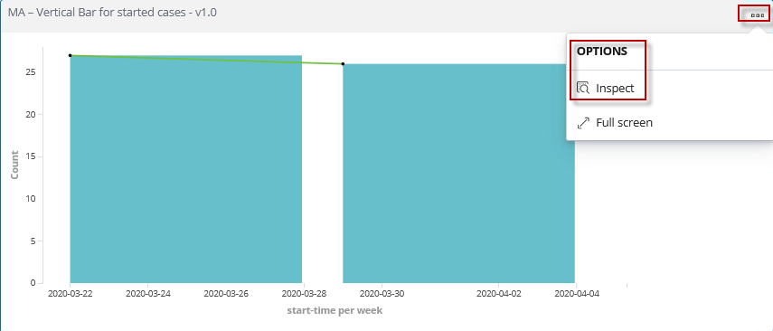
2. Click Options > Inspect  
   The source data for the bar chart are displayed in a data table.  
   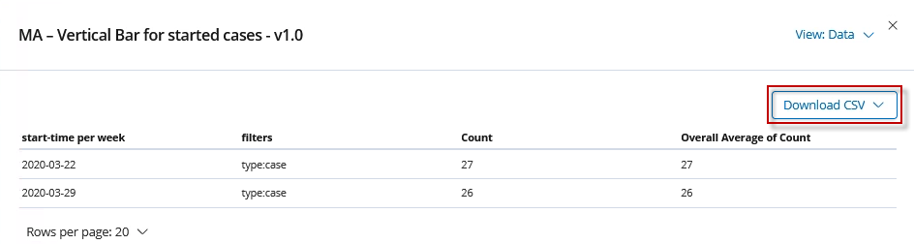
3. Optionally you can download the data in CSV format.
4. Filtering  
   Filtering is not only possible in visualizations, but in dashboards too. However, due to different indexes used in the visualizations some filters might not have an effect on all visulaizations – “No results found”.
5. Specify the filter in the query bar  
   Enter the following expression in the query bar:  
   **state:completed or state:complete**  
     
   Note  
   “complete” is the state for a case, while “completed” is the state for a process (bottom right).
6. Alternatively, you can configure your filter expression. Click Add a filter function. 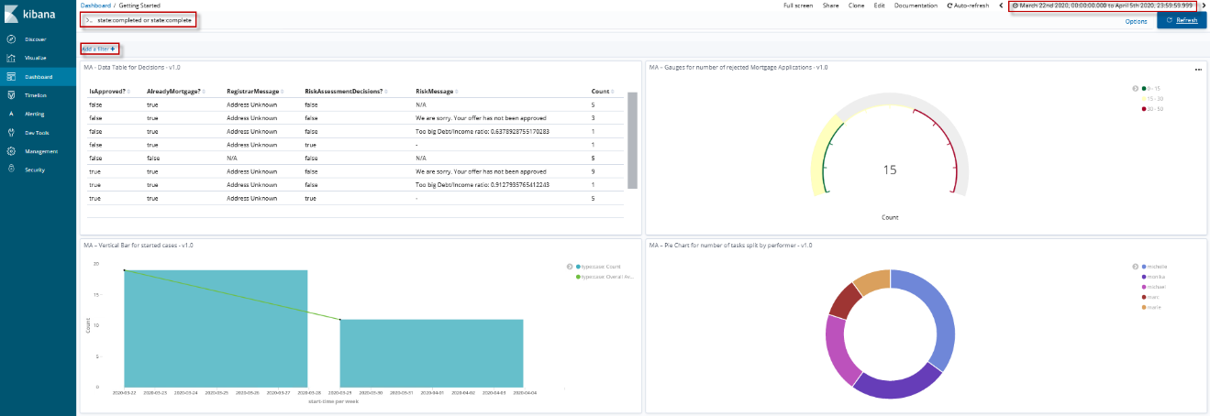
7. In some visualizations it is possible to click on an area or a bar. This sets a filter for this slice. 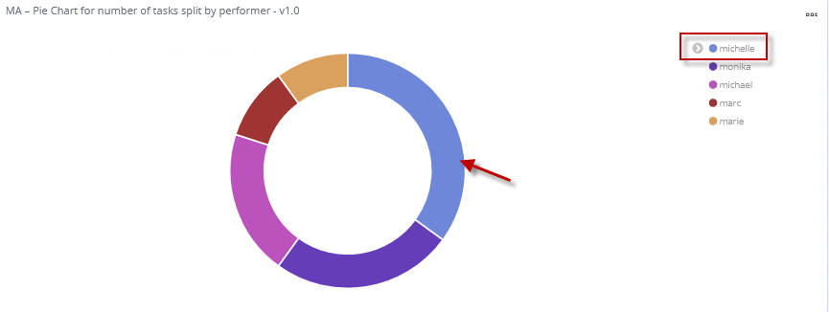  
   The other visualizations – due to its internal case index – don’t cope with this filter setting. Delete the filter.  
   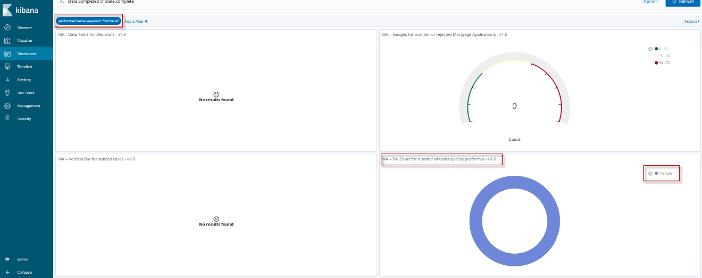
   * + 1. Manipulate and arrange Dashboard Elements

The visualizations and searches in a dashboard are stored in panels that you can move, resize, edit, and delete.   
Ref: [Customize your dashboard.](https://www.elastic.co/guide/en/kibana/7.6/dashboard-create-new-dashboard.html)

To try this out follow these steps:

1. Click Edit in the menu bar to allow edit of your dashboard.



1. In order to move a visualization (widget), click at the top of a visualization and simply move it around or to a new location.
2. To resize a panel, click the resize control in the lower right and minimize/maximize to the new size.   
   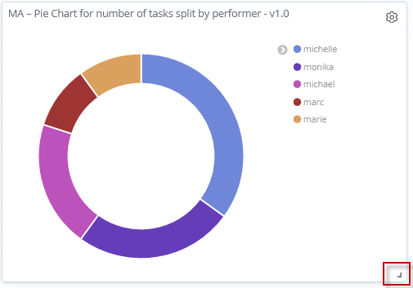
3. Additional commands for managing the panel and its contents are in the gear menu in the upper right. You can optionally try out these features.
4. Inspect for more detail
5. Edit visualization  
   In this mode you can modify any metrics, buckets, styles or specifications of that visualization.
6. Customize panel to resize the panel.
7. Full screen to maximize the panel.
8. Delete from Dashboard to remove the visualization.

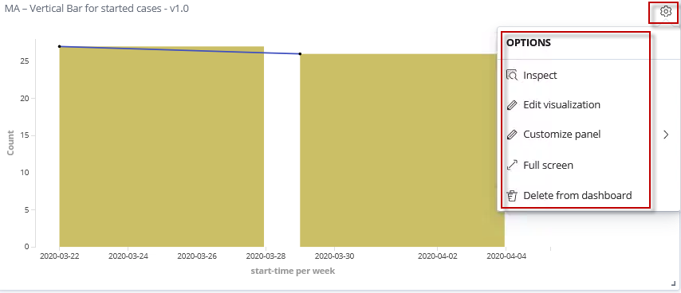

* + - 1. Export Dashboard

Often it is useful to save and backup your work or to [export](https://www.elastic.co/guide/en/kibana/current/managing-saved-objects.html) from a development environment into a production environment.

* You might have multiple environments for development and production. The export and import commands allow you to move objects between different Kibana instances.
* You have a large number of objects to update and want to batch this process. You can export the objects to JSON, make the JSON modification, and re-import the objects.
* If you select and export a dashboard, the nested artefacts are not included. Therefore, you need to select the dashboard, its visualizations, its saved searches, and its indexes.
* It is recommended to use a naming convention to filter out those artefacts that belong to one solution or business area.

Select the checkboxes of the objects you want to export and click Export. Or, to export objects by type:

1. Click Management and then Saved Object.

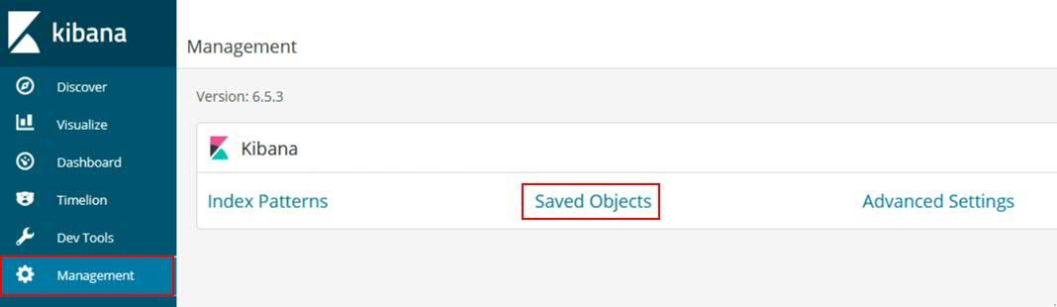

1. In the Search bar enter a value to search for: <your initials> and click Enter.  
   Refine the search selecting Type and mark dashboard and visualization
2. Select all artefacts you want to export. Be aware that by default only 20 items are shown per page.

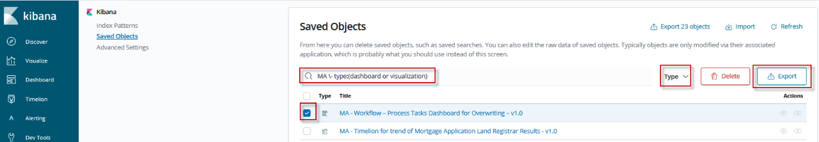

1. Click Export.
2. Select Save File in the appearing window and click OK

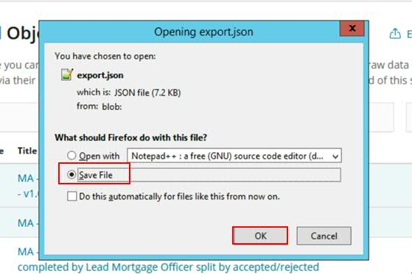

1. Save your export

Exported dashboards do not include their associated index patterns and scripted fields. Re-create the index patterns and scripted field manually before importing saved dashboards to a Kibana instance running on another Elasticsearch cluster.

### Advanced Topics

In this section you will be introduced to additional and advanced features:

1. Scripted fields
2. Timelion

These features are used and explained in detail in exercise: Create new Visualizations specific to the Mortgage Application Solution.

* + - 1. Scripted Fields

Ref: [Scripted Fields](https://www.elastic.co/guide/en/kibana/current/scripted-fields.html)

Note

This section is used for documentation purposes only. Scripted fields are included in process-summaries* index to calculate working- and waittimes. These will be used visualization called Avg of Durations for a Mortgage Application to complete separated by rejected/accepted later on.

Scripted fields compute data on the fly from the data in your Elasticsearch indexes. Scripted field data is shown on the Discover tab as part of the document data, and you can use scripted fields in your visualizations. Scripted field values are computed at query time so they aren’t indexed and cannot be searched using Kibana’s default query language. However they can be queried using Kibana’s new [experimental query language](https://www.elastic.co/guide/en/kibana/current/kuery-query.html). Scripted fields are also supported in the filter bar.

Computing data on the fly with scripted fields can be very resource intensive and can have a direct impact on Kibana’s performance. Keep in mind that there’s no built-in validation of a scripted field. If your scripts are buggy, you’ll get exceptions whenever you try to view the dynamically generated data.

When you define a scripted field in Kibana, you have a choice of scripting languages. Starting with 5.0, the default options are [Lucene expressions](https://www.elastic.co/guide/en/elasticsearch/reference/7.0/modules-scripting-expression.html) and [Painless](https://www.elastic.co/guide/en/elasticsearch/reference/7.0/modules-scripting-painless.html). While you can use other scripting languages if you enable dynamic scripting for them in Elasticsearch, this is not recommended because they cannot be sufficiently [sandboxed](https://www.elastic.co/guide/en/elasticsearch/reference/7.0/modules-scripting-security.html).

Use of Groovy, JavaScript, and Python scripting is deprecated starting in Elasticsearch 5.0, and support for those scripting languages will be removed in the future.

You can reference any single value numeric field in your expressions, for example:

doc['field_name'].value

For more background on scripted fields and additional examples, refer to this blog: [Using Painless in Kibana scripted fields](https://www.elastic.co/blog/using-painless-kibana-scripted-fields)

* + - * 1. *Creating a Scripted Field*

To create a scripted field:

1. Go to Management > Kibana > Index Patterns
2. Select the index pattern you want to add a scripted field to.
3. Go to the pattern’s Scripted fields tab.
4. Click Add scripted field.
5. Enter a name for the scripted field.
6. Enter the expression that you want to use to compute a value on the fly from your index data.
7. Click Create field.

For more information about scripted fields in Elasticsearch, see [Scripting](https://www.elastic.co/guide/en/elasticsearch/reference/7.0/modules-scripting.html).

* + - * 1. *Updating a Scripted Field*

To modify a scripted field:

1. Go to Management > Kibana > Index Patterns
2. Click the index pattern’s Scripted fields tab.
3. Click the Edit button for the scripted field you want to change.
4. Make your changes and then click Save field to update the field.

Keep in mind that there’s no built-in validation of a scripted field. If your scripts are buggy, you’ll get exceptions whenever you try to view the dynamically generated data.

* + - * 1. *Deleting a Scripted Field*

To delete a scripted field:

1. Go to Management > Kibana > Index Patterns
2. Click the index pattern’s Scripted fields tab.
3. Click the Delete button for the scripted field you want to remove.
4. Click Delete in the confirmation window.
   * + 1. Timelion

A Timelion is a time series data visualizer that enables you to combine totally independent data sources within a single visualization. It’s driven by a simple expression language you use to retrieve time series data, perform calculations to tease out the answers to complex questions, and visualize the results.

For example, Timelion enables you to easily get the answers to questions like:

* How many pages does each unique user view over time?
* What’s the difference in traffic volume between this Friday and last Friday?
* What percent of Japan’s population came to my site today?
* What’s the 10-day moving average of the S&P 500?
* What’s the cumulative sum of all search requests received in the last 2 years?

You might also be interested in these tutorial videos:

* [Timelion: Magic, Math, and Everything in the Middle](https://www.elastic.co/elasticon/conf/2017/sf/timelion-magic-math-and-everything-in-the-middle)
* [Timelion Plugin for Kibana Enables Time Series](https://www.elastic.co/videos/timelion-plugin-for-kibana-enables-times-series-paris-meetup)
* [Using Kibana and Timelion to Analyze Earthquake Data](https://www.elastic.co/videos/using-kibana-and-timelion-to-analyze-earthquake-data)

In order to learn this language in detail, it is also recommended to work through this documentation: [Timelion](https://www.elastic.co/guide/en/kibana/current/timelion-getting-started.html)

## Getting started with Kibana – Verification Instructions

The verification about successful completion of this exercise is postponed to the step-by-step instructions of the next chapter related to the results of visualizations in the out-of-the-box dashboards – Questions and Answer chapters.

Optionally you might import the Getting Started Dashboard if you didn’t have enough time to complete the exercise or if you want to compare your work with the provided master solution.

1. In Kibana, click Management. Click Saved Objects.   
   The Edit Saved Objects window appears
2. Click Import

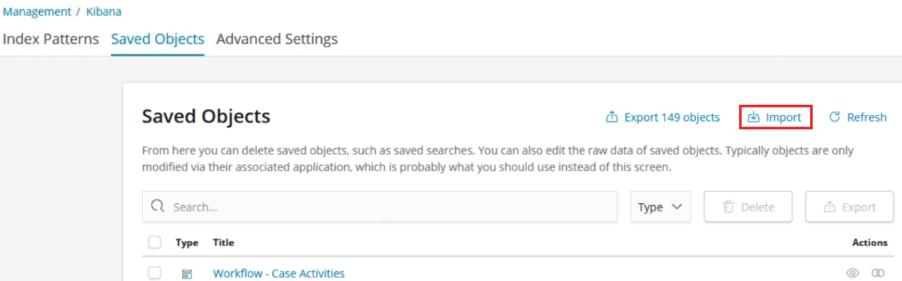

1. Select file “c:\Users\Administrator\ibm-bai-workshop-main\labs\bpmn-case-odm-kibana\getting-started-dashboard.json” which represents the objects to import.
2. Indicate to overwrite objects already in Kibana.   
   
3. Click Import.

## Getting started with Kibana – Summary

In this exercise you should learnt how to use the functionality of Business Automation Insights and Kibana to discover summary events of cases, processes and decisions.

Furthermore, you practiced using and build Saved Searches, Filters, Visualizations and Dashboards.

We want to repeat some of the concepts as their understanding is required for the next exercise. For better illustration everything was put into one slide.

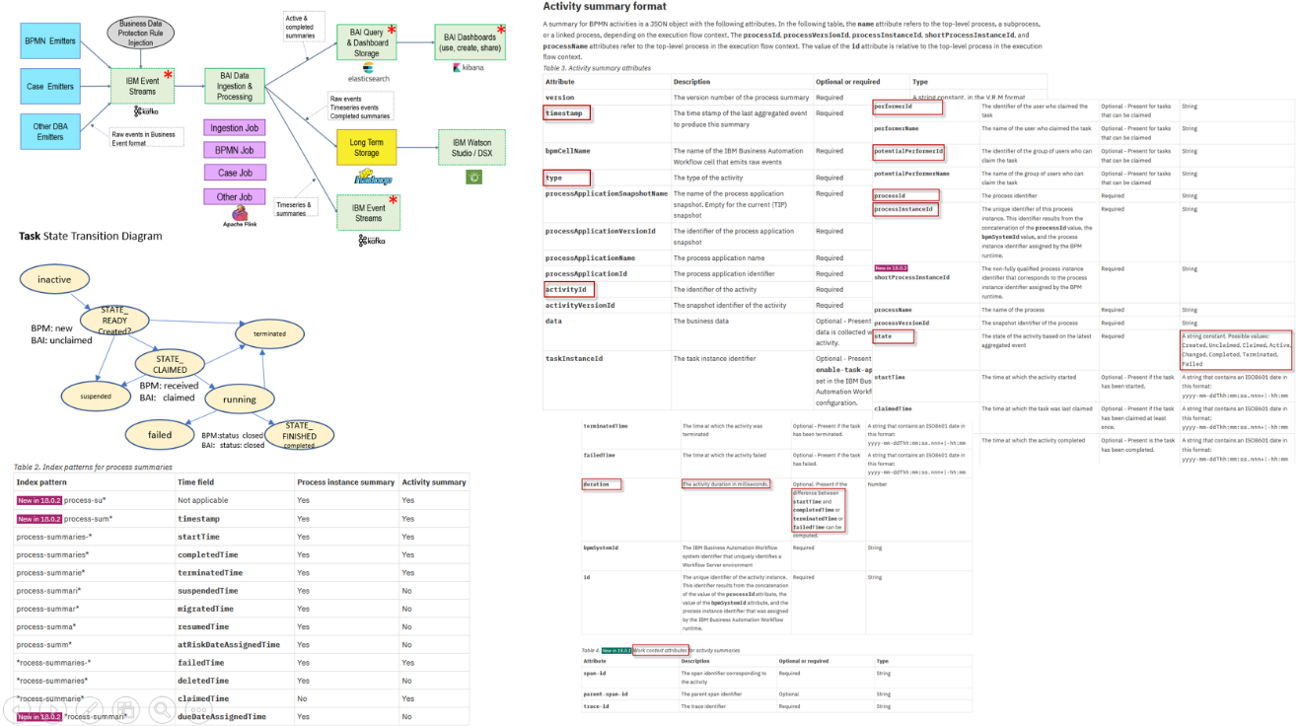

1. The BAI architecture diagram shows the transition, computing, aggregation, storage, and utilization of events from its source (emitter) until displayed in Kibana.
2. The state transition diagram for a task (analogous for activities, process or cases) shows the states during the life cycle of these artefacts. With every state change event is emitted.   
   If you have auto-tracking enabled, tracking variables and – groups, or audit variables for cases specified the events would include business data as well.
3. The activity summary formats list the attributes, description, and details about them. You accessed, filtered, or represented them in the Discover section or when building a Saved Search or Data Table.
4. Finally, you see the index patterns with its cryptic names for different types states and corresponding timestamps. Depending on the objectives for a specific search or visualization you must select the best index when you want to filter a huge amount of summary events - based on your process throughput and the time range specified.

With that you have successfully finished the implementation of the Exercise 4 of the BAI Lab. Congratulations!

# Exercise: Understand the available dashboards on monitored Cases, Processes and Decisions

## Understand the available out-of-the-box dashboards – Introduction

In this exercise you will learn about the provided, out-of-the-box dashboards. These will be used process owners and administrators responsible for Case solutions and business processes in terms of efficiency, quality, volumes, in time processing or responsible for the employees performing human activities.

|  |  |
| --- | --- |
|  |  |

Objective  
End-users should learn

* how to use and interpret the OOTB dashboards for the analysis of cases, processes and decisions
* what kind of visualizations are available at all and meaningful for end-users
* how visualizations can be copied and adopted for your own needs
* what underlying indexes, saved searches, filters are used for a given visualizations

### Workflow - Cases Dashboard

Business Automation Insight provides following visualizations, diagrams, tables, etc. to to analyse cases based on events emitted by the Business Automation Workflow – Case capability.

Open the Case Dashboard to see the visualization while reading about its definition and specification.

Ref: [Workflow - Cases Dashboards](https://www.ibm.com/support/knowledgecenter/en/SSYHZ8_20.0.x/com.ibm.dba.bai/topics/con_bai_case_dashboards.html)

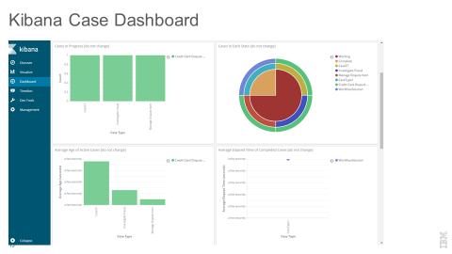

Visualizations of the OOTB Cases dashboard:

1. Cases in progress

This widget displays a bar graph in which each bar shows the number of cases that are in progress for a case type. When you hover over a bar in the graph, a tooltip displays the solution name, the name of the case type, and the number of cases in progress.

1. Cases in each state

This widget displays a pie chart that shows the proportion of cases in each state: Working and Complete. This result is further sorted by Case Type and Solution Name. When you hover over a sector of the pie chart, a tooltip displays the number of cases in that state, the case state, the case type, and the solution name.

1. Average age of in-progress cases

This widget displays a bar graph in which each bar shows the average age of in-progress cases for each case type. The average age is calculated by adding the age for each case and dividing by the number of cases. When you hover over a bar in the graph, a tooltip displays the name of the case type, the solution name, and the average age.

Note   
Due to Kibana constraints, the age of a case in progress is taken as the difference between the time of the last processed event on that case and the start time of that case.

1. Average elapsed time of completed cases

This widget displays a line graph that shows the average elapsed time for each type of the cases that are completed. When you hover over a point in the line, a tooltip displays the solution name, the name of the case type, and the average elapsed time of completed cases.

1. Incoming and outgoing cases in past 3 months

This widget displays a bar graph in which two bars show the number of cases that opened and closed in the past three months for a case type. When you hover over a bar in the graph, a tooltip indicates whether the bar represents incoming or outgoing cases. The tooltip also displays the case type name and the number of incoming or outgoing cases.

1. Total number of cases

This widget displays the total number of cases.

1. Average case duration

This widget displays the average duration of the cases in minutes.

1. Cases started statistics

This widget displays the cases that have been started, based on the selected time frame in Kibana.

1. Cases completed statistics

This widget displays the completed cases, based on the selected time frame in Kibana.

### Workflow – Case Activities Dashboard

Business Automation Insight provides following visualizations, diagrams, tables, etc. to analyse cases activities based on events emitted by the Business Automation Workflow – Case capability.

Open the Case Activities Dashboard to see the visualization while reading about its definition and specification.

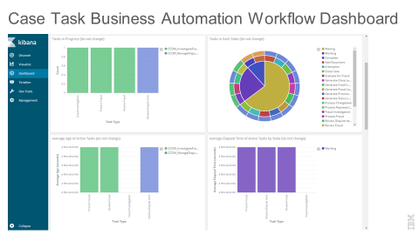

Visualizations of the OOTB Case Activities dashboard:

1. Activities in Progress

This widget displays a bar graph in which each bar shows the number of activities that are in progress for an activity type. When you hover over a bar in the graph, a tooltip displays the case type, the name of the activity type, and the number of activities in progress.

1. Activities in each state

This widget displays a pie chart that shows the proportion of activities in each of the states: Waiting, Ready, Working, Complete, and Failed. When you hover over a sector of the pie, a tooltip displays the number of activities in that state. The tooltip also displays the case type and activity type.

1. Average age of in-progress activities

This widget displays a bar graph in which each bar shows the average age of in-progress activities for an activity type. The average age is calculated by adding the age for each activity and dividing by the number of activities. When you hover over a bar in the graph, a tooltip displays the activity type, the case type, and the average age.

Note   
Due to Kibana constraints, the age of an in-progress activity is taken as the difference between the time of the last processed event on that activity and the start time of that activity.

1. Average elapsed time of in-progress activities by state

This widget displays a bar graph in which each bar shows for an activity type the average elapsed time of in-progress activities in a particular state. When you hover over a bar in the graph, a tooltip displays the name of the activity type, the activity state, and the average elapsed time of that activity type in a particular state.

Note   
Due to Kibana constraints, the elapsed time of an in-progress activity is taken as the difference between the time of the last processed event on that activity and the start time of that activity.

1. Incoming and outgoing activities in past 3 months

This widget displays a bar graph in which two bars show the number of activities that opened and closed in the past three months for an activity type. When you hover over a bar in the graph, a tooltip indicates whether the bar represents incoming or outgoing activities. The tooltip also displays the activity type name and the number of incoming or outgoing activities.

1. Average elapsed time of completed activities

This widget displays a line graph that shows the average elapsed time for each type of the activities that completed. The elapsed time of a completed activity is calculated as the difference between the start time of the activity and end time of the activity. When you hover over a point in the line, a tooltip displays the case type name, the activity type name, and the average elapsed time of completed activities.

1. Total number of activities

This widget displays the total number of case activities.

1. Average activity duration

This widget displays the average duration of the case activities in minutes.

1. Activities started statistics

This widget displays the activities that have been started, based on the selected time frame in Kibana.

1. Activities completed statistics

This widget displays the completed activities, based on the selected time frame in Kibana.

### Workflow - Processes Dashboard

Business Automation Insight provides the following visualizations, diagrams, tables, etc. to analyse processes based on events emitted by the Business Automation Workflow – Business Process Manager capability.

Open the Process Dashboard to see the visualization while reading about its definition and specification.

Ref: [Business Process Dashboards](https://www.ibm.com/support/knowledgecenter/en/SSYHZ8_20.0.x/com.ibm.dba.bai/topics/con_bai_bpmn_dashboards.html)

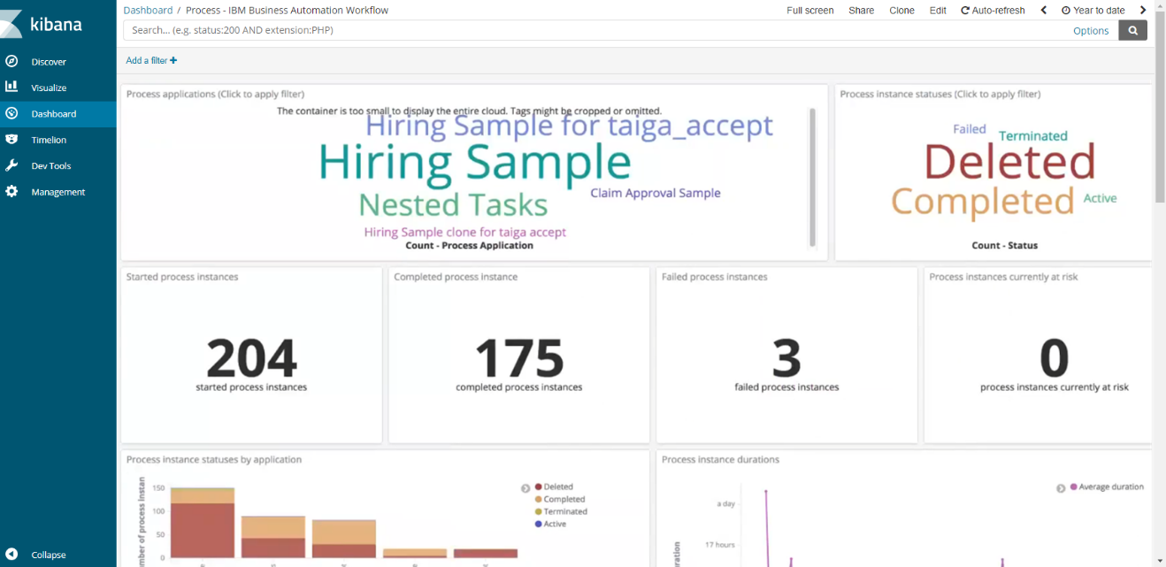

Visualizations of the OOTB Processes dashboard:

1. Process applications

This widget displays a cloud of the process applications names of the BPMN summaries for which the timestamp field is within the Kibana selected time range. Clicking a process application name filters the entire dashboard to show only the data for the selected process application.

1. Process instance statuses

This widget displays a cloud of the process instance statuses of the BPMN summaries for which the timestamp field is within the Kibana selected time range. Clicking a process instance status filters the entire dashboard to show only the data for the selected process instance status.

1. Started process instances

This widget displays the number of process instances for which the startTime field is within the Kibana selected time range.

1. Completed process instances

This widget displays the number of process instances for which the completedTime field is within the Kibana selected time range.

1. Failed process instances

This widget displays the number of process instances for which the failedTime field is within the Kibana selected time range.

1. Process instances currently at risk

This widget displays the number of process instances that are in Active, Suspended, Resumed, or Migrated state and for which the atRiskDateAssignedTime field is set to a date in the past. This widget does not depend on the Kibana selected time range.

1. Process instance statuses by application

This widget displays a bar graph in which each bar corresponds to a process application and the Y-axis is the number of process instances. Each bar is split based on the status of the process instances.

1. Process instance durations

This widget displays a line chart where the X-axis is the start time of process instances and the Y-axis is the average duration of the process instances.

1. Started process instances statistics

This widget is a Timelion graph, which displays a bar chart. The X-Axis shows the startTime field of process instances. The Y-axis shows the number of process instances. Each bar is split based on the process application names.

1. Completed process instances statistics

This widget is a Timelion graph, which displays a bar chart. The X-Axis shows the completedTime field of process instances. The Y-axis shows the number of process instances. Each bar is split based on the process application names.

1. Process instances by IBM Business Automation Workflow system

This widget displays a pie chart that shows how process instances are distributed across the IBM Business Automation Workflow systems that send events to IBM Business Automation Insights.

1. Average process duration by application

This widget is a horizontal bar chart, which displays the average duration (X-Axis) for each process application (Y-Axis). This chart is populated with the process summaries for which the timestamp field is within the Kibana selected time range.

1. Completed, terminated, deleted, suspended and failed process instances

This widget displays a line chart, which shows the timestamp field on the X-Axis and the number of process instances on the Y-Axis. Each line corresponds to one of the following statuses: Completed, Terminated, Deleted, Suspended, or Failed.

### Workflow - Process Tasks Dashboard

Business Automation Insight provides the following visualizations, diagrams, tables, etc. to analyse process tasks based on events emitted by the Business Automation Workflow – Business Process Manager capability.

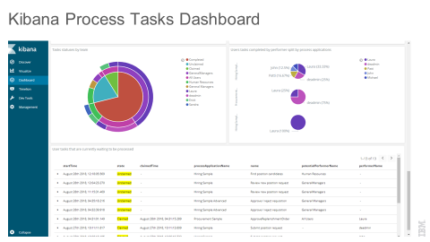

Visualizations of the OOTB Process Tasks dashboard:

1. Process applications

This widget displays a cloud of the process applications names of the BPMN summaries for which the timestamp field is within the Kibana selected time range. Clicking a process application name filters the entire dashboard to show only the data for the selected process application.

1. Task statuses

This widget displays a cloud of the user task statuses of the BPBMN summaries for which the timestamp field is within the Kibana selected time range. Clicking a task status filters the entire dashboard to show only the data for the selected task status.

1. User activities that are currently not completed

This widget displays the number of activities that are in Created, Claimed, Active, or Unclaimed state. This widget does not depend on the Kibana selected time range.

1. User activities that were started in the selected time frame

This widget displays the number of user activities for which the startTime field is within the Kibana selected time range.

1. User activities that were completed in the selected time frame

This widget displays the number of user activities for which the completedTime field is within the Kibana selected time range.

1. User activities completed by team

This widget is a Timelion graph, which displays a bar chart. The X-Axis is the completedTime field of user activities. The Y-axis is the number of user activities. Each bar is split based on the teams that own the activities.

1. User activities started by team

This widget is a Timelion graph, which displays a bar chart. The X-Axis is the startTime field of user activities. The Y-axis is the number of user activities. Each bar is split based on the teams that own the activities.

1. User activities failed by team

This widget is a Timelion graph, which displays a bar chart. The X-Axis is the failedTime field of user activities. The Y-axis is the number of user activities. Each bar is split based on the teams that own the activities.

1. User activities not completed by performer

This widget is a 2-level pie chart that displays, for each performer who owns noncompleted user activities, the name and number of these activities.

1. Task statuses by team

This widget is a 3-level pie chart that displays the number of activities for each existing user task status, split by teams, and then split by individual user.

1. Users activities completed by performer split by process applications

This widget displays a pie chart for each process application name that holds user activities for which the completedTime field is within the Kibana selected time range. For each wedge of the pie chart, you can see who the users are who completed these user activities.

1. User activities that are currently waiting to be processed

This widget displays a Kibana saved search, which lists details about all the activities that are in Created, Claimed, Active, or Unclaimed state.

### Decisions Dashboard

Business Automation Insight provides the following visualizations, diagrams, tables, etc. to analyse decisions based on events emitted by the Operational Decision Manager capability.

Ref: [Decisions Dashboard](https://www.ibm.com/support/knowledgecenter/en/SSYHZ8_20.0.x/com.ibm.dba.bai/topics/con_bai_odm_dashboards.html)

|  |
| --- |
|  |

Visualizations of the OOTB Decisons dashboard:

1. Help

This widget gives a brief description of the dashboard and points you to IBM documentation for more information. To read it, open it up full screen, then minimize it again when you are done.

1. Ruleset selector

From this widget, you filter the rulesets for which you want to see the resulting decisions. From the menu, select the ruleset names, then click outside the menu.

Click Apply changes for the filter to take effect and display the corresponding decisions in the dashboard. To disable the filter, click Clear form or use the Kibana user interface.

1. Service health

This widget displays a pie chart that shows how the decisions are distributed by type of execution results.

The EXECUTION_SUCCESS part counts all the decisions that ran successfully and provided the expected event.  
The TRACE_GENERATION_ERROR part counts the decisions that ran successfully but the associated trace failed to be generated.   
The EXECUTION_FAILURE part counts the decisions that failed to complete.

1. Rate

This widget gives the number of decisions per second. This is an average count which is computed from the selected time range. This widget is correlated to the [Timeline](https://www.ibm.com/support/knowledgecenter/SSYHZ8_18.0.x/com.ibm.dba.bai/topics/con_bai_odm_dashboards.html?view=kc#concept_d33_ntq_tgb__timeline) widget which shows the distribution in time of the same decisions.

1. Count

This widget gives the total number of decisions in the selected time range.

1. Timeline

This widget displays a bar graph in which each bar shows how many decisions per second were taken during the period that is marked by the displayed time stamp. The graph shows a maximum of 10 rulesets. Therefore, it does not reflect the exact detail of the rate number that applies to all rulesets.

When you hover over a bar in the graph, a tooltip displays the number of decisions per second, the ruleset, the time stamp, and the bucket size for the time unit considered. The bucket size represents the number of decisions that were grouped to be represented as the same bar. This size depends on the time range filter level. You can zoom in on a bar by selecting an area around it. The represented period and the time range picker reflect the change accordingly.

1. Ruleset execution duration

This widget displays a bar graph in which each bar shows the average duration of ruleset execution for the period that is marked by the displayed time stamp. It shows a maximum of 10 rulesets. When you hover over a bar in the graph, a tooltip displays the average execution duration, the ruleset, the time stamp, and the bucket size for the time unit considered. This size depends on the zoom level.

Note: this average duration reflects only the execution of the ruleset. It does not include the duration of the event emission process.

1. Tasks table

The table columns reflect the following data.

Tasks The task name, in the following format:   
*RuleflowName*>*TaskName*.

Rulesets The ruleset name, in the following format: *RuleAppName/RuleAppVersion/RulesetName/RulesetVersion*

Executions The number of executions of this task.

1. Rules table

The table columns reflect the following data.

Rules The rule name. For decision tables, the rule name is suffixed with *_rowNumber*.

Rulesets The ruleset name, in the following format: *RuleAppName/RuleAppVersion/RulesetName/RulesetVersion*

Executions The number of executions of this rule.

1. Rulesets table

The table columns reflect the following data.

Rulesets The ruleset name, in the following format: *RuleAppName/RuleAppVersion/RulesetName/RulesetVersion*

Executions The number of executions of this ruleset.

Average execution duration The average duration of ruleset execution, which is computed by dividing the sum of all execution durations by the number of executions.

### Hiring Sample Dashbaord

Refer to [Hiring Sample Dashboard](https://www.ibm.com/support/knowledgecenter/en/SSYHZ8_20.0.x/com.ibm.dba.bai/topics/con_bai_bpmn_hiring_dashboard.html).

The custom dashboard for the Hiring sample shows an example of how to define widgets, such as pie chart, bar chart, and more, to visualize your business data. It provides visualizations based on the execution of the BPMN process and tasks including auto-tracking data.

This dashboard is not subject to the DBA demos labs.

## Understand the available dashboards – Step by Step Instructions

To perform exercises documented in step-by-step instructions on pre-defined dashboards doesn’t make much sense. Instead we want to provide a series of questions for you to validate

1. whether the previously practiced Kibana concepts
2. whether the concepts and charts about Case -, Process - and Decision metrics, histograms, ranges, or end-user performance

are understood. So try to learn about the different kind of charts, representations and purpose for user in the role of a Process Owner.

Some of these questions might be open for interpretation. So make your own decisions if required.

### Questions

* + - 1. Average age of in progress-cases

1. Determine the average age of cases in progress in minutes.

Result: __________

1. Determine the index used for this visualization.  
   Result: __________
2. Update the “duration” used from minutes to human readable form.
3. Update the visualization itself and apply the changes.
4. Determine the value of the average age in human readable form

Result: __________

* + - 1. Determine indexes used

1. Determine the indexes used for following visualizations. Refer to the [KC - Index Patterns](https://www.ibm.com/support/knowledgecenter/en/SSYHZ8_20.0.x/com.ibm.dba.bai/topics/ref_bai_index_patterns.html).
2. Enter your suggestion about the index used
3. Validate your decision by opening/editing the visualization

|  |  |  |
| --- | --- | --- |
| Visualization | Your suggestion | Verification as specified in the visualization |
| Failed process instances |  |  |
| User tasks that were started in the selected time frame |  |  |
| Case in progress |  |  |
| (Case) Activities in each state |  |  |
| Average Activity Duration for Case Activities |  |  |
| Decisions - Rate |  |  |

* + - 1. Total number of Cases

Determine the total number of completed cases from 2020-04-01 till 2020-04-05..

Use the Discover functionality, time picker, correct case-sum… index, and filter criteria.

Result: __________

Compare with the number in Workflow - Cases Dashboard, visualization for completed cases.

Metric: __________

If the numbers are different find out why?  
 Investigation: __________

* + - 1. Number of started Process Instances

Determine the number of started processes from 2020-04-01 till 2020-04-05.

Use the Discover functionality, time picker, correct process-sum..xxxx index, and filter criteria.

Result: __________

Compare with the number in Workflow - Processes Dashboard, visualization for started BPMN Processes.

Metric: __________

If the numbers are different find out why?  
 Investigation: __________

### Answers

See the answers and how to verify them in the associated visualization.

* + - 1. Answer to Average age of in progress-cases

1. Determine the average age of cases in minutes.

Result:   
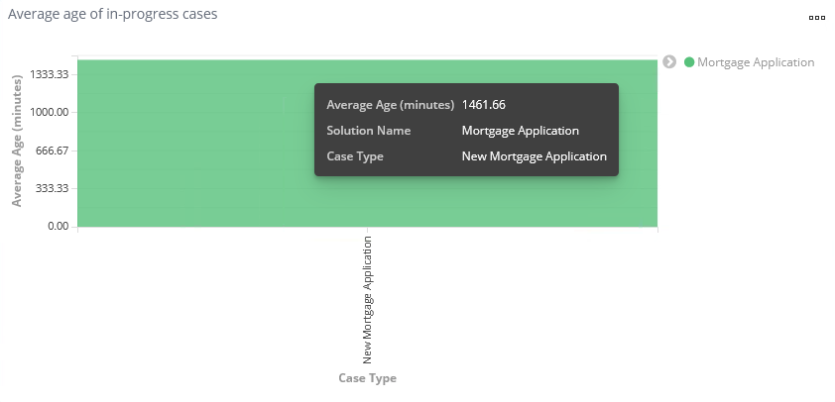

1. Open the visualization Average age of in progress-cases.  
   Determine the index used for this visualization.  
   Result: case-summaries*
2. Determine the specification for the age  
   Result:  
   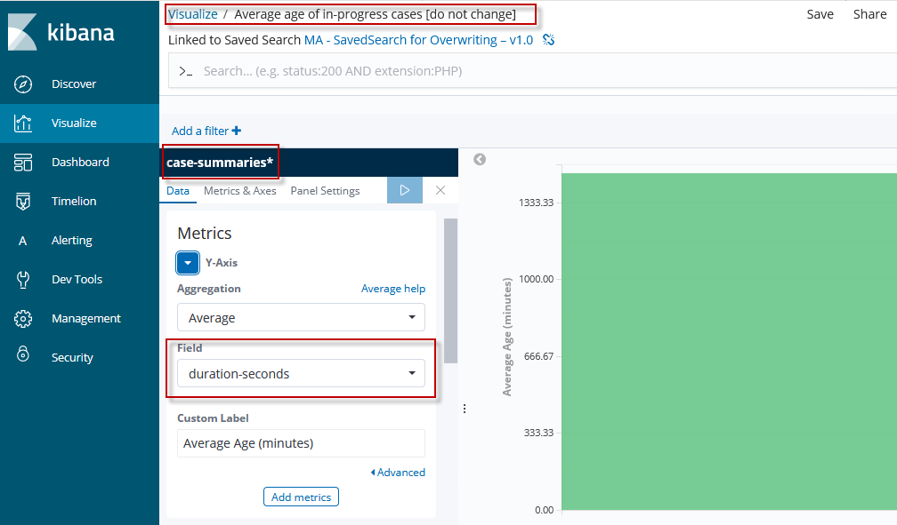  
   while the output format of the duration-seconds is in Minutes.  
   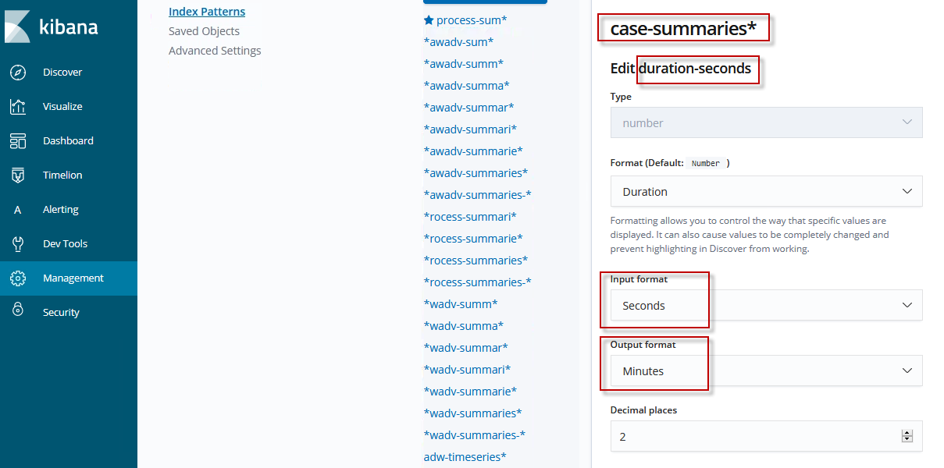
3. Update the duration used from Minutes to Human Readable form.  
   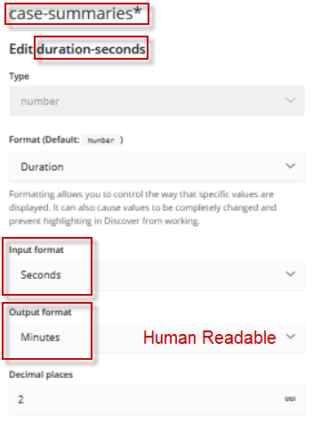  
   Press Save field.
4. Update the label to Average Age (human readable form) and apply the changes.
5. Determine the value of the average age in human readable form

Result:   
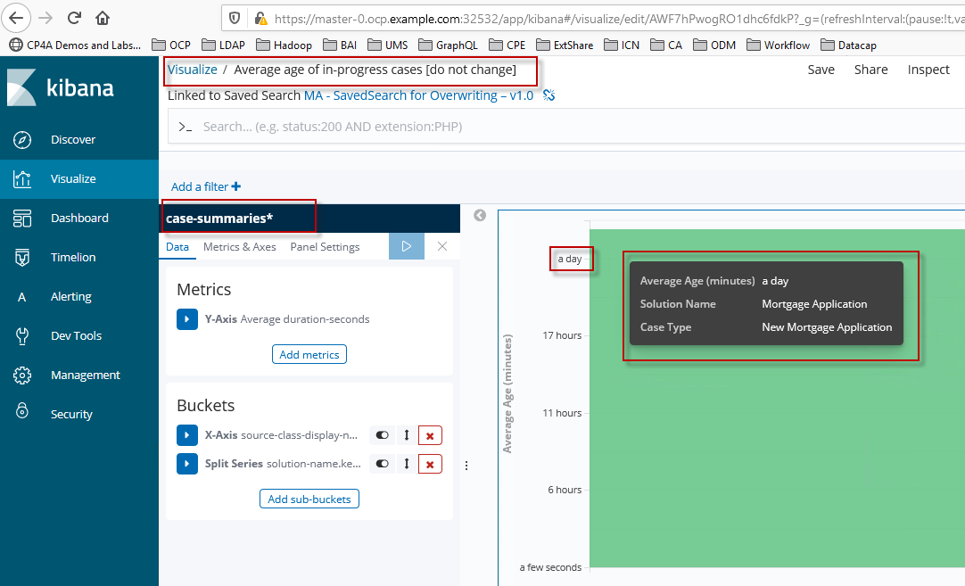  
Note  
To update the format of a duraion to Human Readable is quite import in situations where a long duration is even given in seconds.

* + - 1. Answers to Determine indexes used

1. Determine the index used for following visualizations. Refer to the [KC - Index Patterns](https://www.ibm.com/support/knowledgecenter/en/SSYHZ8_18.0.x/com.ibm.dba.bai/topics/ref_bai_index_patterns.html).
2. Enter your suggestion about the index used
3. Validate your decision by opening/editing the visualization

|  |  |  |
| --- | --- | --- |
| Visualization | Your suggestion | Verification as specified in the visualization |
| Failed process instances | - | *rocess-summaries-* |
| User tasks that were started in the selected time frame | - | process-summaries-* |
| Case in progress | - | case-summaries* in addition with state:working |
| (Case) Activities in each state | - | case-summaries* in addition with state:working |
| Average Activity Duration for Case Activities | - | case-summaries* in addition with type:task |
| Decisions - Rate | - | odm-timeseries* |

* + - 1. Answer to Total number of Cases

Determine the total number of completed cases from 2020-04-01 till 2020-04-05.

Use the Discover functionality

* time picker 2020-04-01 till 2020-04-05 - Refresh  
   during Discover as well as Workflow - Cases   
   Dashboard  
  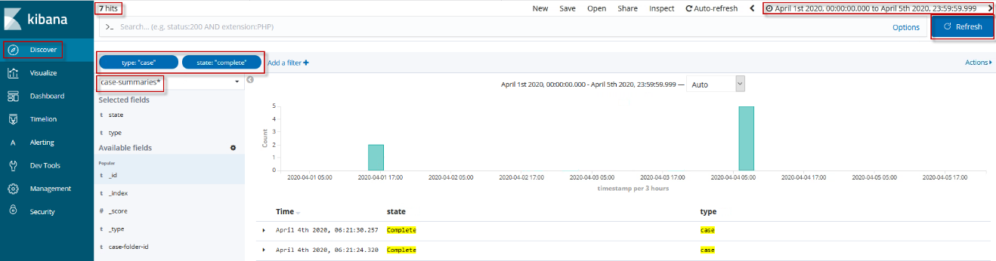
* correct case-sum… index case-summaries*   
   according to [KC - Index Patterns](https://www.ibm.com/support/knowledgecenter/en/SSYHZ8_20.0.x/com.ibm.dba.bai/topics/ref_bai_index_patterns.html)
* filter criteria state:complete type:case

Result: 7

Compare with the number in Workflow - Cases Dashboard, visualization for completed cases.

Metric: 7  
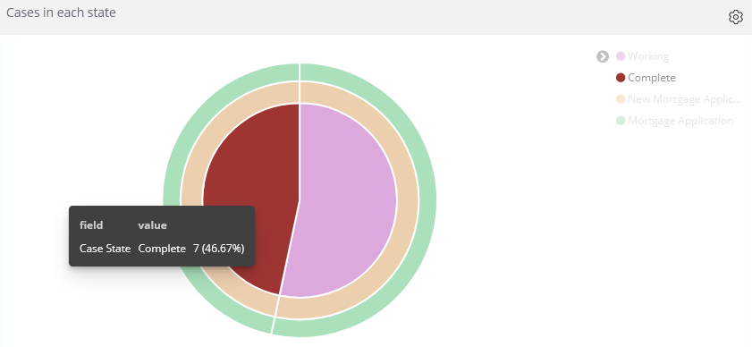

If the numbers are different find out why?  
 Investigation: __________

* + - 1. Answer to Number of started Process Instances

Determine the number of started processes from 2020-04-01 till 2020-04-05.

Use the Discover functionality

* time picker 2020-04-01 till 2020-04-05  
   during Discover as well as Process Dashboard
* correct process-sum… index process-summaries-* startTime  
   according to [KC - Index Patterns](https://www.ibm.com/support/knowledgecenter/en/SSYHZ8_20.0.x/com.ibm.dba.bai/topics/ref_bai_index_patterns.html)
* filter criteria type:process   
   all of them have a start-time and can be in any state

Result: 44  
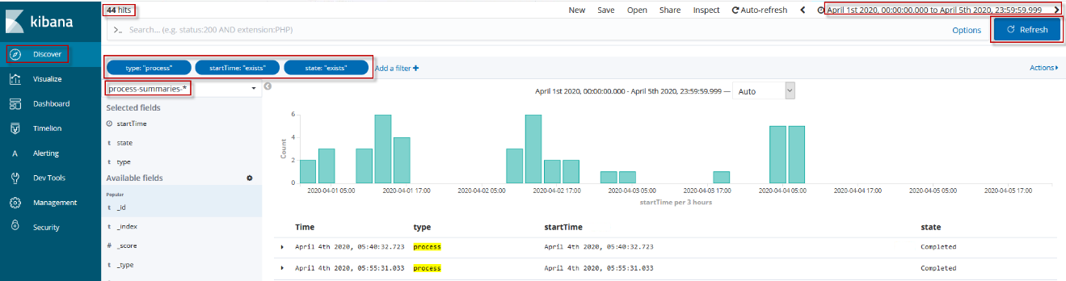

Compare with the number in Process Dashboard, visualization for started BPMN Processes.

Metric: 44  
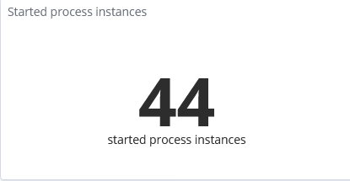

If the numbers are different find out why?  
 Investigation: __________

## Understand the available dashboards – Summary

You should have familiarized by answering the questions with the different kind of charts, representations and purpose for user in the role of a Process Owner.

With that you have successfully finished the implementation of the Exercise 5 of the BAI Lab. Congratulations!

# Exercise: Create new Visualizations specific to the Mortgage Application Solution

## Create new Visualizations and a Dashboard for the Mortgage Application Solution – Introduction

This section addresses the requirements of the Business User about the status and performance of Mortgage Applications.

A Business User is – beyond reports on the number of cases and processes per period and state – interested in business-oriented values, decisions, outcome, or reasons for rejections of mortgage applications. The out-of-the box dashboards can’t provide such application – or industry-related and data specific visualization. Therefore we have to create our custom visualization based on emitted audit – or tracking variable.

During this exercise you develop and configure more sophisticated visualizations. These make use of decisions from the ODM rules or the Mortgage Officer. The charts should enable the Business Owner to make better business decisions, reduce the risk for bad mortgages, or to improve efficiency. The charts transmit outcome on the current status and recent dates. They also show diagrams with the progression and trends of the business based on historical data.

For the development of these more complex charts we don’t want to emphasis on the mechanics of them. We try to follow a design approach or methodology to start with the requirements, i.e. the information needed by the business owner to make their decisions.

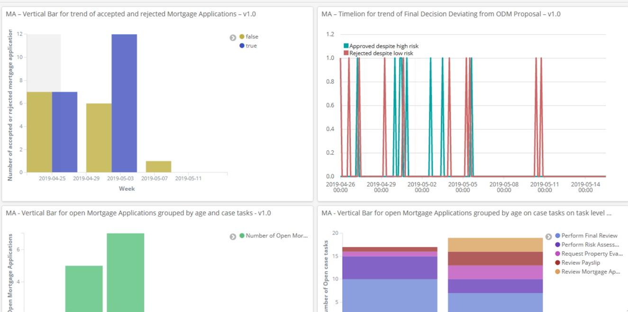

## Create new Visualizations and a Dashboard for the Mortgage Application Solution – Step by Step Instructions

### Open mortgage applications grouped by age

Objective

In the context of the Mortgage Application solution the business owner of the mortgage business needs to understand how long a mortgage application is already being processed (grouped by age ranges) and the activities that are currently worked on by range.

This allows the business owner to see patterns of healthy or unhealthy state of their mortgage business, where a drill down and individual actions might be required to achieve timely completion of mortgage requests.

In this task you will learn how to create a vertical bar chart based on SavedSearch.

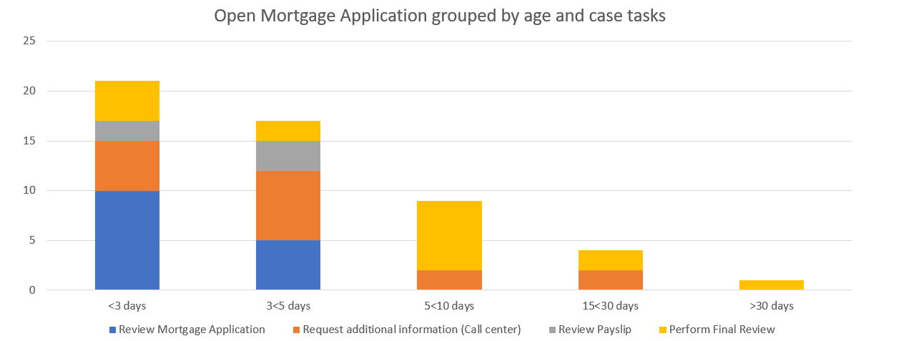

Detailed Requirements

Note

This section summarizes the content of the visualization, points to the chart type required and the buckets to be specified.

The key requirements to implement this visualization are:

1. Consider only “active/working” cases of case type “New Mortgage Application”
2. Group Mortgage Application cases into ranges by age calculated from the start-date
3. It is not necessary to filter according to a time filter, as we consider the complete time period. We are only interested in the age of the cases.
4. For each open Mortgage Application case show the active/working case activities in the respective range as a stacked bar chart

Key Considerations

To build a visualization that represents above business requirement, it is necessary to be able to:

1. Utilize all Case Summary Events independent from the date range selected for the dashboard.
2. Filter and group by data of Case Summary Events (for those cases that are active and to get their start-date to compute their age)
3. Show type and number of their dependent Case Activity Summary Events (those belonging to active cases and that are active themselves)

One aspect to consider is to select an index that is not influenced by the selected date range for the dashboard but that selects all active cases. The reason is that all open Mortgage Applications are to be shown. Otherwise it could happen that some are accidentally not shown as their start date may be outside of the selected time window.

With the current data structure of the summary events for both Cases and Case Activities when filtering an index for active Cases only, associated Case Activities get excluded.

Similarly, when filtering for active Case Activities information about their parent Cases gets excluded.

The same applies to all requirements that need to set Case Activities in relation to Cases or vice versa or where a relationship between Activities and Process Instances is required.

Therefore, the combined requirement can currently not be implemented. Instead it has to be split up into two visualizations to achieve a similar result:

1. Active cases per date range – without case tasks
2. Count of active case activities – using the start-date of the case activity for grouping by age

Building the Visualization – High-Level Instructions

1. Determine the index or saved search to be used:  
   As we look for active cases we need a case index that doesn’t include timestamp (case-su*)
2. Determine and specify the visualization to be used:

a) For the first visualization “Active cases per date range”

Use a vertical bar visualization with an aggregation type of Date Range for the X-Axis based on the start-date for the case

b) For the second visualization “Count of active case activities”

Use a vertical bar visualization with an aggregation type of Date Range for the X-Axis based on the start-date for the case activity

Specify a first bucket splitting the bar based on the variable task-name.keyword with the aggregation type Term.

Building the Visualization – Step-by-Step Instructions

For the first visualization “Active cases per date range”

Creating a Saved Search:

1. In the navigation tree on the left, click Discover
2. Expand the Index-Field and select case-su*. For our purposes, we need to exclude timestamps.



1. Below the Available Fields label, hover over the type field and click the button "add" that appears.

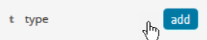

1. Repeat Step 4 with the field state

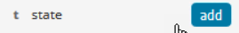

1. In the filter input field. Enter the following expression and click the search button:

type:case NOT state:complete NOT state:Failed

Because only open mortgage application cases are looked at, we limit the selection to type:case and exclude the completed and failed mortgage application casess.

1. Click on the Update button to populate your visualization.  
   In the picture below, you can see the results of your filter options and the previously selected fields type and state with their values.
2. To save your newly created Saved Search click Save in the toolbar at the top of the window.

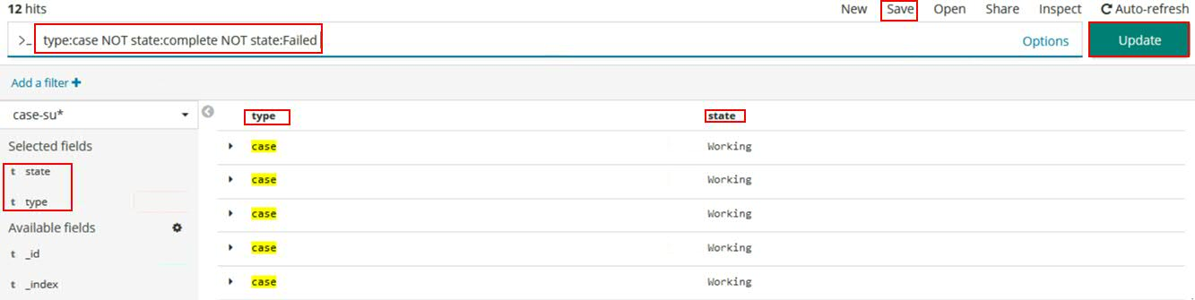

1. In the pop-up dialog enter a name for your Saved Search. For the Saved Search to be be found quickly, please use the following naming convention.

<Initials of the student > - MA - SavedSearch for Open mortgage applications grouped by age– v1.0

Then click Confirm Save.

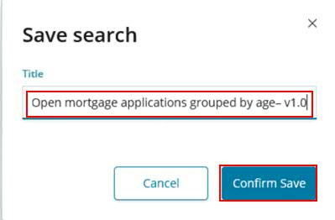

Creating the Visualization based on the Save Search

1. In the navigation tree on the left side, click Visualize.
2. Click the “+”-Button.
3. In the “Select visualisation type”-window, choose the Vertical Bar widget.
4. Enter the previously given name for the Saved Seach and press Enter (It is also possible to enter only a few words (keywords). Suggestions are generated immediately). Your saved Saved Search will be found in the search results. Click on this Saved Search.

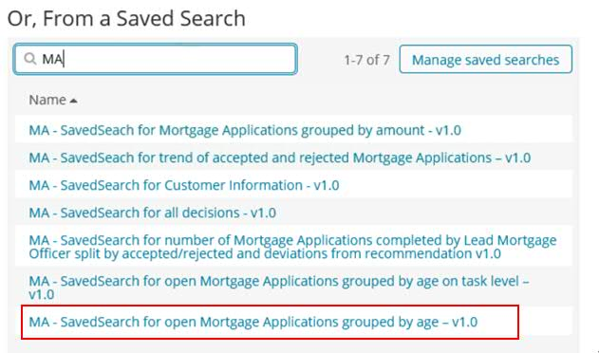

For the Y-Axis perform the following steps:

1. Expand the Y-Axis
2. As Custom Label, enter the following name: Number of Open Mortgage Applications
3. Click the “Apply Changes” button which is symbolized as a “Play” button at the top. The diagram is refreshed.

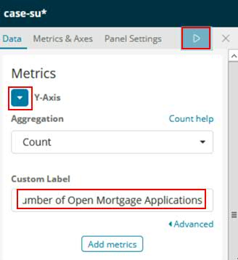

For the X-Axis perform the following steps:

1. Click on X-Axis under Select buckets type.
2. Select Date Range in the Aggregation field.
3. Select start-time in the dropdown labeled Field.
4. Add the ranges as shown in the picture below like from: now-3d/d to: now
5. Click the “Apply Changes” button which is symbolized as a “Play” button at the top. The diagram is refreshed.

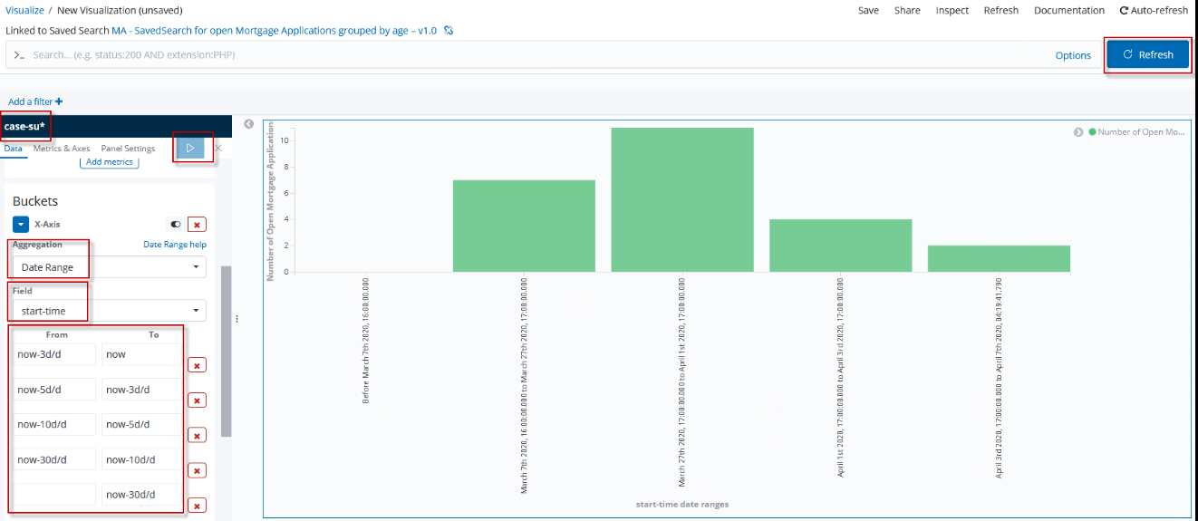

To ensure a more legible and business user-friendly presentation, modify the diagram:

1. Select the Metric & Axes tab
2. Expand Show/Hide Advanced Options section
3. Select angled in the Rotate choice list
4. Enter 10 into the Truncate input field
5. Click the “Apply Changes” button which is symbolized as a “Play” button at the top. The diagram is refreshed.

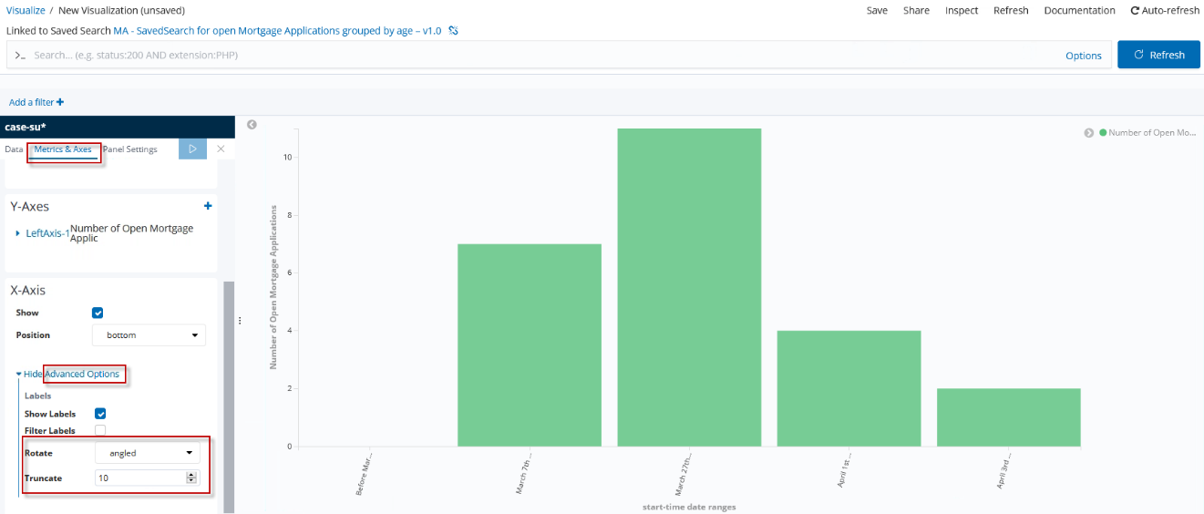

1. If you are satisfied with your visualization and it looks similar to the picture above, you can click Save.

In the pop-up dialog enter the following name for the visualization with your initials:

<Initials of the student > - MA- Vertical Bar for Open Mortgage Applications grouped by age and case tasks - v1.0

Click Confirm Save

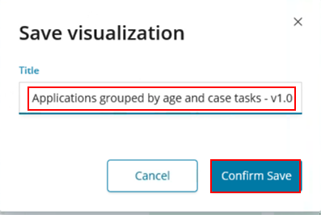

For the second case “Count of active case activities”

Creating a Saved Search:

1. In the navigation tree on the left side, press Discover
2. Expand the Index-Field and select case-su*.



1. Below the Available Fields label, hover over the type field. A button "add" appears. Click this button.



1. Repeat Step 4 with field state



1. In the filter input field. Enter the following expression and click the search button:

type:task NOT state:complete NOT state:Failed

Because the tasks of open mortgage applications are sought, we exclude the completed and failed mortgage applications and filter only for type task.

Then click on the search button. In the picture below, you can see the results of your filter options. You also can see the previously selected fields type and state with its values.

1. In the top of the right side. Click Save.

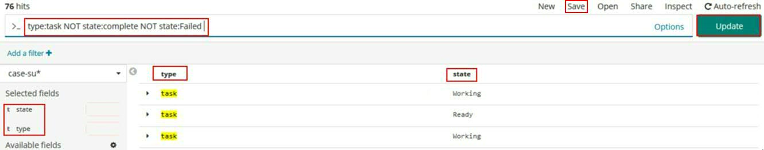

1. The input area pops up. Enter a name for your SavedSearch. That the SavedSearch can be found quickly, it is a useful to follow a naming convention..

Use the following name with your initials:

<Initials of the student > - MA - Vertical Bar for open Mortgage Applications grouped by age on case tasks on task level - v1.0

Then press Confirm Save.

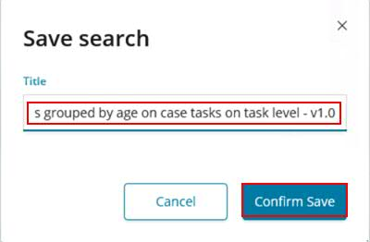

Creating the Visualization based on the Saved Search

1. In the navigation tree on the left side, click Visualize.
2. Click the “+”-Button.
3. In the Select visualisation type window, choose the Vertical Bar widget.
4. Enter the previously given name for the SavedSeach and press Enter (It is also possible to enter only a few words (keywords). Suggestions are generated immediately). Your saved SavedSearch will be found in the search results. Click on this SavedSearch.

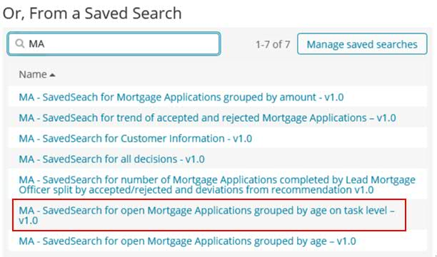

1. Expand the Y-Axis
2. As Custom Label, enter the following name: Number of Open Mortgage Applications
3. Click the “Apply Changes” button which is symbolized as a “Play” button at the top. The diagram is refreshed.

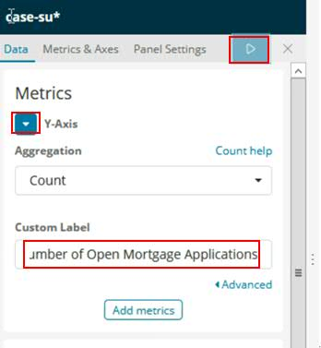

1. Click on X-Axis under Select buckets type.
2. Select Date Range in the aggregation field.
3. Select start-time in the Field field.
4. Add the following ranges as shown in the picture below
5. Click the “Apply Changes” button which is symbolized as a “Play” button at the top. The diagram is refreshed.

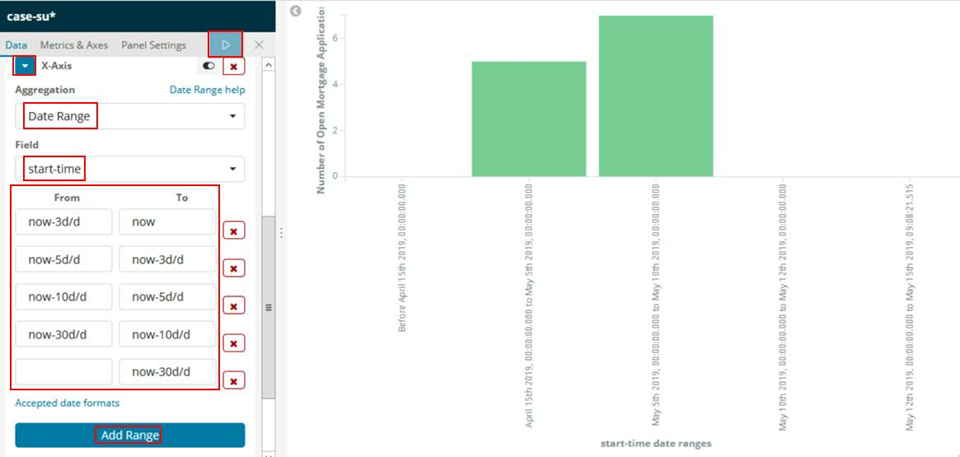

1. Click on the Add sub-buckets Label

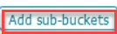

1. Select Split Series.
2. In the Sub Aggregation field, select Terms.
3. In the Field field, select the property task-name.keyword.

Now the diagram will be split according to the string values of the term task-name-keyword.

1. Click the “Apply Changes” button which is symbolized as a “Play” button at the top. The diagram is refreshed.

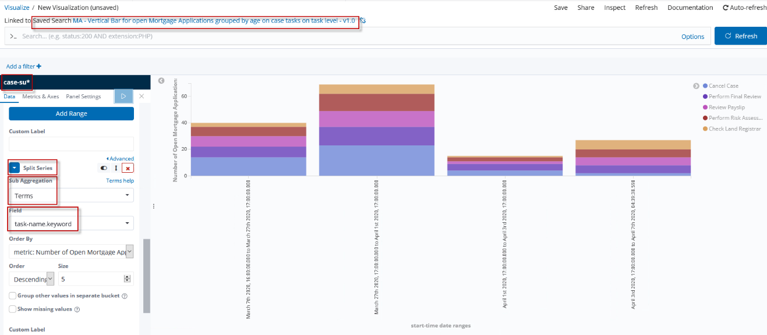

To ensure a more legible and user-friendly presentation, modify as indicated below:

1. Select the Metric & Axes tab
2. Expand Show/Hide Advanced Options under X-Axis
3. Select angled in the Rotate choice list
4. Enter 10 into the Truncate input field
5. Click the “Apply Changes” button which is symbolized as a “Play” button at the top. The diagram is refreshed.

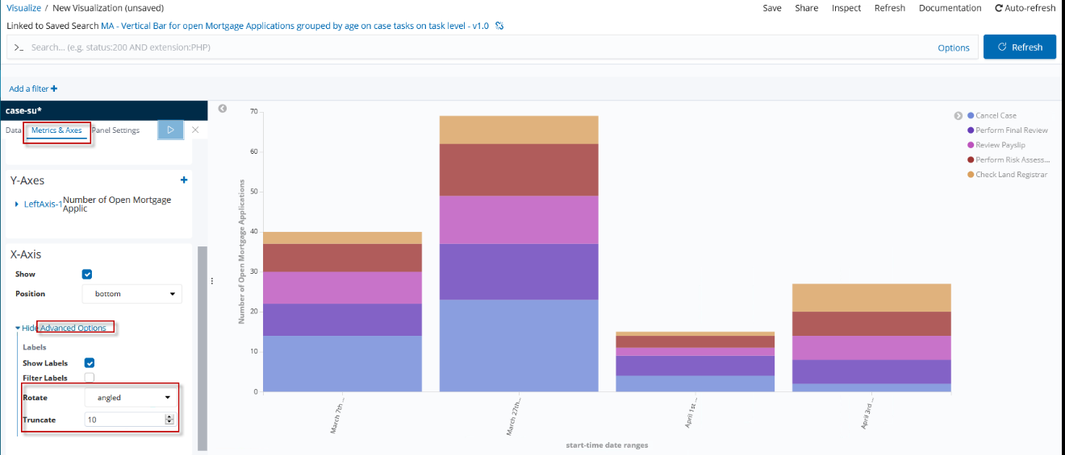

1. If you are satisfied with your visualization and it looks similar to the picture, then you can click the Save button.

When the input area pops up, enter the followiung name with your initials:

<Initials of the student > - MA - Vertical Bar for Open Mortgage Applications grouped by age on task level - v1.0

Click Confirm Save

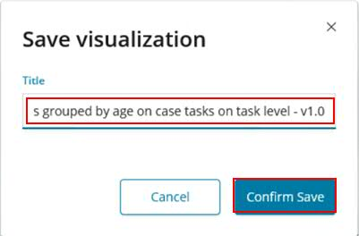

Summary

Modelling is possible for either cases grouped by age or only or case-tasks grouped by age. Both isn’t possible yet. With a merge-index function like the join in sql it would be easy to resolve the issue. Actually, we try to fix this.

### Trend of accepted vs. rejected mortgage applications

Objective

Comparison between trends of accepted and rejected mortgage applications over time. Business users can recognize deviations from this visualization and react if necessary. In this task you will learn how to create a vertical bar chart.

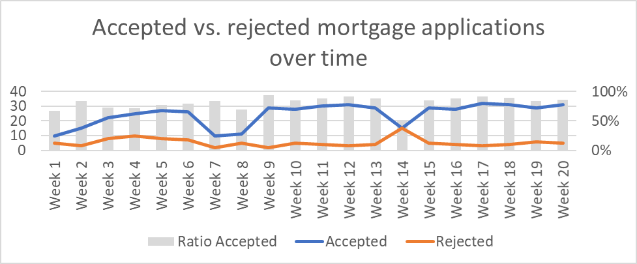

Detailed Requirements

Note

This section summarizes the content of the visualization, points to the chart type required and the buckets to be specified.

The key requirements to implement this visualization are:

1. Interest only in property “data.MA_IsMortgageApproved” of “complete” cases of case type New Mortgage Application
2. The mortgage applications are summarized on a weekly basis.
3. Separated or stacked by the value of the boolean property “data.MA_IsMortgageApproved”

Key Considerations

There are some limitations regarding the ratio. Only for numeric properties it’s possible to compute and display the ratio. We use a boolean property, so we can’t display the ratio.

The same problem exists when displaying the right y-axis in percent.   
The index you use includes all completed cases. So, we use case-summaries-*.  
  
Building the Visualization – High-Level Instructions

1. Determine the index or saved search:  
   As we look for completed case we need a case index that includes timefield end-time with covering the case state “completed”:  
   (case-summaries-*)
2. Determine and specify the visualization required or recommended  
   Use a vertical bar visualization with an aggregation type of Date Histogram for the X-Axis based on the end-time for the case and select weekly under the interval tab.

Specify a first bucket splitting the bar based on the variable data.MA_IsMortgageApproved with the aggregation type Term.

Building the Visualization – Step-by-Step Instructions

1. In the navigation tree on the left side, click Visualize.
2. Click the “+”-button.
3. In the Select visualisation type window, choose the Vertical Bar widget.
4. Select index case-summaries-* which includes the end-time from the left choice list.

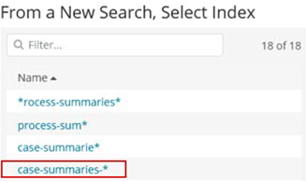

1. Expand the Y-Axis.
2. As Custom Label, enter the following name: Number of accepted or rejected applications.
3. Click the “Apply Changes” button which is symbolized as a “Play” button at the top. The diagram is refreshed.

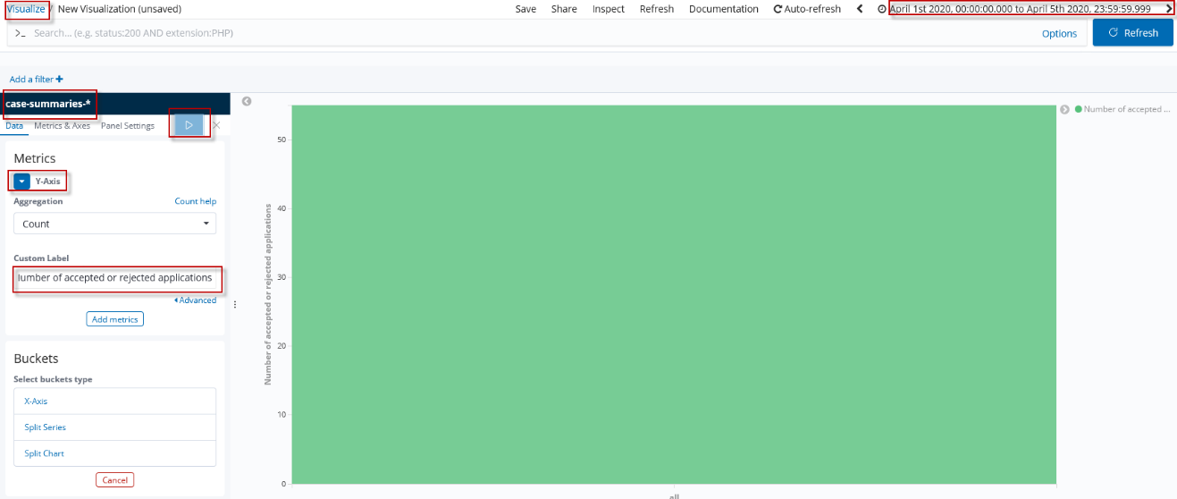

1. Click on X-Axis under Select buckets type.
2. Select Date Histogram in the aggregation field.
3. Select end-time in the Field field.
4. In the Interval choice list, select Weekly.
5. Click the “Apply Changes” button which is symbolized as a “Play” button at the top. The diagram is refreshed.

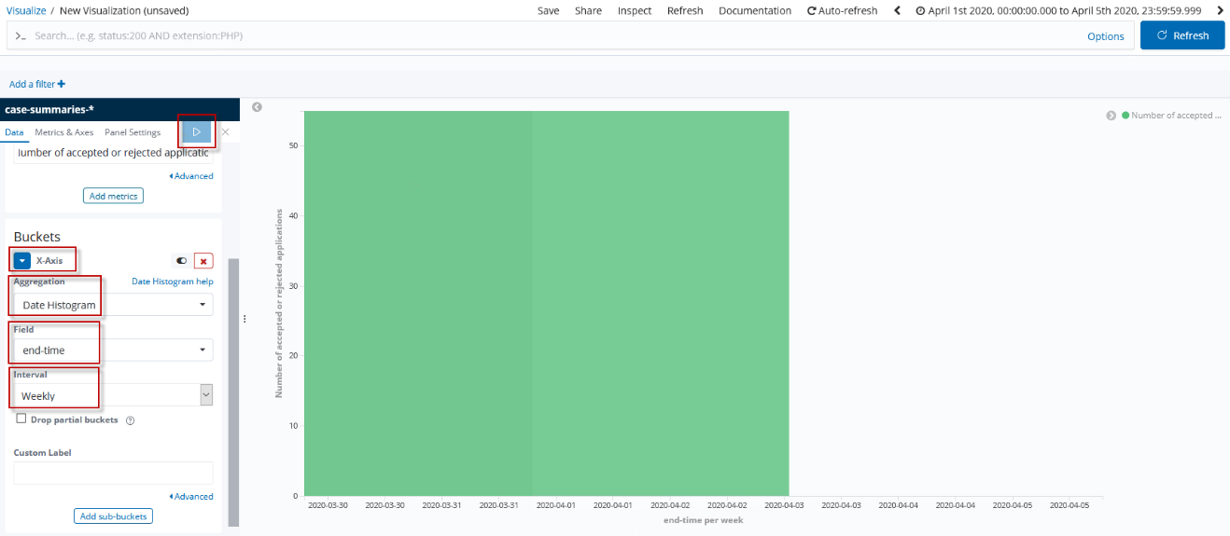

1. Select Split Series

.

1. In the Sub Aggregation field, select Terms.
2. In the Field field, select the property data.MA_IsMortgageApproved.

Now the diagram will be split according to the boolean values of the term data.MA_IsMortgageApproved.

1. Click the “Apply Changes” button which is symbolized as a “Play” button at the top. The diagram is refreshed.

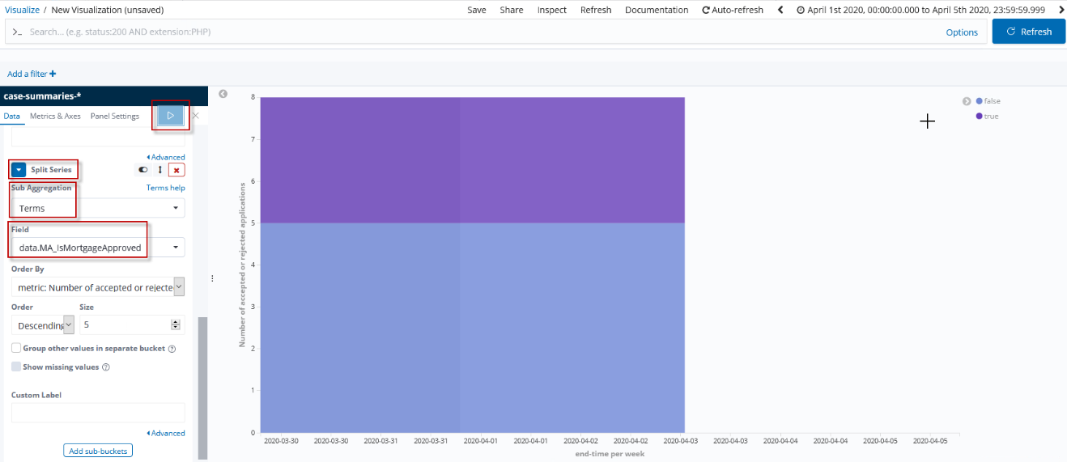

1. In the navigation tree, click Metrics & Axes.
2. Expand the Mode label and set it to normal. Now the splits are no longer stacked. The two bars are easier to read next to each other.
3. Click the “Apply Changes” button which is symbolized as a “Play” button at the top. The diagram is refreshed.

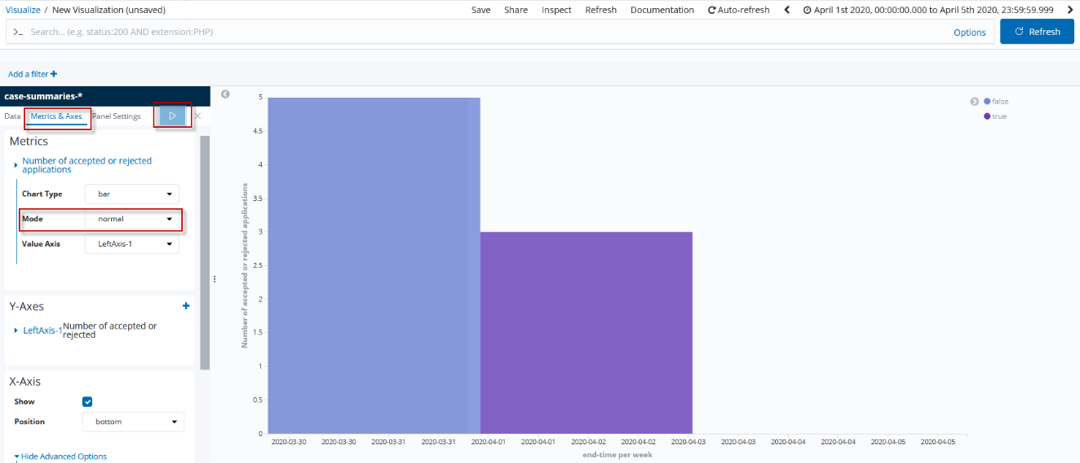

1. If you are satisfied with your visualization and it looks similar to the picture, then you can click the Save button.

If the input area pops up, enter the following name with your initials:

<Initials of the student > - MA – Vertical Bar for trend of accepted and rejected Mortgage Applications – v1.0

Click Confirm Save

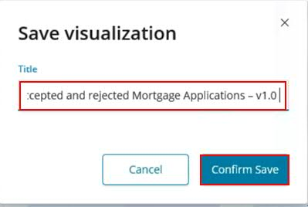

Summary

Modelling is possible, but you have some limitations regarding the fine-tuning for the visualization. It’s not possible to display the percentage on the right x-axis or to show the ration in the chart.

### Trend of Final Decision Deviating from ODM Proposal

Objective

Comparison between the final decision from the mortgage officer to the proposed decision from the risk management system. In detail, the widget shows the overruled decisions by the mortgage officer:

* approved by ODM and rejected by Mortgage Officer
* rejected by ODM but overruled and approved by Mortgage Officer

In this section you will learn how to use a timelion visualization.



Detailed Requirements

Note

This section summarizes the content of the visualization, points to the chart type required and the buckets to be specified.

The key requirements to implement this visualization are:

1. Interest in the combination of the boolean variables data.MA_RiskAssessmentDecision and data.MA_IsMortgageApproved
2. Also interest only in “completed” cases of case type New Mortgage Application (case-summaries-*)
3. The mortgage applications are summarized on a weekly basis.
4. Separated or stacked by the combination of the values data.MA_RiskAssessmentDecision:true AND data.MA_IsMortgageApproved:false OR data.MA_RiskAssessmentDecision:false AND data.MA_IsMortgageApproved:true (Both possibilities for overruling are covered)

Key Considerations

In the vertical bar option settings, you only have one opportunity to select the sub-bucket “split series”. For this visualization you need two sub-buckets of type split series. In the first case you must filter for “data.MA_RiskAssessmentDecision:true AND data.MA_IsMortgageApproved:false” and in the second case for “data.MA_RiskAssessmentDecision:false AND data.MA_IsMortgageApproved:true”. Both in one filter query isn’t possible because in this case you will have only one line in the chart.

(You can solve the problem with split chart but then you will have two charts)

Therefore we are using a Timelion Expression. In a Timelion expression there are also some limitations regarding the split-option, but a workaround with a second .es() is possible. Why is the split-option not working? Because this option only splits the series for one property. We are using a combination of properties.

Building the Visualization – High-Level Instructions

Determine and specify the visualization required or recommended

1. Use a timelion visualization
2. As we look for completed case we need a case index that includes timefield end-time with covering the case state completed. (case-summaries-*)
3. We could use “timestamp” for the timefield (represented in the x-axis).
4. Filter in query option for approved by ODM and rejected by the Mortgage Officer
5. Repeat Step 2-4 with a new .es()-query and filter option: rejected by ODM and approved by Mortgage Officer

Building the Visualization – Step-by-Step Instructions

1. In the navigation tree on the left side, click Visualize.
2. Click the “+”-button.
3. In the select visualization type window, select Timelion.
4. In the timelion.expression text-field, enter the following expression:

.es(timefield='timestamp')

1. Click the “Apply Changes” button which is symbolized as a “Play” button at the top. The diagram is refreshed.

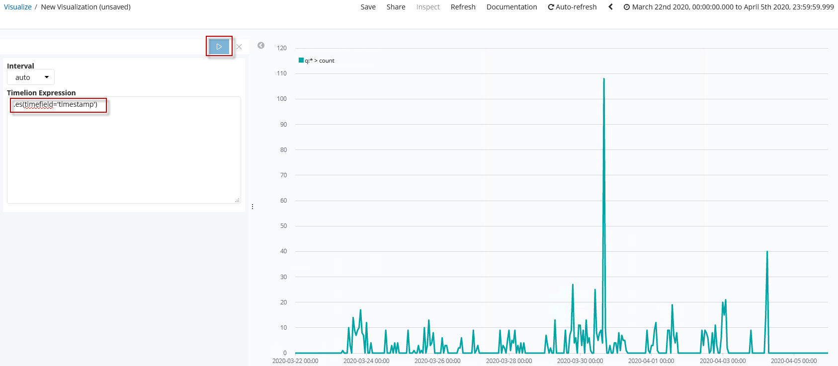

1. Add the following expression to your timelion expression in the text-field after ‘timestamp’: and prior to “)”.

,index='case-summaries-*'

1. Press Play in the upper right corner

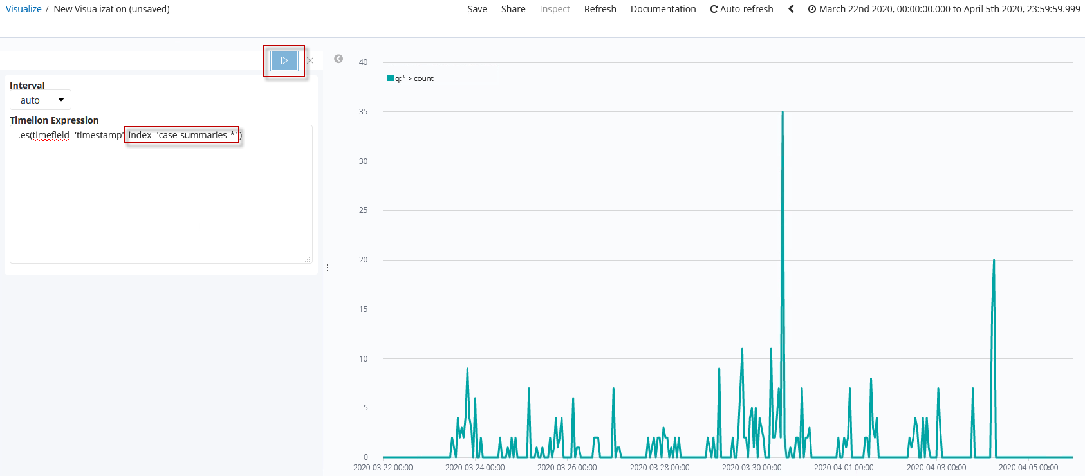

1. Add the following query-expression to your timelion expression:

,q="data.MA_RiskAssessmentDecision:false AND data.MA_IsMortgageApproved:true"

1. Click the “Apply Changes” button which is symbolized as a “Play” button at the top. The diagram is refreshed.

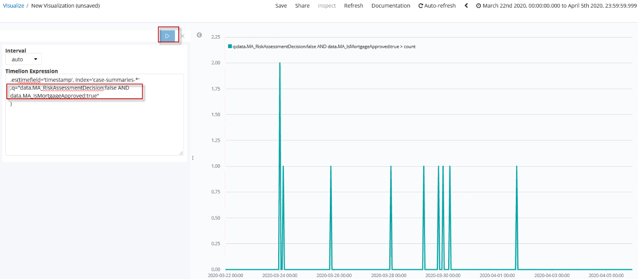

1. We have now developed the first curve for the graph. The first curve represents the accepted mortgage applications although it was recommended by the ODM system to reject the mortgage application.

Now a curve has to be added for the reverse case. The proposal from the ODM system was an approval, but the final decision to approve the mortgage application was rejected.

In this case only the values of the properties have to be changed from false to true or from true to false.

Therefore, we can copy the current expression and append it to the expression.

After that only the boolean values have to be exchanged.

1. Or you add the following expression in the timelion expression text-field:

, .es(timefield= 'timestamp',index='case-summaries-*',q="data.MA_RiskAssessmentDecision:true AND data.MA_IsMortgageApproved:false " )

1. Click the “Apply Changes” button which is symbolized as a “Play” button at the top. The diagram is refreshed.

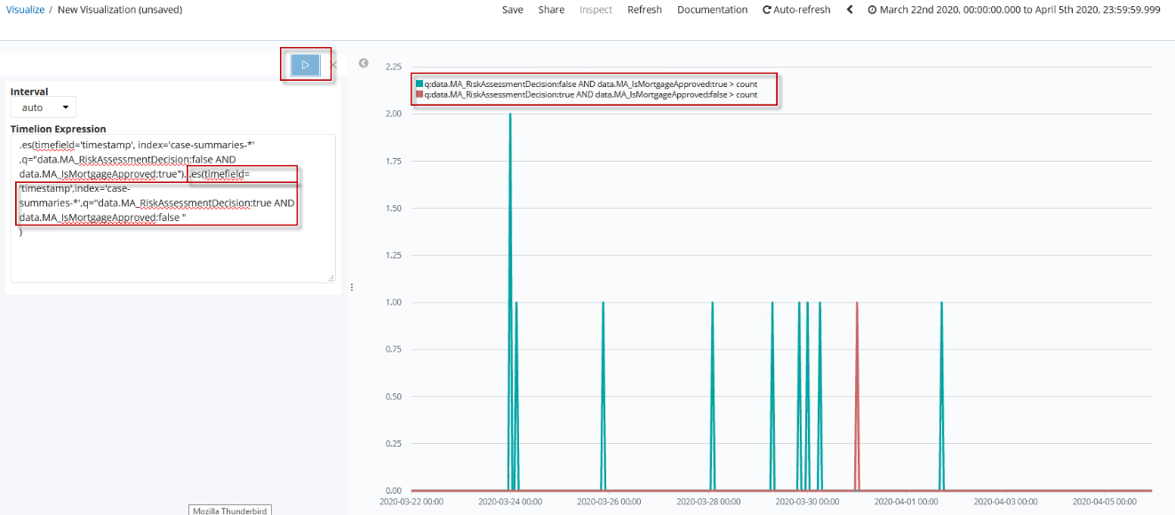

1. To make sure everyone understands what the curves mean, we update the legend.

For each .es() function we add a .label() with the name of the legend after the parenthesis of the .es() function.

Add the following expressions after the parenthesis of the .es() functions:

a) .label("Approved despite high risk")

b) .label("Rejected despite low risk")

1. Click the “Apply Changes” button which is symbolized as a “Play” button at the top. The diagram is refreshed.

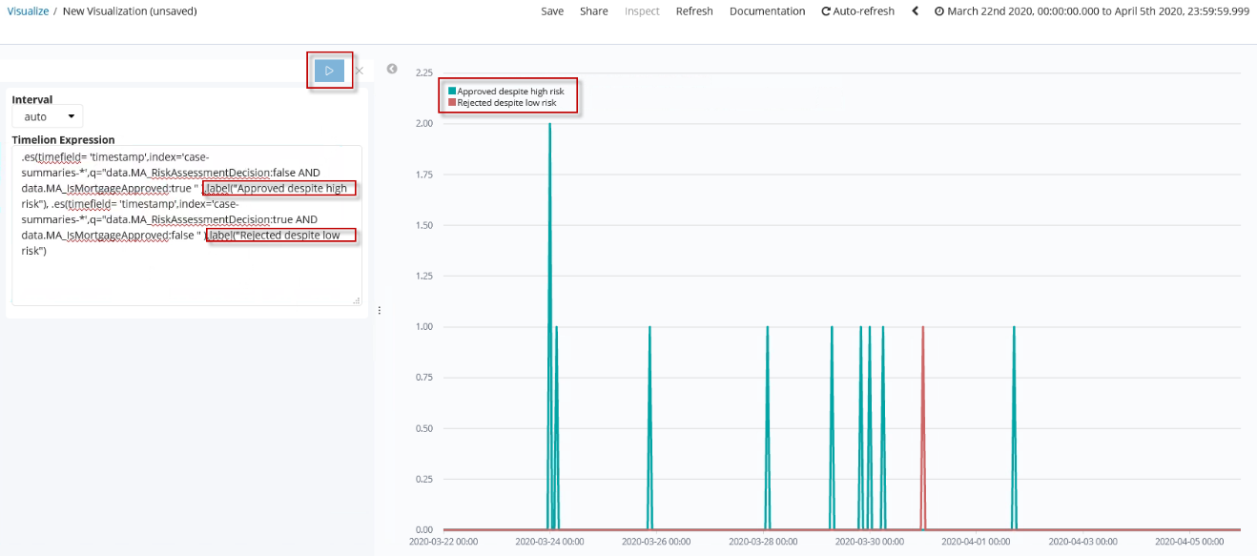

1. For verification the whole timelion expression is shown below:

.es(timefield='timestamp' , index='case-summaries-*' ,q="data.MA_RiskAssessmentDecision:false AND data.MA_IsMortgageApproved:true" ).label("Approved despite high risk"), .es(timefield= 'timestamp',index='case-summaries-*',q="data.MA_RiskAssessmentDecision:true AND data.MA_IsMortgageApproved:false " ).label("Rejected despite low risk")

1. If you are satisfied with your visualization and it looks similar to the picture, then you can click the Save button.

If the input area pops up, enter the followiung name with your initials:

<Initials of the student > - MA – Timelion for trend of Final Decision Deviating from ODM Proposal – v1.0

Click Confirm Save.

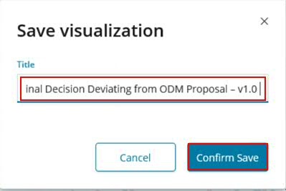

Summary

Modelling is possible. You may have problems with the vertical bar widget or with the split option in timelion expression but you can fix the issue by using a second .es()-query. Timelion expression is much more powerful than other widgets, because you can react flexibly and individually to diagrams. However, the error rate is much higher due to syntax errors. Using Good Practices or experience help to avoid these problems.

### Avg of Durations for a Mortgage Application to complete separated by rejected/accepted

Objective

Total -, wait - and working time of mortgage applications separated by accepted or rejected and compared to each other in one visualization. In this task you will learn how to create Scripted Fields and learn how to use them in a vertical bar visualization.

Note

This requires precise definitions about these individual times on process/case - and activity/tasks level considering the life cycle of these – refer to state transition diagrams.

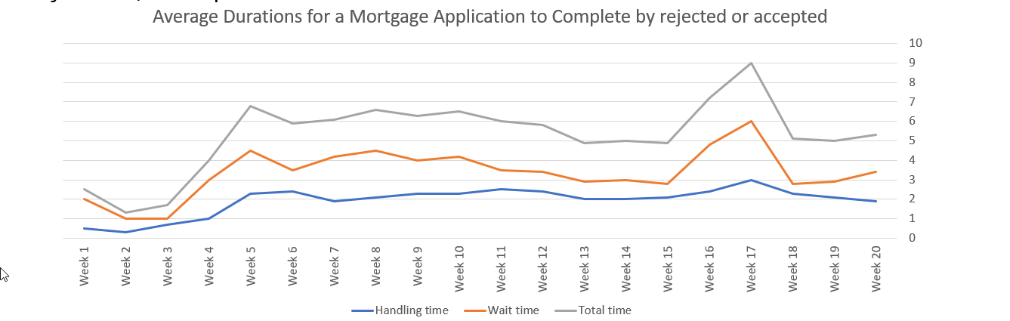

Note  
In the current release BAI includes a duration for processes and activities. However, when you want to further investigate times spend for human tasks you need to compute this on your own based on the knowledge of the possible states and state changes of human tasks and their time stamps. The slide beneath illustrates this.

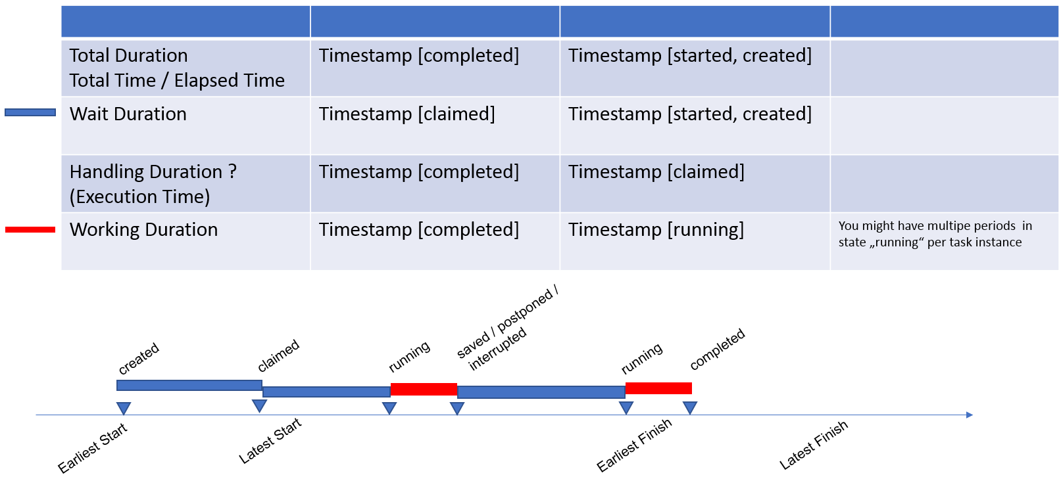

Detailed Requirements

Note

This section summarizes the content of the visualization, points to the chart type required and the buckets to be specified.

The key requirements to implement this visualization are

1. Interest in completed mortgage applications of case type New Mortgage Application

(case-summaries-*)

1. Split series by total time, wait time and working time for accepted or rejected mortgage applications
2. Wait time: time between states created and claimed
3. Working time: time between states claimed and completed
4. The mortgage applications are summarized on a weekly basis.

Key Considerations

BAI currently has a few limitations regarding durations. It provides overall durations, while wait time and working time are not included in the existing indexes. There is the possibility to compute these durations via Scripted Fields together timestamps for state changes.

For human activities three timestamps are required: startTime, claimedTime and completedTime. This allows to calculate the workingTime and waitTime for activities. On process level we can only display the total / elapsed duration.

A further restriction is to aggregate and to calculate these activity durations per process instance as well as to determine min, max and average values on a process template level.

Therefore we decided to specify the total duration on process level, separated by the attribute IsMortgageApproved {true, false}, to specified in Vertical Bar for Average Duration for Mortgage Application to complete by approved/rejected.

In this section we focus and practice how to create a vertical bar chart on activity level with total -, wait- and working time for the BPMN task “Perform Final Review”.

A second requirement is to separate on approved or rejected mortgages, e.g. to determine the “wasted” time. This would result in six lines/bars in a single visualization. In order to improve the readability of the chart we decided to develop two widget. Actually to copy the first one and adopt the filter criteria.

Building the Visualization – High-Level Instructions

1. Create two Scripted Fields (waitTime and workTime)
2. Use a vertical bar visualization
3. Determine the index:  
   As we look for the activity “Perform Final Review” we need a process index that includes timefield end-time with covering the task state “completed”:  
   (process-summaries*)
4. Add two Y-axis with aggregation field average
5. Select for each Y-Axis workingTime and waitTime
6. We could use “startTime” for the timefield (represented in the X-Axis).
7. Filter in query option for   
   type:userTask AND name:'Perform Final Review' AND data.TG_MA.finalReview.string:true

Building the Visualization – Step-by-Step Instructions

Creating Scripted Fields

Note

As we have imported all indexes in section Import Index Patterns the scripted fields for working- and waitTimes are already specified in the process-summaries* index. Therefore you can continue with Creating the_visualization.

1. In the navigation tree on the left side, click Management.
2. Select Index Patterns

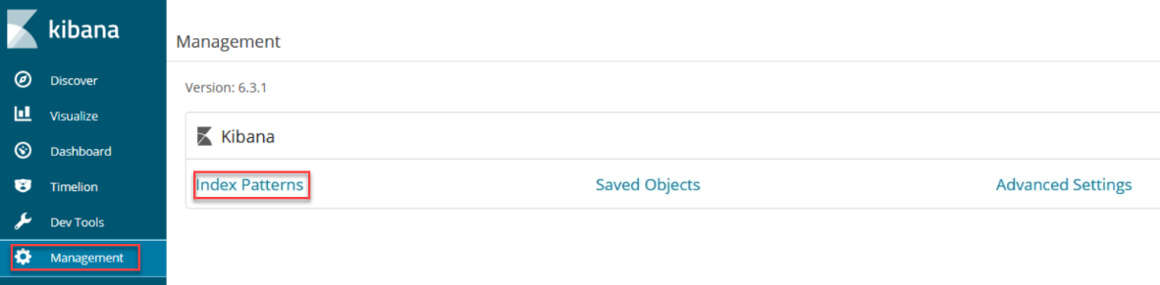

1. Select index process-summaries*
2. Click on tab Scripted fields
3. Click button Add scripted field

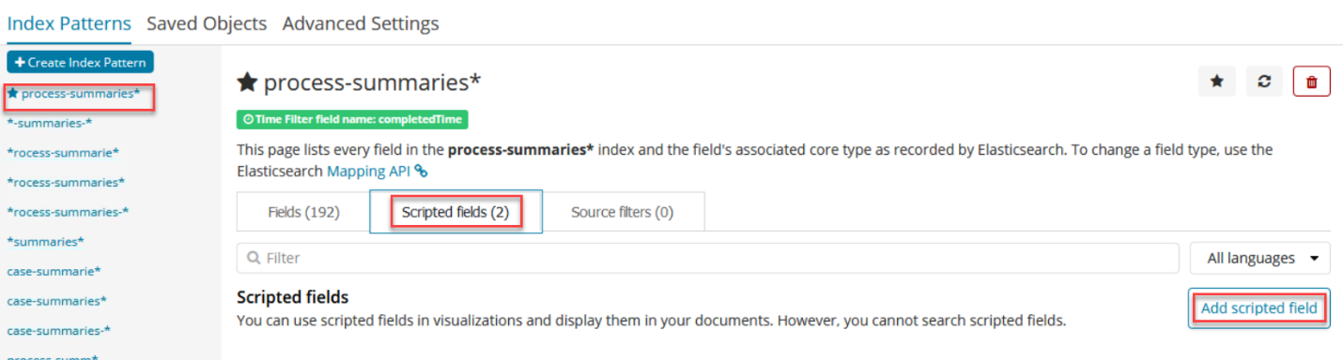

1. Name : waitTime. (It’s important tu use exactly this name)
2. Language: painless
3. Type: number
4. Format: Duration
5. Input Format: Milliseconds
6. Output Format: Human Readable
7. Script:   
   if (!doc['claimedTime'].empty && !doc['startTime'].empty){

return doc['claimedTime'].date.millis - doc['startTime'].date.millis}

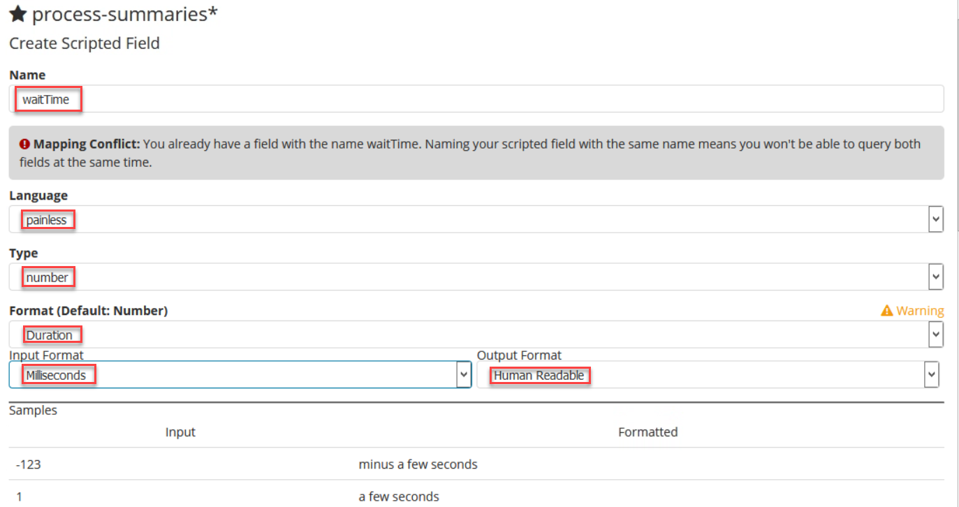

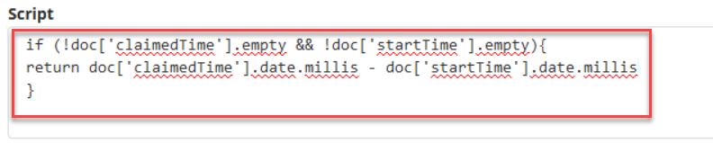

1. Create Scripted Field by clicking on the Create Field button below.

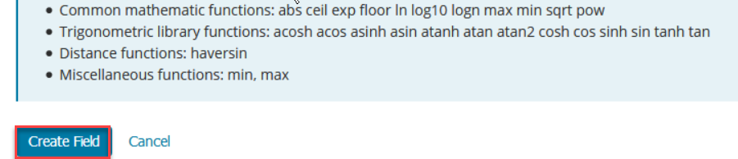

1. Repeat Step 6-14 with following changes:

* Name: workingTime
* Script:

if (!doc['claimedTime'].empty && !doc['completedTime'].empty){ return doc['completedTime'].date.millis -doc['claimedTime'].date.millis }

In the navigation tree click Discover and verify if the scripted fields have been added:

1. Select index process-summaries*
2. Add waitTime and workingTime among Selected Fields

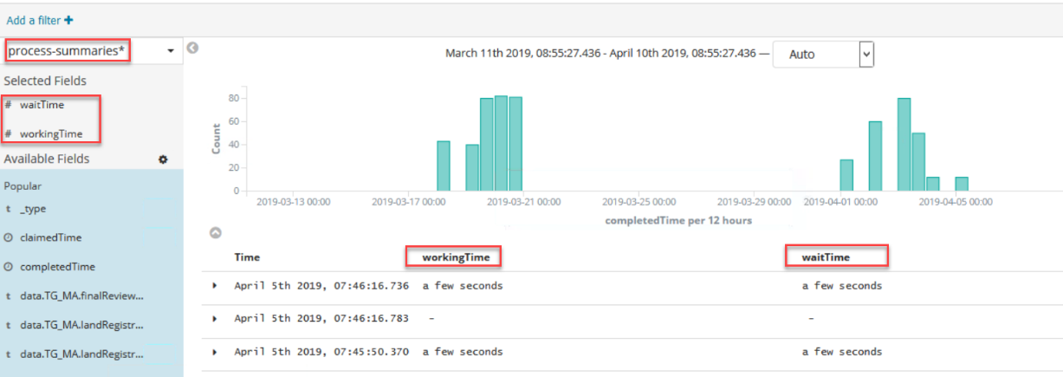

Creating the visualization

1. Click Visualize in the navigation tree.
2. Click the “+”-button.
3. In the selct visualization type window, select vertical bar
4. An index must be added so that the end time is present in the results.Therefore select process-summaries*

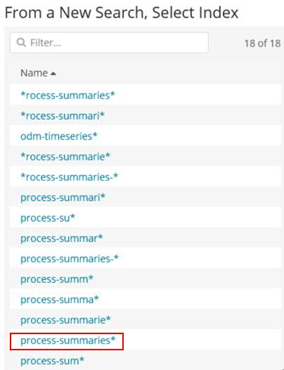

1. Expand the Y-Axis
2. In the aggregation field, select Average.
3. In Field field, select duration
4. Enter Average Total Duration for the custom label.

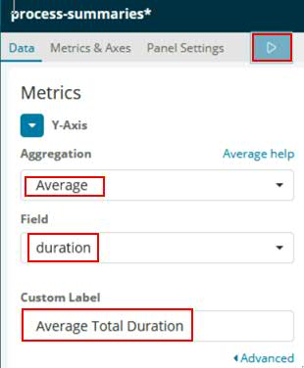

1. Click Y-Axis in the Select metrics type area

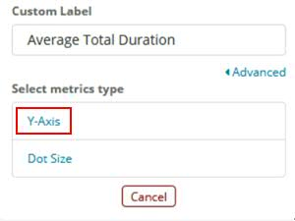

1. Repeat steps 6-8 two times with following changes:

First time: Field: waitTime

Custom label: Avg Wait Duration

Click Add metrics >Y-Axis

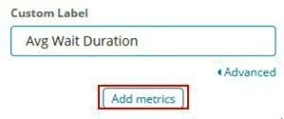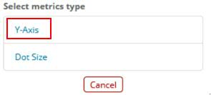

Second time: Field: workingTime

Custom label: Avg Working Duration

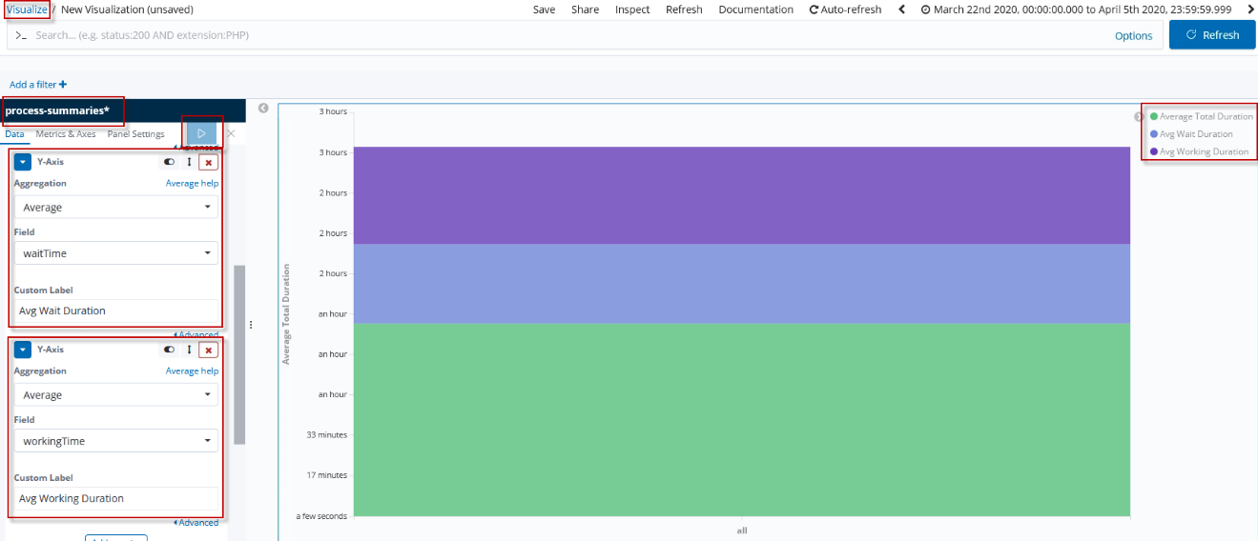

1. Click on X-Axis under Select buckets type.
2. Select Date Histogram in the aggregation field.
3. Select completedTime in the Field Field.
4. In the Interval choice list, select Weekly.
5. Click the “Apply Changes” button which is symbolized as a “Play” button at the top. The diagram is refreshed.

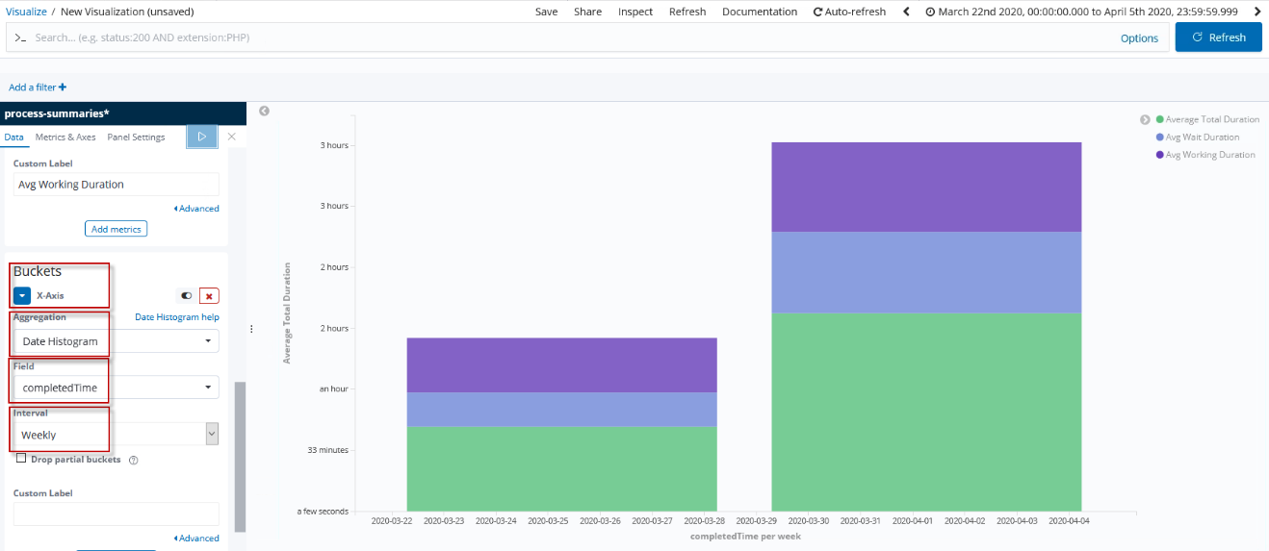

1. Click on the Add sub-buckets label
2. Select Split Series

.

1. In the Sub Aggregation field, select Filters.
2. In the Filter 1 field, enter the following expression:

type:userTask AND name:'Perform Final Review' AND data.TG_MA.finalReview.string:true

1. Click on the Black Arrow
2. Enter the letter A
3. Click the “Apply Changes” button which is symbolized as a “Play” button at the top. The diagram is refreshed.

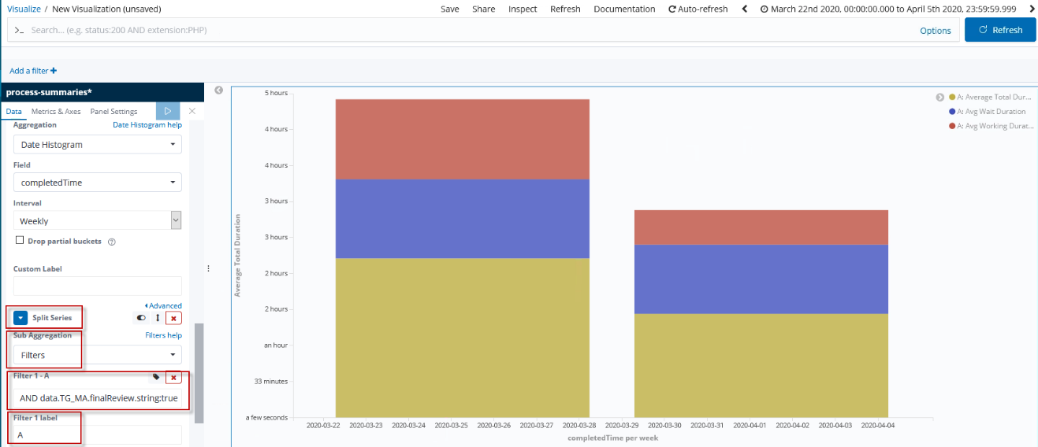

1. Navigate to Metrics & Axes Tab
2. Expand Average Total Duration
3. Change field Mode from stacked to normal
4. Repeat steps 24-25 for Avg Wait Duration and Avg Working Duration
5. Click the “Apply Changes” button which is symbolized as a “Play” button at the top. The diagram is refreshed.

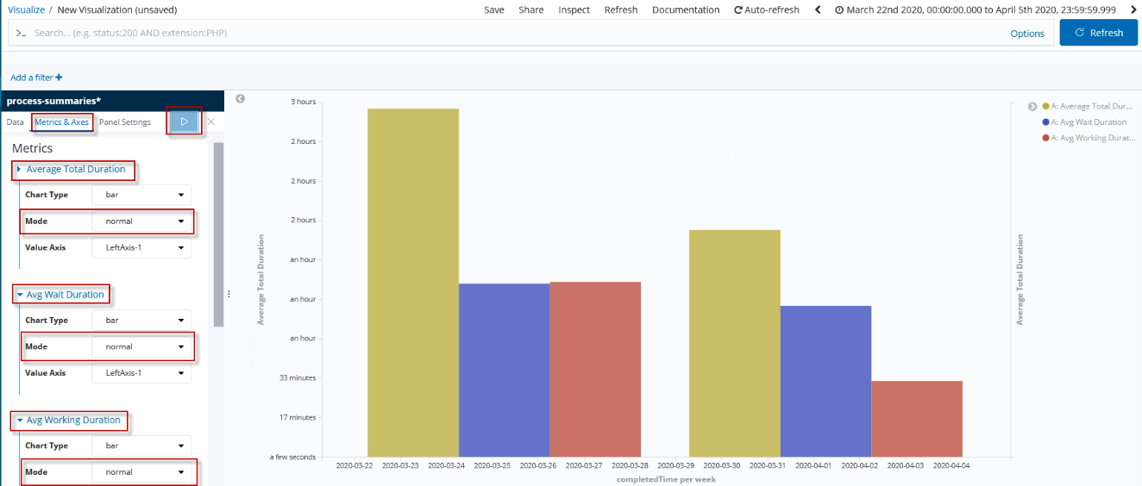

1. When you are satisfied with your visualization and it looks similar to the picture, then you can click the Save button.

When the input area pops up, enter the followiung name with your initials:

<Initials of the student > - MA - Vertical Bar for average duration of approved Mortgage Applications for task 'Perform Final Review' split by Working- and Waittime - v1.0

Press Confirm Save

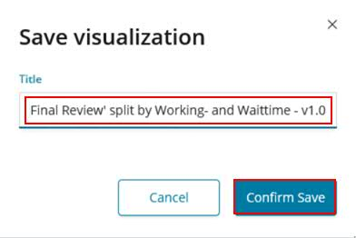

1. After successfully completing this visualization, you can now try the visualization for the rejected case. You only have to set the variable data.TG_MA.finalReview.string from true to false.
2. 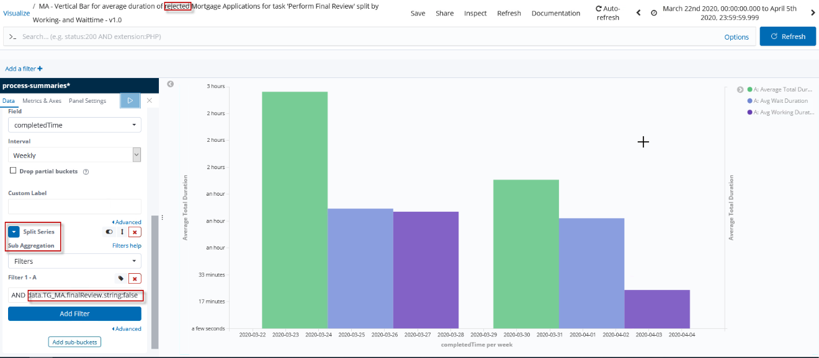

Save this with name:

<Initials of the student > - MA - Vertical Bar for average duration of rejected Mortgage Applications for task 'Perform Final Review' split by Working- and Waittime - v1.0

Summary

Modelling is not possible yet. Only on process level in our example for activity “Perform Final Review” it is possible to separate totalTime, waitTime and workingTime. This might be change in future updates.

Potentially after future updates, it may become possible to compute the entire total, wait and working on bpmn-level via a trace id.

### Create a new Dashboard for the Mortgage Application-specific solution

In this section you will execute the following steps as you have leaned in Building a Dashboard.

The business-related visualizations created in the previous sections are now added to a new dashboard

1. In the side navigation, click Dashboard.
2. Click Create new dashboard. 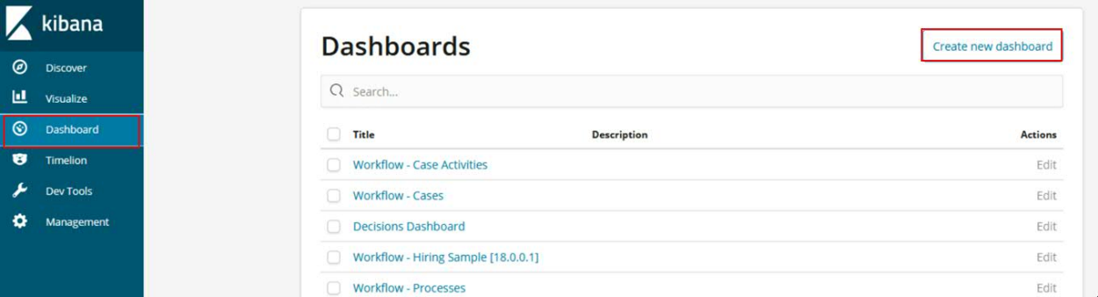
3. Click Add in the Kibana toolbar at the top.
4. Enter the names of your previously created visualizations and click to add them:

* <Initials of the student > - MA - Vertical Bar for average duration of rejected Mortgage Applications for task 'Perform Final Review' split by Working- and Waittime - v1.0
* <Initials of the student > - MA - Vertical Bar for average duration of approved Mortgage Applications for task 'Perform Final Review' split by Working- and Waittime - v1.0
* <Initials of the student > - MA – Timelion for trend of Final Decision Deviating from ODM Proposal – v1.0
* <Initials of the student > - MA – Vertical Bar for trend of accepted and rejected Mortgage Applications – v1.0
* <Initials of the student > - MA - Vertical Bar for Open Mortgage Applications grouped by age on task level - v1.0
* <Initials of the student > - MA- Vertical Bar for Open Mortgage Applications grouped by age and case tasks - v1.0

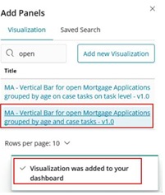

1. When you’re finished adding and arranging the panels, go to the menu bar and click Save.
2. In Save Dashboard, enter a dashboard title and optionally a description. For our purpose use: <Initials of the student > - MA - Business Dashboard for Mortgage Application – v1.0

To store the time period specified in the time filter, enable Store time with dashboard.

Click Confirm Save.   
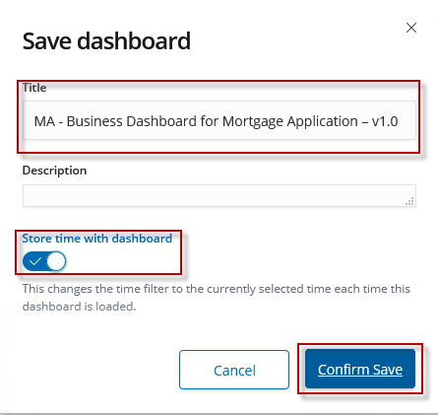

The dashboard with the visualizations added should look similar to the screenshot beneath.

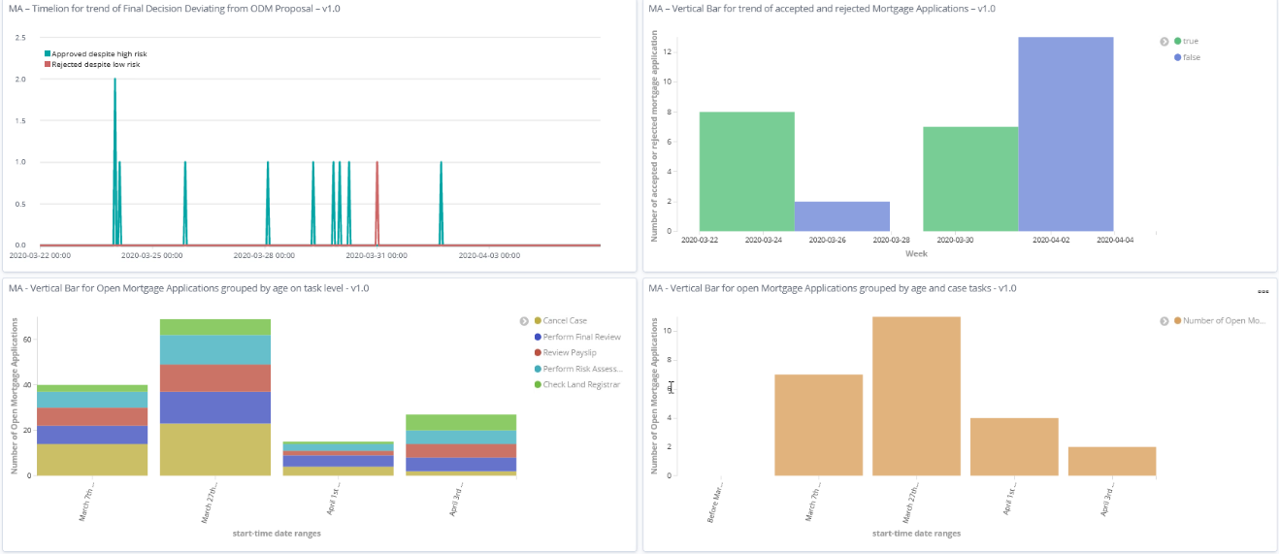

### Create mortgage-specific visualizations without step-by-step instructions

In preceding sections you already created several general as well as specific visualizations for a Business Expert in the Mortgage Department of an enterprise.

You followed the top-down method to design, implement and test visualizations.

Now its time again to practice what you learned. Follow the high level instructions to build at least one of your own.

1. Understand the objectives
2. Specify the detailed requirements
3. Outline the Key Considerations
4. Building the visualization
5. Determine the index or saved search
6. Determine and specify the visualization you want to use
7. Specify the Y-Axis
8. Specify the buckets and aggregations for the X-Axis
9. Build and test your visualization
10. Save the visualization with your initials and a meaningful name

Don’t be afraid. At the end of the exercise you will import a master solution with the following visualizations. Remember, you might start with an existing visualization, save it with a new name and adopt the specification to the attributes of the event/index and syntax for the type of visualization.   
You might also directly import these additonal visualizations and Business Dashboard to see the final graphs and reports as descrbied on Create new Visualizations and a Dashboard for the Mortgage Application Solution – Verification Instructions.

* + - 1. Trend of proposed approval/rejection by ODM

Objective

1. Show the absolute numbers (and trend) of decision to accept and reject mortgage requests per week (as lines or bars)
2. Show the percentage and trend of recommended accepts vs rejects (as bars)
3. Show the trend over the last x weeks (x to be defined)
4. The chart is based on executing second decision service with the Perform Risk Assessment case activity and associated BPMN

Requirement

|  |
| --- |
|  |

Design

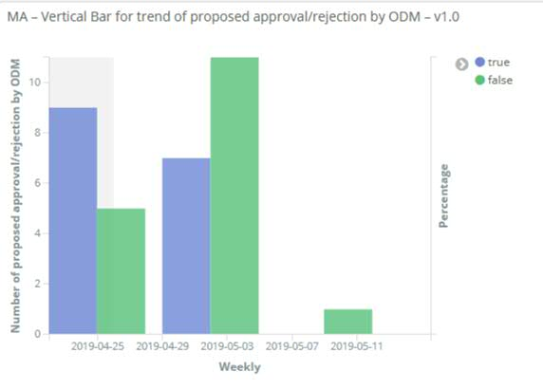

* + - 1. Trend of Mortgage Application Land Registrar Results

Objective

1. Show the absolute numbers (and trend) of the results from Land Registrar as lines or bars.
2. *Show the trend over the last x weeks (x to be defined)*
3. As described in the legend in the pictures below there are three possibilities:

* Address Unknown
* Address Known and Mortgage Blocked
* Address Known and Mortgage not blocked.

To reach this you must work in combination with two properties.

Land Registrar Message and Land Registrar Decision

Requirement

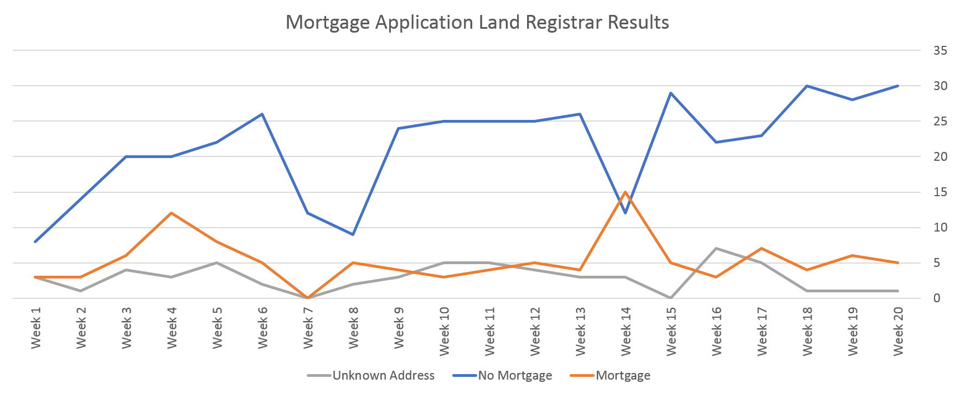

Design

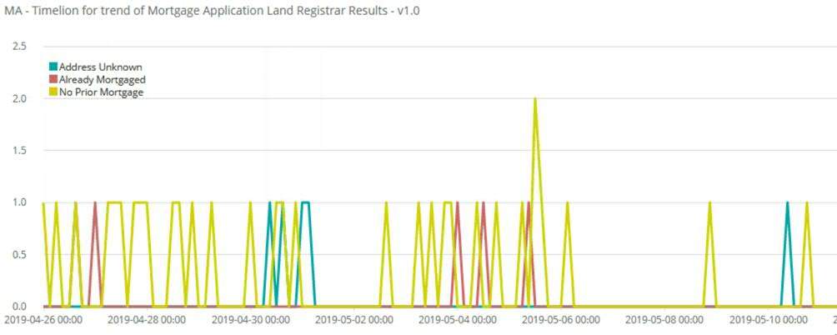

* + - 1. Number of Mortgage Applications completed by Mortgage Officer split by accepted/rejected and deviations from ODM proposal

Objective

1. Show the number of mortgage applications split by the performing mortgage officer
2. You can either display the number per week in bars. Or you can create a line cumulating the number.
3. *Show the trend over the last x weeks (x to be defined)*
4. Since no performers are displayed at case level, we refer to the process task "Perform Final Review". Therefore, you must use a process index.

Requirement

Design

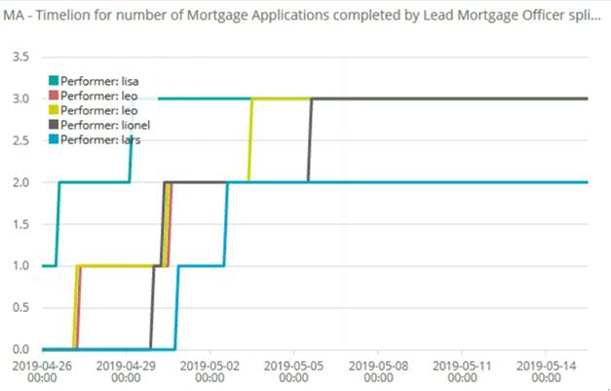

* + - 1. Mortgage Applications grouped by amount

Objective

1. Show the overall number of mortgage applications per week grouped by the Loan Amount
2. Grouping is done based on the requested amount case property.
3. *Show the trend over the last x weeks (x to be defined)*
4. The generated data have amounts between 0 and 1200000. Note this when grouping

Requirement

Design

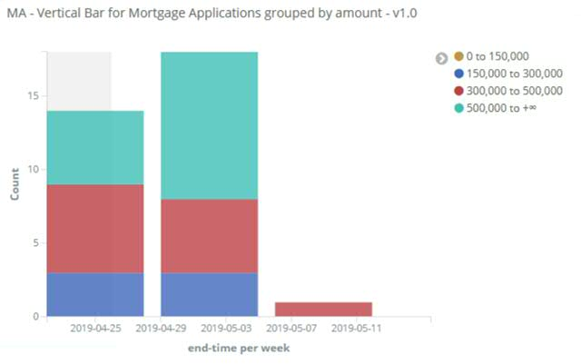

* + - 1. Data Table for Customer Information

Objective

1. Show all customer information as well as the according information of the mortgage application in a table

Requirement

As the head of the Mortgages Organization I need a compact summary of all customer information at a glance.

Design

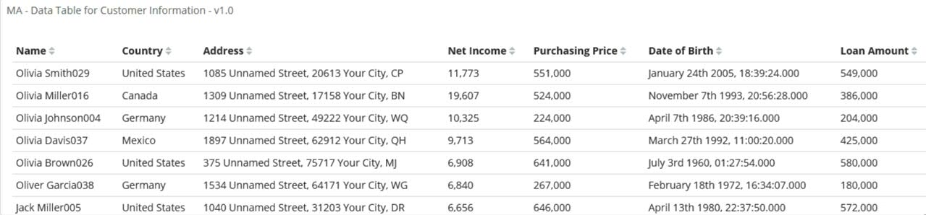

* + - 1. Mortgage Applications with LoanAmount by country

Objective

1. Show the sum of all Loan Amounts per country in a world map (region map)

Requirement

As the head of the Mortgages Organization I need an overview of the total loan amounts in each country. With this information, the company can concentrate on the countries that have the highest loan amounts.

Design

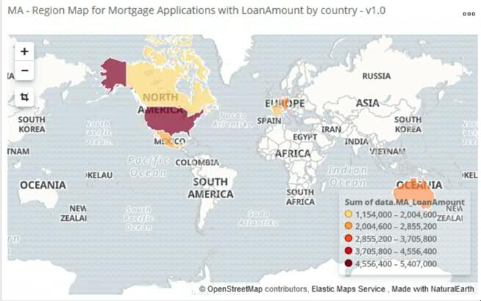

* + - 1. Vertical Bar for Average Duration for Mortgage Application to complete by approved/rejected

Objective

1. Show the average duration in lines for accepted and rejected cases. In addition, display the total average duration.

Requirements

Design

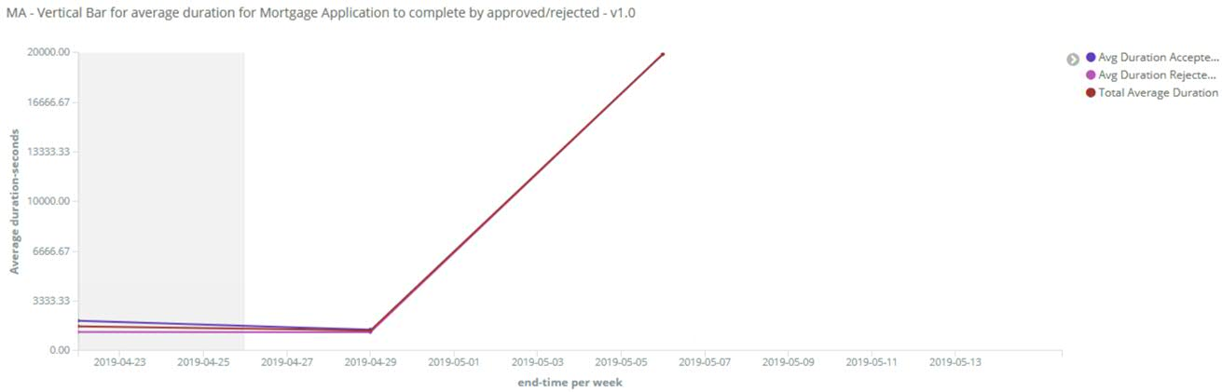

* + - 1. Add your own visualizations to the Business Dashboard

Add your own visualizations to your dashboard created in Create a new Dashboard for Mortgage Application specific solution.

<Initials of the student > - MA - Business Dashboard for Mortgage Application

## Create new Visualizations and a Dashboard for the Mortgage Application Solution – Verification Instructions

As part of the validation of the artefacts created on your own you can import the master solution of the MA –Business Dashboard for Mortgage Application in order

1. to compare them with your specification and diagram
2. to demonstrate them as part of the end-to-end scenario

Follow these steps:

1. Import the and associated artefacts (visualizations) and Business Dashboard
2. In Kibana, click Management in the navigation tree
3. Select Saved Objects  
   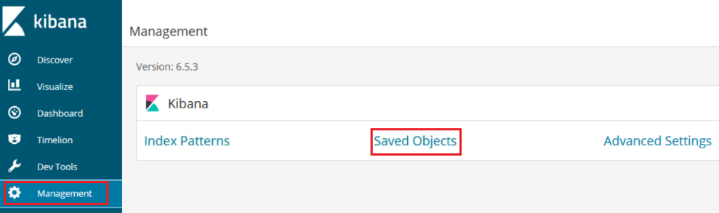
4. Click Import. 
5. Click Import again
6. Select file “c:\Users\Administrator\ibm-bai-workshop-main\labs\bpmn-case-odm-kibana\saved-search-visualizations.json” that represents the objects to import.
7. Indicate to overwrite objects already in Kibana. This should not be the case as you named your artefacts with initials.  
   
8. Repeat steps c. to f. for file “c:\Users\Administrator\ibm-bai-workshop-main\labs\bpmn-case-odm-kibana\business-dashboard.json”.
9. Click Import.
10. Open the dashboard and verify the additional visualizations with yours.

Note  
We don’t claim that our solutions of these additional visualizations are the only and best way to convey results and reports on business data. Therefore, your work might be different or more expressive. Feel free to share your solution with us.

## Create new Visualizations and a Dashboard for the Mortgage Application Solution – Summary

In this exercise you learnt how to build visualizations for the Business User. Remember to develop widget to enable the Business Owner to make better business decisions, to reduce the risk for bad mortgages, or to improve efficiency.

Follow the method to gather the business requirements for monitoring applications when you design them for customer in different industries.

With that you have successfully finished the implementation of the Exercise 6 of the BAI Lab. Congratulations!